November 17, 2023
Stanton Community School

Santa Lucia is December 9th
We are busy getting prepared for our annual Santa Lucia Festival of Lights which will be held Saturday, December 9th, 7 p.m. at the Stanton High School Gym.
Grades 1-6 will take part in this nostalgic Festival. (Kindergarten students will have a special program at a later time this school year.) Children should be at the gym between 6:45 – 6:50 p.m., SEATED QUIETLY, on the stage bleachers on the north end of the stage. The Fifth and Sixth grade students should go to the weight room no later than 6:50 p.m. (Some 4th graders will also be asked to fill in for the dancing part as in the past.) It is very important for every student to participate as it is part of the music curriculum and their music grade.
The students should wear the following:
Boys: White shirts, dark pants, red vest or bow/ribbon tie (if you have one) or red suspenders. Black or very dark dress type shoes (preferably no tennis shoes)
Girls: White blouse, red, blue or yellow skirt, striped apron (if you have one), red tights or knee socks and floral rings for your hair (if you have one) dark shoes preferably black and also no tennis shoes.
*We will have clothing items for the student’s outfits in the elementary office after we return from Thanksgiving break. Please send your student to the elem office if they need anything but please know that our selection is very limited.

School Activities

Notification of Student Absences
Parents must call the high school office (829-2162) or elementary office (829-2171) to report any student absences or to notify the office if a student needs to leave early or arrive late due to an appointment, trip, etc. This allows us to provide homework or anything the student might miss in advance of the absence. It is the parent’s responsibility to notify the school in a timely manner. All student absences with no notification are unexcused absences on the student’s attendance record. Parents can also email Mrs. Elwood at celwood@stantonschools.com in the high school office or Mrs. Druivenga at jdruivenga@stantonschools.com in the elementary office to report the above.
Dance Team Showcase
The Stanton Dance Team Showcase will be Saturday, November 18th at 6 pm at the Stanton High School. Admission is $5 and concessions will be available.
Stanton little girls dance/ cheer team will perform on November 18th at the showcase. Please have students at the Viking Center by 5:30 to practice. We will then go as a group to the high school gym.
Get Your Stanton Bracelets!!
Stanton dance team is selling purple/white/black Puravida bracelets to raise money for nationals in February. $10 each Stanton colors! These would make excellent Christmas gifts! Please contact Jana McCunn or any dance team member to purchase!
Red Cross Blood Drive
Stanton's FCCLA is sponsoring a Red Cross Blood Drive on Wednesday, December 13 from 9:30 AM- 3:30 PM at the Viking Center. Your donation not only saves lives but it also helps Stanton seniors with scholarship money. To schedule an appointment, call the high school office or go to redcrossblood.org.
Pink Out Sponsored by the FCCLA
Stanton's FCCLA is sponsoring a "Pink Out" night on Friday, December 15. All the money that is raised is donated to Coaches vs Cancer to fight cancer. There will be a variety of activities that evening to raise money. Look for more details in upcoming bulletins. A Pink Out t-shirt order form was sent out to all students and is due back before November 21st (just before Thanksgiving). If you are in need of an order form or want to order a t-shirt, please contact the high school office.
Attn: All Seniors!!
Please give two senior photos and a baby photo to Mrs. Carpenter before Thanksgiving break. These will be scanned for use in the yearbook. If we do not receive photos before then, we will use the Josten composite senior photo and no baby photo.
More Post-Season Volleyball Honors
Congratulations to Juniors, Lauren Johnson and Kyla Hart, who were named to the Southwest 1A All-District team. Lauren was also honored as an All-State 4th Team pick for this season. So very proud of our Viqueens!!

Staff Highlights
Sandy Allen, Custodian
Mrs. Allen was born in Racine, Wisconsin. Her father was employed with the Chicago Northwestern Railroad and they transferred a lot throughout Wisconsin and Illinois, eventually settling in Norfolk, Nebraska in 1968. Mrs. Allen graduated from Norfolk Senior High in the mid 1970's. She also attended Creighton University for a brief time.
Mrs. Allen has seven children, ten grandchildren, and one great grandson..with a great granddaughter due in February. She raised her family primarily in Boulder, Colorado, and is married to Jerry Wallace.
Her hobbies include: reading a broad range of genres of literature, attending opera and theater productions, volunteering in the community, and staying physically active.
Mrs. Allen is most grateful for her employment at Stanton Community School District for the privilege of working with such devoted and talented faculty and support staff. I am truly blessed!
Josh Porter, Paraeducator and Kitchen Assistant
Mr. Porter's hometown is Stanton, Iowa. He attended Stanton Community School and Southwestern Community College, where he obtained a degree in Business Management. His daughter Karter is in 3rd grade.
Mr. Porter's hobbies include golfing, watching the Dallas Cowboys, Kansas City Chiefs and Nebraska Cornhuskers, playing cards with friends, and going to different dirt racing tracks throughout the spring and summer.
His favorite thing about working at Stanton is seeing all the kids coming through the lunch line, and their very unique sense of taste. He also enjoys being able to assist students in the classroom the same way I was when I went to school here.

Spotlight on Students of the Week
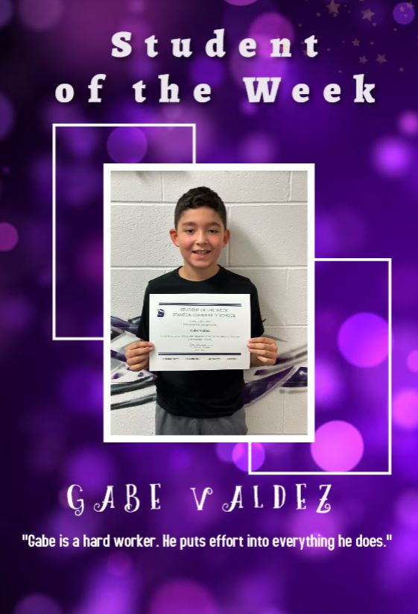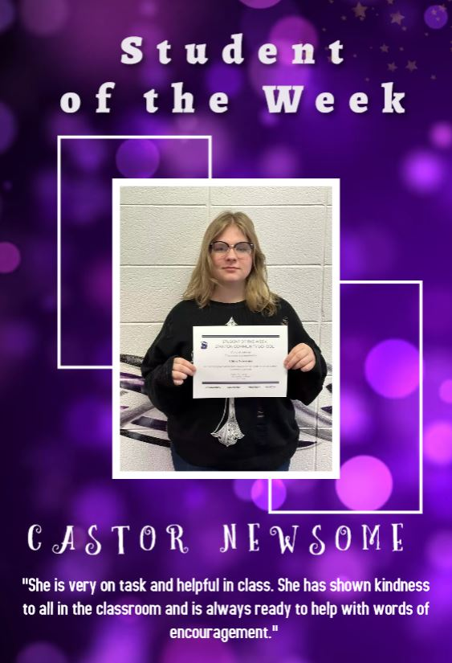

From the Desk of Our Principal
With winter weather just around the corner, please note that the district will send a text and email if we have a late start or cancellation. We will also post to the district Facebook page and notify local news and radio stations. Please let the office know if you have any questions.
* The state has allowed school districts to use up to 5 days of virtual learning in the school calendar as snow days. Similar to previous years, if we have advanced notice, we will send devices home with students and email parents if we are planning to have a remote learning day.
November 17th, 2023
Upcoming Dates:
Tuesday, November 21st - MS/HS Midterm Grade Check
Wednesday, November 22nd - No School
Thursday, November 23rd - No School - Happy Thanksgiving!
Friday, November 24th - No School

Lunch and Breakfast Menu
Mon., Nov 20th Breakfast: Pop-Tart/Muffin/Juice/Milk
Lunch: Cheesy Pull Aparts, Lettuce, Broccoli, Applesauce, Pears & Milk
Tues, Nov 21st Breakfast: Bagel Bites/Muffin/Juice/Milk
Lunch: Creamed Turkey, Mashed Potatoes, Green Beans, Sweet Potatoes, Stuffing, Peaches, Mixed Fruit, Pumpkin Dessert & Milk
Wed., Nov 22nd NO SCHOOL
Thurs., Nov 16th NO SCHOOL
Fri., Nov 17th NO SCHOOL
Mon., Nov 27th Breakfast: Cereal/Muffin/Fruit Juice/Milk
Lunch: Rib/Hot Dog, Baked Beans, Potato Salad, Pineapple, Mixed Fruit & Milk
Tues., Nov 28th Breakfast: Oatmeal Bar/Muffin/Fruit Juice/Milk
Lunch: Breakfast Pizza, Hashbrown, Juice, Applesauce, Tropical Fruit & Milk
Wed., Nov 29th Breakfast: Breakfast Sandwich/Muffin/Fruit Juice/Milk
Lunch: Chicken Pattie/Bun, Mixed Veggies, Tater Twisters, Pears, Peaches, Chocolate Chip Bar & Milk
Thurs., Nov 30th Breakfast: Bacon & Egg Pizza/Muffin/Fruit Juice/Milk
Lunch: Lasagna Roll-Up, Lettuce, Carrots, Applesauce, Pears, Breadstick & Milk
Fri., Dec 1st Breakfast: French Toast/Muffin/Fruit Juice/Milk
Lunch: Beef Stew, Cooked Carrots, Peaches, Apple Slices, Biscuit, Teddy Grahams & Milk

Yearbooks are now on sale for a mere $55! Find a yearbook student and get yours ordered today! Price increase is coming in November, so get yours at the lowest price now!
Also, anyone who has summer candids that the yearbook could use, contact Charm Carpenter for an email address to send those photos to! Thanks for your support!

Upcoming Events
Fri., Nov 17th 6:00 JV BB Achieve Challenge – Red Oak
6:00 V BB Achieve Challenge – Red Oak
Sat., Nov 18th 6:00 Dance Team Showcase Night
Mon., Nov 20th 4:00 JH Boys BB @ East Mills
Tues., Nov 21st CC Science Fair @ Hamburg
6:00 V BB Jamboree w Exira/EHK
Wed., Nov 22nd NO SCHOOL
Thurs., Nov 23rd Happy Thanksgiving
Fri., Nov 24th NO SCHOOL
Mon., Nov 27th 4:00 JH Girls BB @ Lenox
4:00 JH Boys BB @ Lenox
Wed., Nov 29th 1:05/1:15 Early Dismissal
Thurs., Nov 30th State Dance Competition
Fri., Dec 1st State Dance Competition
4:00 JH Boys BB @ Sidney
6:00 V girls BB @ Sidney
7:30 V boys BB @ Sidney

Community Events
Holiday Hoopla, Christmas in Stanton, will be held on Saturday, November 25th from 5 pm to 7 pm in downtown Stanton. Many or our wonderful local businesses will be hosting open houses. There will be fun events for all ages including a lighted kids parade beginning at 5pm that will take place on the Main Street sidewalk, ham giveaways and The After Party at the Oly from 8 pm to 11 pm.

