December 15, 2023
Stanton Community School

School Activities
Thank You
A big “Thank You” to the 1st-6th grade parents that helped with supervision during the Santa Lucia program last Saturday night. Your assistance was very much appreciated and helpful!
Kindergarten Christmas Program
The kindergarten classes will have a Christmas program at 2:30 pm on Friday, December 15, in the music room (aka band room). Light refreshments will be served afterwards. Parents and grandparents are invited to attend.
Fifth Grade Food Drive
The 5th graders would like to have a Holiday Food Drive to help area families. We want to have a contest for all K-5 classes, to see who can collect the most points from now until Dec. 21st.
We will no longer have a points system for the items brought in. Instead, each item is just worth one point. The students that choose the winning team with the most points earn a movie and pizza party in January!
Please, when donating items, make sure they are not outdated! We look forward to helping the people in our community and having a fun contest while doing it. Thank you to everyone in advance for the generous donations and support!
Coach Sloth
On Monday December 11th, Coach Ryan Sloth visited Stanton Elementary School to share his love of writing, reading, and being a kind person. The students heard Coach Sloth share his experiences playing football, being in Hollywood movies, and caring for others. Coach Sloth shared his famous magic coloring book, which was a huge hit with all the students and teachers! He also had the kids act out his book Hank the Bully and they were fantastic actors and actresses. We had Omaha Channel 3, KMTV, join us too for the morning presentation. Here is the link to their story: https://www.3newsnow.com/southwest-iowa/coach-sloth-has-a-few-tricks-up-his-sleeve-to-promote-literacy-and-kindness Coach Sloth has a few tricks up his sleeve to promote literacy and kindness Ryan Sloth (real name) played football for Iowa State in the late ‘90s. He followed that up with an arena football career, Hollywood movie appearances, and now, he writes children’s books. www.3newsnow.com
We thank Coach Sloth for spending the day in Stanton and helping us continue our love for writing, reading, and for each other! Here is the link to his website: https://coachsloth.com/index.php

.
Get Your Stanton Bracelets!!
Stanton dance team is selling purple/white/black Puravida bracelets to raise money for nationals in February. $10 each Stanton colors! These would make excellent Christmas gifts! Please contact Jana McCunn or any dance team member to purchase!
Pink Out Sponsored by the FCCLA
Stanton's FCCLA is sponsoring a "Pink Out" night this Friday, December 15. All the money that is raised is donated to Coaches vs Cancer to fight cancer. There will be a variety of activities that evening to raise money.

Staff Highlights

Mrs. Ashley McDonald, School Counselor
Mrs. McDonald grew up on a farm south of Stanton with her mom, dad, brother, and sister. She attended Stanton Community School for grades kindergarten to 12th grade, where she graduated in 2000. After high school, Mrs. McDonald attended college and graduated with a bachelor's degree in accounting from the University of Nebraska in Omaha. She eventually went on to get her master's degree in professional school counseling from Buena Vista University.
Mrs. McDonald currently lives in Stanton with her husband, John, and 4 kids: Elly, James, Quinn, and Maeve. Her brother and sister also live in southwest Iowa so she gets to see them and their families a lot, which is fun!
In her free time, she likes to attend different sporting events where she loves watching the Vikings and Viqueens, along with Creighton and Iowa State. She also enjoys going on walks with her friends, shopping, hanging out with friends and family, and last but not least planning and going on vacations!
Her favorite part about working at Stanton Schools is working with a caring and dedicated staff. She also appreciates all of our respectful and kind students and parents.
Mr. Jeff Grebin, Business Teacher
Mr. Grebin grew up in Harmony, Minnesota and graduated from Harmony High School. He attended Rochester Community College and Mankato State University.
His family includes his wife Shay; daughters Sydney 29 and Gabi 13; sons Rafe 20, Nolan 18, and Rylan 16; and favorite son-in-law Brandon.
Mr. Grebin really enjoys helping people. He also enjoys time with his family & friends. He loves challenges and problem-solving, and looks forward to almost anything that is competitive. He loves playing softball and is looking forward to trying new things (maybe pickleball). Mr. Grebin also likes to fix, design, and build things.
His favorite things about working at the Stanton Community School District are the great relationships, high expectations, and strong support from our community.

HEY SENIORS!
Seniors: final week for those baby photos and senior photos! See Mrs. Charm if you have any questions.
New Yearbook Option
Yearbook has a new digital experience for all those who purchase a 2024 yearbook! Check with any yearbook member or Mrs. Charm to learn more about it!

Spotlight on Students of the Week

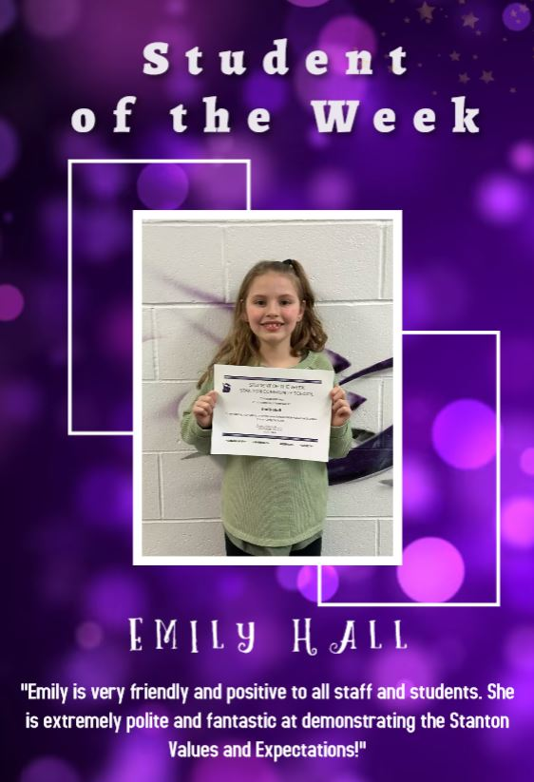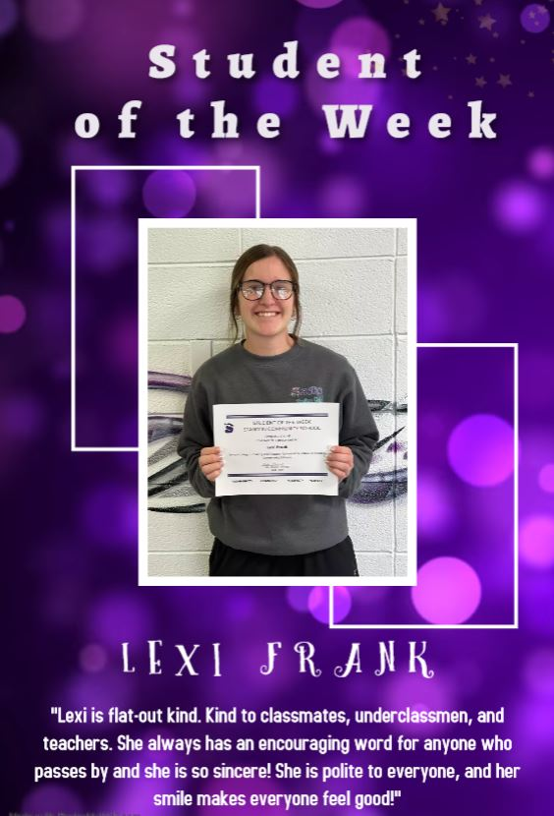

Upcoming Events
Fri., Dec 15th 4:00 JH B BB w Fremont Mills
5:00 JV B BB w Fremont Mills
6:00 V G BB w Fremont Mills
7:30 V B BB w Fremont Mills
Mon, Dec 18th 4:00 JH B BB at Bedford
6:00 JV B BB at Bedford
6:00 HS G BB at Bedford
7:30 HS B BB at Bedford
Tues., Dec 19th 5:30 HS G BB w Grandview Christian
5:30 JV B BB w Grandview Christian
7:00 V B BB w Grandview Christian
6:00 FFA Game Night
Wed., Dec 20th 1:05/1:15 Early Dismissal
Thurs., Dec 22nd 1:05/1:15 Early Dismissal
End of 2nd Qtr, 1st Semester

Lunch and Breakfast Menu
Mon., Dec. 18th Breakfast: Cereal/Muffin/Juice/Milk
Lunch: Chicken Fried Steak/Bun, Cheesy Broccoli, Baked Beans, Mixed Fruit, Pears & Milk
Tues, Dec 19th Breakfast: Mini Donuts/Muffin/Juice/Milk
Lunch: Grilled Cheese, Tomato Soup, Tri-Tater, Peaches, Pineapple & Milk
Wed., Dec. 20th Breakfast: Soft Cereal Bar/Muffin/Juice/Milk
Lunch: French Bread Pizza, Lettuce, Celery, Applesauce, Strawberries & Milk
Thurs, Dec 21st Breakfast; Bagel Bites/Muffin/Juice/Milk
Lunch: Creamed Turkey, Mashed Potatoes, Green Beans, Sweet Potatoes, Peaches, Mixed Fruit, Jello, Rye Bread & Milk
Fri., Dec 22nd Breakfast: Cookie/Muffin/Juice/Milk
Lunch: Deep Dish Pizza, French Fries, Corn, Pears, Applesauce & Milk

Girls Basketball
Stanton 65 – Lenox 50
Hannah Olson scored her way on to the all-time single game scoring list going 14 for 22 from the field and 3 for 3 from the free throw line capping off a 31 point performance. Those points were much needed as the Queens faced their toughest competition of the season taking on visiting Lenox last Thursday evening. Once again, the Viqueens set the stage racing to a 41-23 halftime lead and maintained that margin to the final buzzer. The 31 points by Hannah which is tied for the 6th best in the Viqueen record book overshadowed an all-time single game assists performance by Kyla Hart, Kyla’s 11 assists are tied for the best performance of any Viqueen in Stanton Girls Basketball history. Stats Leaders: Hannah Olson 31 pts, 12 rebs, 5 steals, Leah Sandin 15 pts, 4 rebs, 3 steals, Lauren Johnson 10 pts, 11 rebs, 2 steals, Riley Burke 8 pts, 4 rebs, 2 steals, Kyla Hart 11 assists, 6 rebs
Stanton 50 – East Mills 20
The Queen’s had to shake off the fatigue from the Lenox game the night before to make runs against the scrappy Wolverines in the 1st and 3rd quarters while holding off the opponent in the 2nd and 4th quarters from making a comeback. Defensively the Queens were outstanding, forcing the Wolverines into 37 turnovers while only getting called for 5 total fouls. Offensively Stanton dominated the paint with Hannah Olson and Lauren Johnson combining for 35 points. Stats Leaders: Leah Sandin 12 pts, 3 assists, 6 steals, Lauren Johnson 17 pts, 10 rebs, 4 steals, Hannah Olson 18 pts, 6 rebs, 9 steals, Kyla Hart 7 assists
Stanton 70 – Essex 22
Hot shooting especially from the 3-point line propelled the Viqueens to their first 70 point game of the season, the red hot Queens cashed in 11 of 15 three point attempts on the night. Riley Burke would lead the way going 3 for 3 from 3 for the game. Leah Sandin would lead the team in scoring with a game high 29 points and recording impressive shooting totals going 11 of 15 from the field including 4 of 6 from three while also going 3 of 4 from the charity stripe. However, the performance of the night was turned in by Kyla Hart, her passing and ball distribution to her teammates for scores netted an all-time single game record of 12 assists. Kyla now stands alone on the leader board for most assists in one game in Viqueen basketball history. The Queens are now 5-0 on the season and will host 6-0 Fremont Mills on Friday. Stats Leaders: Leah Sandin 29 pts, 4 assists, 4 steals, Lauren Johnson 8 pts, 10 rebs, Kiela Franzen 6 pts, 5 rebs, 2 steals, Hannah Olson 12 pts, 4 rebs, 8 steals, Riley Burke 9 pts, 2 rebs, 2 steals, Kyla Hart 12 assists, 5 rebs, 2 steals
Community Events
Drive Thru Christmas
Located at: Stanton Old Lumber Yard Event Center
Saturday, December 16th from 5-7 pm
Sunday, December 17th from 5 to 7 pm
Friday, December 22nd from 5 to 7 pm
Stanton’s Legion Santa Claus
Stanton children up to and including second grades are invited to walk through and see Santa Claus at the Stanton Old Lumber Yard Event Center on Saturday, December 16th from 5pm-7pm. Anyone is welcome to walk through and see Santa, but only those who call Santa’s helpers will receive gifts. The high school choir will provide music. Hot chocolate and apple cider will be served. Santa’s helpers will be waiting to talk on the phone (712)829-2687 to the children on Wednesday, December 13th and Thursday, December 14th from 5:30pm-7:30pm. Be sure to tell Santa each child’s name. Give this information clearly in order that Santa will not forget anyone!

