December 1, 2023
Stanton Community School

.
Corner Conference Science Fair
The Corner Conference Science Fair was held in Hamburg on November 21, 2023. The students had a great time sharing their projects with judges and enjoyed the Wildlife Encounters presentation. The following students were selected to participate in the Corner Conference Science Fair this year.
7th Grade: Jayden Burke, Tristan Elwood, Rhys King, Elisabeth Kutzli, Quinley McDonald, Gracelynne Roberts, Ty Roberts, Addison Spencer, Cooper Stephens
8th Grade: Nolan Case, Cooper Dreyer, Lilly Focht, Hannah Gibbs, Gabi Grebin, Brett Hart, Addison Jones, Gabe Kingery, Addie Peterson, Lauren Roberts, Josiah Shipp, Jayden Snow, Kennedy Stites
We had three students who placed in the top five in their categories. Congratulations!
Cooper Dreyer- 5th place Earth Science
Nolan Case- 3rd place Earth Science
Gabe Kingery- 2nd place Physical Science
Get Your Stanton Bracelets!!
Stanton dance team is selling purple/white/black Puravida bracelets to raise money for nationals in February. $10 each Stanton colors! These would make excellent Christmas gifts! Please contact Jana McCunn or any dance team member to purchase!
Red Cross Blood Drive
Stanton's FCCLA is sponsoring a Red Cross Blood Drive on Wednesday, December 13 from 9:30 AM- 3:30 PM at the Viking Center. Your donation not only saves lives but it also helps Stanton seniors with scholarship money. To schedule an appointment, call the high school office or go to redcrossblood.org.
Pink Out Sponsored by the FCCLA
Stanton's FCCLA is sponsoring a "Pink Out" night on Friday, December 15. All the money that is raised is donated to Coaches vs Cancer to fight cancer. There will be a variety of activities that evening to raise money. Look for more details in upcoming bulletins

School Activities
Santa Lucia is December 9th
We are busy getting prepared for our annual Santa Lucia Festival of Lights which will be held next Saturday, December 9th, 7 p.m. at the Stanton High School Gym.
Grades 1-6 will take part in this nostalgic Festival. Children should be at the gym between 6:45 – 6:50 p.m., SEATED QUIETLY, on the stage bleachers on the north end of the stage. The Fifth and Sixth grade students should go to the weight room no later than 6:50 p.m. (Some 4th graders will also be asked to fill in for the dancing part as in the past.) It is very important for every student to participate as it is part of the music curriculum and their music grade.
The students should wear the following:
Boys: White shirts, dark pants, red vest or bow/ribbon tie (if you have one) or red suspenders. Black or very dark dress type shoes (preferably no tennis shoes)
Girls: White blouse, red, blue or yellow skirt, striped apron (if you have one), red tights or knee socks and floral rings for your hair (if you have one) dark shoes preferably black and also no tennis shoes.
*We will have clothing items for the student’s outfits in the elementary office after we return from Thanksgiving break. Please send your student to the elem office if they need anything but please know that our selection is very limited.
Kindergarten Christmas Program
The kindergarten classes will have a Christmas program at 2:30 pm on Friday, December 15, in the music room (aka band room). Light refreshments will be served afterwards. Parents and grandparents are invited to attend.
Driver’s Education
We will be offering a Driver's Ed Course, starting January 8 - Feb 7. Cost of the course is set at $325.00 for Stanton students. We have a signup sheet in the office, if your student will be 14 years or older and will have their permit in hand by the 1st day of class, please have them stop in and sign up. We do need a copy of their permit in the office before class starts. If you have any questions please call the HS office 829-2162.
There will be more information to follow!
Driver’s Ed Schedule for 2024
Monday, January 8 6:30AM-8:00AM
Wednesday, January 10 1:30PM- 4:30PM
Friday, January 12 6:30AM-8:00AM
Monday, January 15 (No School) 8:00AM-11:00AM
Wednesday, January 17 1:30PM- 4:30PM
Friday, January 19 6:30AM-8:00AM
Monday, January 22 6:30AM-8:00AM
Wednesday, January 24 1:30PM- 4:30PM
Friday, January 26 6:30AM-8:00AM
Monday, January 29 6:30AM-8:00AM
Wednesday, January 31 1:30PM- 4:30PM
Friday, February 2 6:30AM-8:00AM
Monday, February 5 6:30AM-8:00AM
Wednesday, February 7 1:30PM- 4:30PM
Drive times will be set up with the students.

Upcoming Events
Fri., Dec 1st 4:00 JH Boys BB @ Sidney
6:00 V girls BB @ Sidney
7:30 V boys BB @ Sidney
Sat., Dec 2nd FFA IAT Leadership Conference
Tues., Dec 5th 4:00 JH G BB with Griswold
4:00 JH B BB @ Griswold
6:00 V G BB @ Griswold
6:00 JV B BB @ Griswold
7:30 V B BB @Griswold
Wed., Dec 6th 1:05/1:15 Early Dismissal
Thurs., Dec 7th 7:30 am FFA Meeting
4:00 JV B BB w Lenox
6:00 V G BB w Lenox
7:30 V B BB w Lenox
Fri., Dec 8th 4:00 JH G BB at EM (Old N. Valley school)
4:00 JH B BB w EM at VC gym
6:00 V G BB at East Mills
7:30 V B BB at East Mills
Sat., Dec 9th 7:00 Santa Lucia in HS gym

HEY SENIORS!
The yearbook is still looking for senior photos and baby photos of each senior.
We want to see the senior POV on portraits!
We have made some changes in the yearbook and want to showcase each senior, but we can only do that if you get those photos to us ASAP!
Help us dry Mrs. Charm's tears!
She's crying all day long!
Send your photos through email to her,
And turn her sobs into a song!

Spotlight on Students of the Week
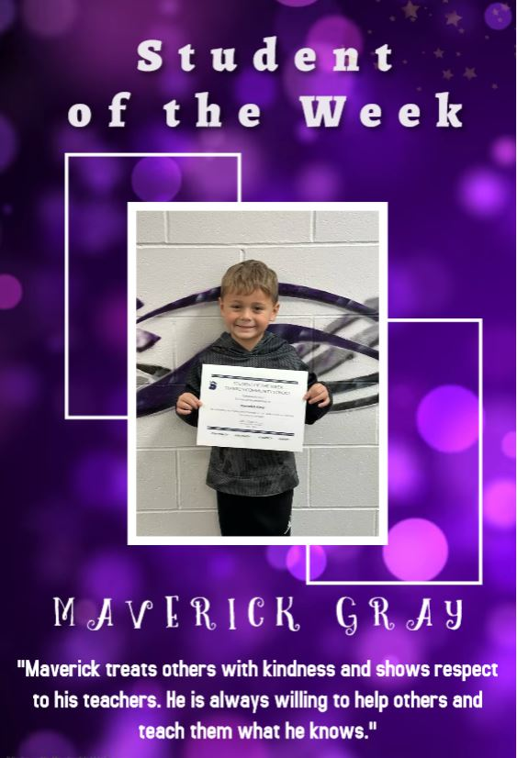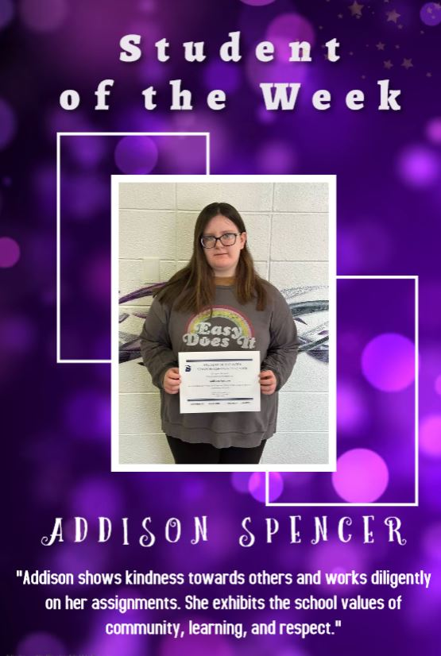

Staff Highlights
Darla Brooke - MS/HS Family and Consumer Sciences Teacher
Mrs. Brooke's hometown is Villisca, Iowa. She graduated from Villisca High School, and then graduated from the University of Northern Iowa with bachelor's degrees in Family & Consumer Sciences Education and Family Services. She also graduated from Iowa State University with a master's degree in Family & Consumer Sciences.
Mrs. Brooke previously taught at Clarinda Middle School and has had a shared position with South Page and Clarinda. She also worked for Iowa State University Extension as Montgomery County Extension Education Director, Page and Montgomery County Home Economist, and Page County 4-H & Youth Director
She is married to Lee, who farms. They have 3 adult children: Bailey Clubb (Cody husband), Leah, and Logan (Annie wife). They also have 2 grandchildren, Bowen and Raylee.
Mrs. Brooke's hobbies include working outside, especially mowing; exercising; swimming and boating; hanging out with friends, family and grandkids. Her favorite things about Stanton are that she enjoys teaching at a smaller school with smaller classes. She also appreciates all of the community support .
John Mainquist - 3rd Grade Teacher
Mr. Mainquist is from Stanton, IA and a graduate of Stanton Community Schools. He completed his undergrad at Northwestern College in Orange City, IA then transferred to Central College in Pella, IA. He received his Masters from Dordt University in Sioux Center, IA.
Mr. Mainquist's mom is Mrs. Sheila Mainquist, the TAG Teacher at Stanton Schools and part-time school counselor at Fremont-Mills Schools. He has a sister, Christine Mainquist-Whigham, brother-in-law Alex Whigham, and nephew Callum Whigham (22 months).
His hobbies include playing music (guitar, bass, piano, drums), listening to music (indie-folk), watching volleyball (Creighton Bluejays), watching soccer (Omaha Union), spending time with his nephew, reading books (favorite author - John Mark Comer), singing (church choir), and watching The Office.
Mr. Mainquist's favorite thing about Stanton Schools is being able to see all the K-12 students every day, serving in various roles in the school, and being connected with the families and the community. He has cherished his teachers as a student, and is blessed to be serving the students as a teacher! "Stanton is my home!"

Lunch and Breakfast Menu
Mon., Dec. 4th Breakfast: Cereal Bar/Muffin/Juice/Milk
Lunch: Fiestada, Lettuce, Corn, Pears, Applesauce & Milk
Tues, Dec 5th Breakfast: Crescent Roll/Muffin/Juice/Milk
Lunch: Ham & Potato Casserole, Green Beans, Peas, Mixed Fruit, Mandarin Oranges, Roll & Milk
Wed., Dec. 6th Breakfast: Breakfast Pizza/Muffin/Juice/Milk
Lunch: Stadium Dog, Chili & Cheese, Potato Wedges, Baked Beans, Pears, Strawberries & Milk
Thurs, Dec 7th Breakfast: Pancakes/Muffin/Juice/Milk
Lunch: Chicken Alfredo, California Vegetables, Lettuce, Pears, Applesauce, Breadstick & Milk
Fri., Dec 8th Breakfast: Omelet/Muffin/Juice/Milk
Lunch: Walking Taco, Lettuce/Cheese, Corn, Refried Beans, Pineapple, Oranges, Goldfish & Milk

From the Desk of Our Principal

November 17th, 2023
Upcoming Dates:
Friday, Dec. 22nd – End of 2nd Quarter/1st Semester
*Friday, Dec 22nd – Stanton Community School District will have a 2-hour early dismissal for the holiday break.
Thursday, Jan 4th – Classes will resume

Santa Lucia Bake Sale
The Santa Lucia Bake Sale Committee would greatly appreciate community members to donate baked goods to the bake sale. Please bring items to the school concourse on Saturday, December 9th, before 6.

Community Events
Holiday Open House at the Library
The Stanton Public Library will hold an open house on Thursday, December 7th from 2 to 4 pm. Refreshments will be served.
Cue the Lights!
Stanton’s Annual Holiday Light Contest is open to all Stanton residents. Categories are most classic, best small display and the Clark Griswold award. One winner in each category will receive Stanton Chamber Bucks. Judging will be held on Thursday, December 7th, Winners will be announced at Santa Lucia on Saturday, December 9th. Let the Fun Begin!!
Drive Thru Christmas
On Saturday, December 9th (after Santa Lucia), come check out the Christmas trees, lights and more at the OLY in Stanton! Donations to the local food pantry are requested but not required to drive through.

