,
STANTON COMMUNITY SCHOOL December 9th, 2022

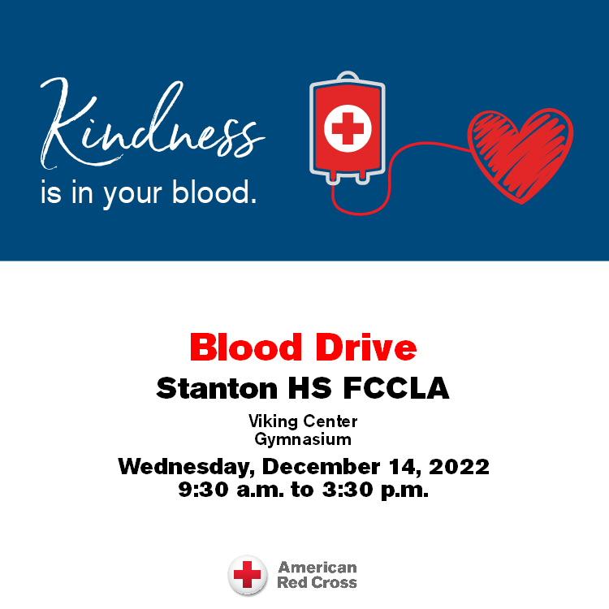

Please join us for a blood drive at Stanton HS FCCLA on Wednesday, December 14, 2022 from 9:30 a.m. to 3:30 p.m. Visit RedCrossBlood.org to schedule an appointment.

SCHOOL ACTIVITIES
Santa Lucia
Our annual Santa Lucia Festival of Lights will be held this Saturday, December 10th, 7 p.m. at the Stanton High School Gym. Grades K-6 will take part in this nostalgic Festival. Mr. Lantz would like for the children to be at the gym between 6:45 – 6:50 p.m., SEATED QUIETLY, on the stage bleachers on the north end of the stage. The Fourth, Fifth and Sixth grade students should go to the weight room no later than 6:50 p.m. It is very important for every student to participate as it is part of the music curriculum and their music grade. The students should wear the following:
Boys: White shirts, dark pants, red vest or bow/ribbon tie (if you have one) or red suspenders.
Girls: White blouse, red, blue or yellow skirt, striped apron (if you have one), red tights or knee socks and floral rings for your hair (if you have one).
Driver's Education
Parents: We have a Driver’s Ed class starting on January 9, 2023. Your students will be asked to sign up in the office if they are interested in taking this year’s course. We will need to have a copy of their permit by the 1st day of class in order for them to start.
As of now we do not have the fees set, just for reference.... last year’s fee was $325.00 payable by the 1st day of class, these fees are subject to change and Board approval.
Fifth Grade Food Drive
The 5th graders would like to have a Holiday Food Drive to help area families. We want to have a contest for all K-5 classes, to see who can collect the most points from now until Dec. 21st.
The following point system will be used and allow us to see which class can earn the most points. The class with the most points will earn a movie and pizza party in January!
5 Points: Cereal, Peanut Butter, Toilet Paper, Laundry Detergent
4 Points: Flour, Sugar, Canned Meat (chicken/tuna), Spaghetti Sauce, Canned Meals (spaghettios, ravioli, stew, or chili), and Soups
3 Points: Hamburger/Tuna Helper, Macaroni and Cheese, Cake/Brownie/Muffin Mixes, Instant Mashed Potatoes, Beans, Oatmeal, Crackers, Rice, Paper Towels, Kleenex, and Juice
2 Points: Dish Soap, Hand Soap, Body Soap, Shampoo, Toothpaste, Toothbrushes, Mouthwash, Pizza sauce, Pasta, Pie Filling, Popcorn
1 Point: Any canned Good (fruits and vegetables), boxed jello, boxed pudding
Please, when donating items, make sure they are not outdated! We look forward to helping the people in our community and having a fun contest while doing it. Thank you to everyone in advance for the generous donations and support!
Get Your Yearbook!
Yearbooks are on sale! Yearbooks can be ordered online by clicking the Jostens banner on the school website. You may also contact a yearbook staff member to order a yearbook. Yearbooks start at $50 and can be personalized for additional cost. After December 23, prices increase to $65 so order your yearbook early to save money! Contact Carli Smith, Carly Roberts, Adrian Haynie, Jasmine Osher, Grace Koppa, Kennedy King, or April Vanderholm to order a yearbook today!

Band and Choir Christmas Concert!
Please come and join us for a Christmas concert on Thursday, December 15th at 7pm in the Stanton, High School Gymnasium.
The concert will include 5th and 6th grade band. JH and HS combined concert band, JH Choir and HS Choir. The alumni band will join on one number with the band and all who have sung the Benediction in the past will be encouraged to sing with the H.S. Choir. Admission cost is free will donation.
Community Pep Band Rehearsals
All who play musical instruments wanted! Come join us on Tuesday evenings at 7pm in the High School Music Room.
We are working on Christmas music to play at the OLY for the Legion Santa on Saturday, December 17th. We will also play at some of the upcoming basketball games. All are welcome! It's a blast!!
Notes From Our Counselor
8th Grade Career Conference
The 8th graders attended the 8th Grade Career Conference at Southwestern Community College on Thursday, December 1st. Southwest Regional STEM and the Iowa Intermediary Network partnered together to host the event. Through face-to-face connections and interactive sessions, students explored career opportunities.
The sessions addressed the following:
*career connections
*career opportunities
*employablity skills
*career pathway navigation
*high school course offerings to prepare for the pathway
*opportunities for job shadow internship, mentorship, apprenticeship
*engaging activity for students
AIM Career Fair
Mrs. McDonald took a group of students to the AIM Career Fair on Friday, December 5th. The conference is sponsored by area business and industry for Southwest Iowa High School students and promotes careers in agriculture, industry, and manufacturing. The students chose careers of interest to them and spent hands-on time with the professional while learning more about the career.
From the Desk of Our Principal
2022-23 Snow Day / Remote Learning Day
The Stanton Community School District Calendar includes a plan to use virtual snow days when possible, this school year. If we have enough advanced notice, we will send devices or materials home for all grade levels. Please note the following important information:
*If the weather event keeps us out of school for more than one day, only the first day will be remote. Other days will be traditional snow days.
*If the weather event lasts for several more days, we will consider having another remote learning day built into that time.
*Please note, the remote days will only be used if we have enough notice to send devices or materials home with students.
*All announcements regarding remote and traditional snow days will be posted through email, text message, and Facebook.
Our 2nd Quarter and 1st Semester will wrap up on Thursday, December 22nd. Stanton Community School District will have a 2-hour early dismissal on December 22nd for the holiday break. We will resume classes on Wednesday, January 4th.
The district currently has a job opening for a food service kitchen assistant. Please submit application materials to Katie Elwood, K-12 Principal, at kelwood@stantonschools.com or you may mail application materials to 605 Elliott Street, Stanton, IA 51573.
Become a Teammates Mentor!
Are you ready to be a champion in the life of a Stanton student? We want you on our TEAM! The Stanton TeamMates Mentoring Program is looking for caring adults in the community to serve as mentors for our students! Call 712-829-2162 to learn more!
Become a Mentor today. Please go to teammates.org for more information.
Athletics
Varsity Girls Open season with 3 W’s
Picking up where they left off the Viqueen’s were victorious against Sidney, Coon Rapids, and Griswold during the first week of competition. The Queen’s opened with a tough conference foe in Sidney. The game was a typical slug fest with a back-and-forth affair and a lead not exceeding 9 points throughout the contest. In first half play each team had scoring runs only to have the other team do the same. According to Coach Snyder, “We just could not open up and maintain any kind of lead”. At half the game was knotted at 29. “At half time we made a defensive adjustment on one of their hot shooters, I credit Abby Burke’s defensive play as she held that player to zero points in the second half”. The team defense and staying with the offensive game plan began to pay off in the second half as Stanton went on a 11-2 run and open a 5-point edge by the end of the 3rd quarter. The Queen’s would continue to pound the ball inside to Marleigh Johnson and Jenna Stephens who would lead the team in scoring with 15 and 21 points respectively. “Jenna was able to get to the free throwline and in the process foul out their post presents”. Final Stanton 53 Sidney 48.
Stanton 50 Coon Rapids 26
Defense was the name of the game at CRB on Monday night as the Queen’s full court assault stymied any chance at a comeback after jumping out to a 16-2 first quarter lead. “We had struggled to finish some easy shots against Sidney and those struggles continued so our defensive play allowed us to build and maintain a lead”. Abby Burke would lead the Queen’s in the scoring column going 4-10 from 3-point range and 4-4 from the free throw line. While Marleigh Johnson scored 12 points going 4-6 shooting including 1-1 from 3 and 3-3 at the free throw line and also dishing out 5 assists. In JV action, Lauren Johnson led with 8 points and Riley Burke poured in 7 points.
Stanton 63 Griswold 11
The defensive onslaught made its way to Griswold Tuesday night holding the Tigers to 11 total points. The overmatched Tigers struggled all night to get an open shot against a swarming Viqueen defensive attack. Coach Snyder said “One of the goals this year is to build team depth, we were able to work on it against CRB and again tonight”. The younger Queen’s would gain valued experience as the lead ballooned to the games end. In the 22-6 JV victory over Griswold, Hannah Olson had 7 points, followed by Lauren Johnson, Riley Burke and Kiela Franzen who all had 4 points.
COMING EVENTS
Tuesday, Dec. 13th 4:00 JH BB at Essex
6:00 HS BB at Essex
Wednesday, Dec 14th Early Dismissal 1:05/1:15 pm
9:30 -3:30 Red Cross Blood Drive
Thursday, Dec. 15th 7:00 JH/HS Christmas Concert
Friday, Dec. 16th 4:00 JH Boys BB at Fremont-Mills
6:00 HS BB at Fremont-Mills
Saturday, Dec 17th 9:00 am HS Girls BB v Underwood at MAC, Council Bluffs

ANNOUNCEMENTS
Santa Lucia Voting
Santa voting will take place at the Swedish Cultural Center (Old Main) between the hours of 9:00 a.m. and 3:30 p.m. Residents of the Stanton Community School District, who are school age and above, are eligible to vote. Immediate families of open enrolled students may also vote. The candidate receiving the most votes will be crowned Santa Lucia Queen that evening.

Santa Lucia Bake Sale

The Santa Lucia Bake Sale Committee would greatly appreciate community members to donate baked goods to the bake sale. Please bring items to the school concourse on Saturday, December 11, before 6:00 p.m.
Bible Club
Friendly reminder: Junior Bible Quiz will not meet on Wednesday, December 21st. It will resume with school, on January 4th!
Stanton's Bible Quiz sent 2 teams to Des Moines, on November 19th! "FBI: Faithful Bible Investigators" - Liliana, Kemper Doty, Nora Shearer, Pippa King, and Selena and "The Lord's Tasty Potatoes": Jaidyn Guffey, Logan Hopf, Cylin Williams, Owen Shearer, & Rhys King. The kids did a great job preparing for the competition and winning some of the 5 rounds they competed in! All kids earned the verse memorization award! It was great fun.
The next competition that we will attend is March 18th. The next quiz is based on a whole different set of information, so if your child is interested, he/she is welcome to join us, as we will start preparing for that quiz starting in January, Wednesdays after school til 2:30pm. Let me know if you have any questions about the program. Kristin King 712-592-3858
Christmas at the OLY
The Stanton Old Lumber Yard Event Center is excited to announce dates for the Christmas Drive-Thrus where you can experience over 40 Christmas trees, lights and more! Dates include Saturday, December 10th after Santa Lucia; Sunday, December 11th from 6pm-8pm, Saturday, December 17th from 5pm-7pm (Legion Santa); Sunday, December 18th from 6pm-8pm and Thursday, December 22nd from 6pm-8pm. Donations to the local food pantry are requested but not required to drive through.
Stanton’s Legion Santa Claus
Stanton children up to and including second grades are invited to walk through and see Santa Claus at the Stanton Old Lumber Yard Event Center on Saturday, December 17th from 5pm-7pm. Anyone is welcome to walk through and see Santa, but only those who call Santa’s helpers will receive gifts. The high school choir will provide music. Hot chocolate and apple cider will be served. Santa’s helpers will be waiting to talk on the phone (712)829-2687 to the children on Wednesday, December 14th and Thursday, December 15th from 5:30pm-7:30pm. Be sure to tell Santa each child’s name. Give this information clearly in order that Santa will not forget anyone!

BREAKFAST MENUS DECEMBER 12th- DECEMBER 16th
Monday  Cereal  Muffin/Fruit  Juice/Milk | Tuesday  Donut  Muffin/Fruit  Juice, Milk | Wednesday  Waffle  Muffin/Fruit  Juice/Milk | Thursday  Cinni Mini  Muffin/Fruit  Juice/Milk | Friday  Breakfast Bagel  Muffin/Fruit  Juice/Milk

LUNCH MENUS DECEMBER 12th- DECEMBER 16th
Monday  Hamburger/Bun  Potato Smiles  Baked Beans  Mixed Fruit  Cherry Crisp  Milk | Tuesday  Chicken Strips  Mashed Potatoes/Gravy  Cooked Carrots  Oranges, Pineapple  Roll  Milk | Wednesday  Burrito/Hot Dog  Corn  Tomato Juice  Mandarin Oranges  Peaches  Milk | Thursday  Lasagna Roll-Up  Lettuce  Carrots  Pears  Applesauce, Breadstick  Milk | Friday  Nachos  String Cheese  Corn/Ranchero Beans  Cantaloupe  Mixed Fruit, Bug Bites  Milk

ELEMENTARY MS/HS
