,
STANTON COMMUNITY SCHOOL October 26th, 2022

Thursday, October 27th Parent Teacher Conferences (8am to 8pm) NO SCHOOL
Friday, October 28th NO SCHOOL

SCHOOL ACTIVITIES
Our E.T. Class is Out of This World!!
The Emerging Technology students are always looking for new real world projects to help Stanton businesses, community, and beyond. Check out some of our latest work on Facebook (Viking Productions). We are also developing and honing our video production skills. Would you like a custom made commercial made for your business or for your organization's upcoming event? As the class gets more practice, the turnaround time on photoshopping and video productions will get better and better. Have a challenge for us? Please send us a message on our Viking Productions Facebook account or call the high school and ask for Mr. Grebin
BLANKET HOODIES FOR SALE!
The Booster club is selling Stanton blanket hoodies.
The blanket hoodies come in either grey or purple and are $50. Order forms are available at the school, or you can contact a booster club member to order; all orders are due by November 1st. You can pay with cash, check, or VENMO and is due with your order form. These will make GREAT Christmas presents!
SHS BAND & CHOIR
Any community members and alumni that played in band in the past are encouraged to be a part of the Community Pep Band. We practice on Tuesday evening at 7pm in the band room. We will play at as many home games as possible. Contact Mr. Lantz with any questions at llantz@Stantonschools.com
Elementary Trash Bag Fundraiser
We have restocked our trash bag supply in the elementary office. All three sizes of trash bags are available for purchase. The rolls are $12.00 each and checks should be made payable to Stanton Schools. If you are interested in purchasing trash bags, please call the elementary office at 829-2171.
Become a Teammates Mentor!
Are you ready to be a champion in the life of a Stanton student? We want you on our TEAM! The Stanton TeamMates Mentoring Program is looking for caring adults in the community to serve as mentors for our students! Call 712-829-2162 to learn more!
Become a Mentor today. Please go to teammates.org for more information.
Stanton District Strategic Planning Committee
The Stanton Community School Board is looking for two to three community volunteers to be placed on the District Strategic Planning Committee. The committee would help the school board prioritize both current and future building needs. This committee will consist of community members, school staff members, and school board members. We anticipate several evening meetings this fall/winter with possible follow-up meetings
if needed. If you are interested or have any questions, please reach out to David Gute, Superintendent, at (712) 829-2162. You may also email Mr. Gute at dgute@stantonschools.com.

OPPORTUNITIES AVAILABLE AT SCS
We have the following job openings at Stanton Community Schools: food service kitchen assistant, substitute teachers, substitute paraeducators, substitute bus drivers, and substitute kitchen staff. If you are interested in applying, please contact Mrs. Katie Elwood at kelwood@stantonschools.com or by phone at 712-829-2162.

ATHLETICS
Viqueen Volleyball
The Viqueens hosted Riverside in the regional semi-final on Monday, October 24th. The match was filled with excitement, many lead changes and lots of fun volleyball! The Queens dropped the first set with a 19-

25 score but came roaring back in the second for a 25-20 victory. In the third set, it was a neck to neck battle the entire set with Riverside pulling ahead in the last moments to win the set 25-27. In the fourth set, the Viqueens prevailed for the win with a 25-22 victory which forced a fifth set battle for the teams. The Queens fought hard and remained poised the entire match but Riverside pulled through at the end with a 16-14 victory. The Queens could not have represented their team, school, and community any better than they did the entire season! The Queens ended the season at 30-9 which is the first time since 2013 that the program has recorded a 30-win season. The program had a difficult tournament schedule but handled that challenge very well and played many teams of larger classes. What a wonderful ride it has been this season and we commend the players not only for their competitive spirit but also for the wonderful young ladies they are!
Thank You!!
The Viqueen volleyball team and coaches would like to express their sincere appreciation for the support the team received this season. A special “Thank You” to Ashley McDonald, Amy Tibben and Paul Vanderholm who served as line judges during the season, to Jo Peterson, John Mainquist, Katie Elwood and Rick and Tammy Boyer for helping at the score table during matches and to our bus drivers who made sure we always arrived and came home safely. A huge “Thank You” to our outstanding team managers, Carli Smith and Lexi Jones who helped with stat taking, videotaping, and warmups. To Adam Jorgensen, our conditioning coach, thank you for the hours you have poured into helping us become stronger and faster and the time you have spent with our team at weekend tournaments and on the bench at our matches. Your faith and belief in our team is immeasurable and is beyond appreciated! To Harriet Olson, Mansor and Diana Kia and Al Thole – your contributions and donations to the team were so thoughtful and we cannot thank you enough! Thank you to the Stanton Booster Club for providing each player a photo button and for the team meal the week of Parents Night. Thank you to all parents for contributing towards the weekend tournament meals and the team meal before our final game. A huge “shout out” needs to go to our incredible student section who did a great job supporting the team at home and away games. We are thankful to be a part of such a wonderful community and the positive support and encouragement we have received is very much appreciated.
Cross Country
The Stanton Cross Country team ran in their final meet of the 2022 season at Lake Icaria on Thursday, October 21. Coach Stephens said.” I am so proud of these athletes! Cross country is such a grueling sport, and they took it head-on!! I am so very proud of everyone for everything they have accomplished.”
Our two seniors, Kyle Pastore and Addison Olson were great leaders for our team this year. They both gave each practice and meet everything they had! Kyle and Addison both improved their times at Lake Icaria when compared to the last time we ran there. Kyle finished the course with a time of 25:57 and Addison finished with a time of 26:20.
Our sophomore girls Ella Peterson, Hannah Olson, and Riley Burke all ran faster than the last time we ran at Lake Icaria. Ella, Hannah, and Riley were wonderful additions to the group this year. They brought a lot of fun and excitement to the team. Hannah ran with a time of 28:42, Ella ran 30:02, and Riley finished with a time of 31:07. Zooey is our only male sophomore runner on the team. Zooey continued to show improvement each and every time he ran. He continuously pushed himself. Zooey ran his final race of the season with a time of 22:37.
Our only freshman runner was Eric Kutzli. Eric improved a great deal throughout the season, running over 4 minutes faster than the last time he ran at Lake Icaria with a time of 25:17. All of the runners had an amazing season as they set and surpassed their goals for the season!
ANNOUNCEMENTS
Clover Kids
Clover Kids is a fun 4-H program designed for kindergarten through third-grade children. Clover Kids
fosters positive relationships and builds valuable life skills through a variety of hands-on activities. The
Stanton Clover Kids will meet on the second Wednesday of the month immediately following the school
day, until 2:30 at the Viking Center. If you have questions or want to enroll your child, please contact the
Montgomery County Extension Office at 712.623.2592 or email xmontgomery@iastate.edu

Stanton Chamber of Commerce’s 16th Annual Trick
Or Treat on the Trail
Trick or Treat on the Trail will be held on Saturday, October 29th from 3 to 5 pm. There will be various groups and individuals passing out candy and treats to all of the little goblins! No dogs, please!
COMING EVENTS

Thursday, Oct. 27th NO SCHOOL
8:00 AM TO 8:00 PM PARENT TEACHER CONFERENCES
National FFA Convention
Frdiay, Oct. 28th NO SCHOOL
National FFA Convention
Saturday, Oct. 29th National FFA Convention
Wednesday, Nov. 2nd Early Dismissal 1:05/1:15
Thursday, Nov. 3rd 7:30 AM FFA Meeting

BREAKFAST MENUS OCTOBER 31- NOVEMBER 4th
Monday  Cereal  Muffin/Fruit  Juice/Milk | Tuesday  Breakfast Pizza  Muffin/Fruit  Juice, Milk | Wednesday  French Toast  Muffin/Fruit  Juice, Milk | Thursday  Crescent Roll  Muffin/Fruit  Juice/Milk | Friday  Omelet  Muffin/Fruit  Juice/Milk
LUNCH MENUS OCTOBER 31-NOVEMBER 4th
Monday  Full Moon  Sea Monster Scales  Frog Legs  Dragon Drool  Skeleton Teeth  Milk | Tuesday  Chicken Strips  Mashed Potatoes/Gravy  Cooked Carrots  Oranges, Pineapple  Roll, Milk | Wednesday  Fish Sandwich  Baked Beans  Hashbrown  Mixed Fruit  Apricots  Milk | Thursday  Burrito/Hot Dog  Corn  Tomato Juice  Mandarin Oranges  Peaches  Milk | Friday  Grilled Cheese  Tomato Soup  Potato Wedges  Apple Slices  Mixed Fruit  Milk

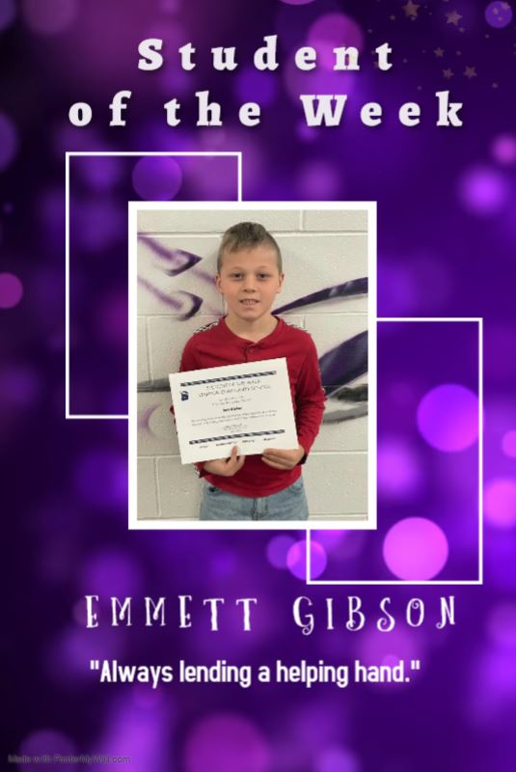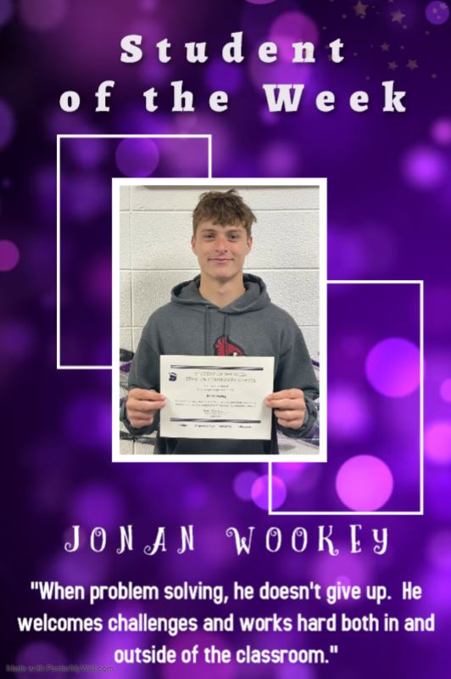

Code No. 102.E1

ANNUAL NOTICE OF NONDISCRIMINATION

The Stanton Community School District offers career and technical programs in the following areas of study:

Business Education
Agriculture Education
Industrial Education
Family and Consumer Science Education

It is the policy of the Stanton Community School District not to discriminate on the basis of race, color, national origin, sex, disability, religion, creed, age (for employment), marital status (for programs), sexual orientation, gender identity and socioeconomic status (for programs) in its educational programs and its employment practices. There is a grievance procedure for processing complaints of discrimination. If you have questions or a grievance related to this policy please contact Mrs. Ashley McDonald, 605 Elliott St., Stanton, Iowa 51573, smainquist@stantonschools.com, (712) 829-2162.

NOTE: A school district may have a different coordinator for each law or consolidate the responsibilities under one employee. The Iowa Department of Education encourages districts to have no more than two (2) coordinators: one for employment and one for programs. If the district has more than one coordinator, publications of this policy and notifications must include the name, contact address, contact phone number and email address for each coordinator.

