,
STANTON COMMUNITY SCHOOL January 13, 2023

Reminder: There will be NO SCHOOL on Monday, January 16th as stated on the school calendar.

SCHOOL ACTIVITIES

REMINDER FOR PARENTS
As stated in the school handbook: Every effort should be made toward getting students to school every day on time. Much of the child’s progress depends on his/her regular attendance at school as students who do not attend school on a regular basis develop gaps in their learning. Students with poor attendance patterns are more likely to drop out before graduation from high school. Parents should not expect their child to be promoted if skills are not mastered due to excessive absences. Elementary students that arrive to school after 10:00 A.M. and MS/HS students that arrive after 2nd period will be counted a half day absent for the morning and elementary students that leave before 2:00 PM and MS/HS students that leave before 2:10 PM will be counted a half day absent for the afternoon.
PARENTS NEED TO CALL THE SCHOOL EACH DAY THAT A STUDENT IS NOT IN SCHOOL. A written note is required only if the parents or guardian does not make telephone contact. Written excuses from the parent should include:
- Date of absence
- Exact reason for absence
- Parent’s signature
All parents are asked to call the elementary office (829-2171) or the MS/HS office (829-2162) if your child will be absent/late/leaving early from school. It is very important that communication is made to the school.
Pick Up Zone for Elementary Students
We ask that anyone picking up elementary students at dismissal use the Pickup Zone! The Pickup Zone is the wide lane between the school building and the Viking Center (the drive that is west of the school). We have noticed parents picking up students in front of the building again which is not permitted due to safety issues with students getting across the crosswalk. Please feel free to use designated Pick-Up Zone to ensure the safety of all of our students and staff. Thank you in advance!
Winter Formal
The Winter Formal Dance will be held Saturday, January 14th. The 6th - 8th grade dance will be from 6-8 pm, with 9th-12th grade from 8:30-10:30 pm. The dance will be held in the high school commons area. If you plan to bring a date from another school, you MUST go to the high school office to sign them up. Admission is $5.00 per person. Members of the court are Freshmen:
Britney Silva and Dylan Reynolds, Sophomores: Riley Burke and Peyton TePoel, Juniors: AJ Baker and Axel King and Seniors: Alice Duckett, Presley Lesher, Addison Olson, Damian Meek, Marissa Strough and Kyle Pastore.
Get Your Yearbook!
Yearbooks are on sale! Yearbooks can be ordered online by clicking the Jostens banner on the school website. You may also contact a yearbook staff member to order a yearbook. Yearbooks start at $65 and can be personalized for additional cost. Yearbooks can also be ordered through the school website. Click on the Jostens banner to order your yearbook today! Contact Carli Smith, Carly Roberts, Adrian Haynie, Jasmine Osher, Grace Koppa, Kennedy King, or April Vanderholm to order a yearbook today!
National Honor Society Valentines Fundraiser
Get a CRUSH for your crush! The Stanton National Honor Society will be selling Valentine’s Day treats again this year. Options include Crush soda pop, Sweetarts, Hershey's kisses, or all three. Order forms are due January 24th. Thanks for helping us fund scholarships to our seniors!"
“Pink Out” Activities Planned
The FCCLA will be sponsoring a Pink Out this Friday, January 13. Our high school basketball teams will be hosting Griswold on this evening. Fundraising activities will include Chuck a Duck, Pass the Bucket and a
drawing for the "Guess the number Christmas lights". We will also have a 3-point shot and free throw contest. Please mark this special night on your calendar and plan to attend!
Guess the Number of Lights
Guess the correct number of Christmas lights on a 50-foot Christmas tree and win a $50 Casey's card. The
Stanton's FCCLA is sponsoring this fundraiser for Relay for Life. The winner will be drawn on Friday, January 13th during the Pink Out event. Each guess is $3.00 or 2 for $5.00. Buy your guesses at each home basketball game between now and January 13th, from the high school office, or from Mrs. Brooke.
Little Vikes Dance and Cheer
This Friday, Jan 13th the Little Vikes Dance/Cheer girls will perform at halftime of the boys’ basketball game. This is our annual "PINK OUT" Night so the girls can either wear their camp shirts OR pink shirts. Please have girls at the high school by 7:00pm, they will need to meet Miss Brooklyn, Dance team and Cheerleaders should meet in the lunchroom with 2 min left in the 2nd quarter. Any questions please reach out to Jana 712-789-0146
January is National Mentor Month

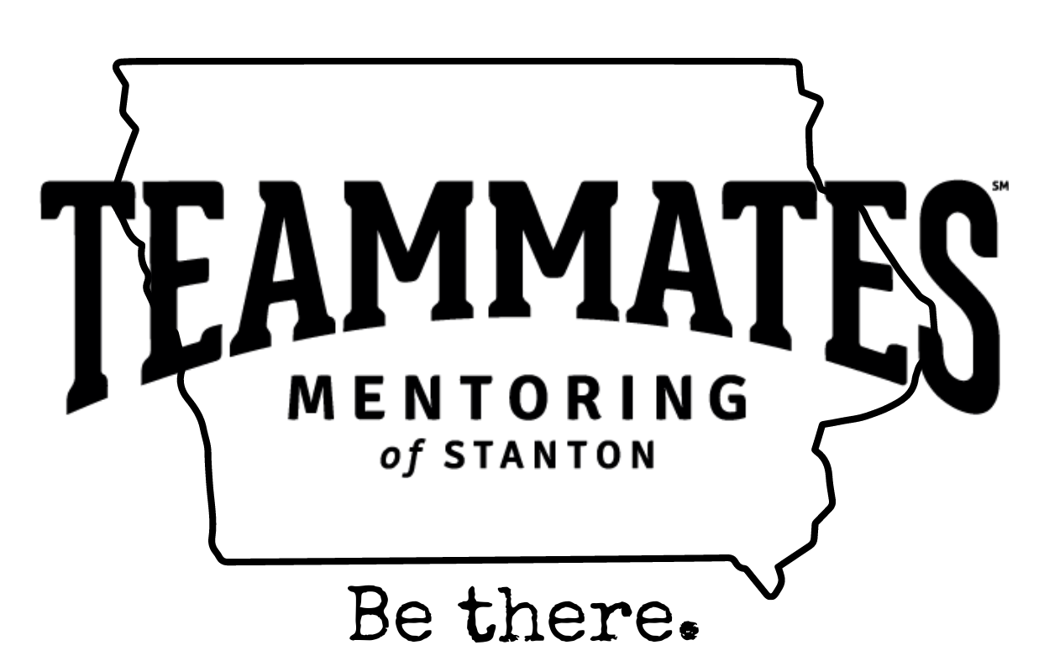

Stanton’s Teammates Mentoring program is officially up and running! The first two matches of the program were made in December, and we are happy to announce that by the beginning of February we will have at least 5 more matches in our community! We have several upcoming events that we are excited to share! On Tuesday, January 24th the local Teammates program will sponsor a fundraiser Walking Taco meal during the basketball games with East Mills. We hope to have additional activities that evening as well and will have a table set up in the concourse with informational materials for anyone wanting to know more about the program. The Teammates organization is also sponsoring an “Almost Famous Popcorn Fundraiser” in upcoming weeks. Almost Famous Popcorn is an Iowa company based in Cedar Rapids that offers the most incredible popcorn in many, many different flavors! More information to come regarding all the above upcoming events!
Fifth Quarter
There is a 5th quarter at the Mamrelund Church basement this Friday for students in 9th-12th grade. It starts after the end of the varsity boys’ game and ends at 11:00.
Elks Antler Program
The Red Oak Elks Lodge is looking for youth ages 12 to 20 along with their parents/guardians that would be interested in ANTLERS, a wonderful Junior Elks program starting here at Lodge #1304 in 2023. It is a chance for young people in our communities to get involved with the Elks in the many service-related projects our Lodges sponsor. More information can be requested from the elementary office. Please call 829-2171 for a general introduction outlining what the ANTLERS program is all about, as well as an ANTLERS membership application form. If you'd like to learn more or know of someone that would enjoy being a part of this, please email Jim Hoskinson at heritageportraits@yahoo.com. Thank you!

With winter weather, please note that the district will send a text and email if we have a late start or cancellation. We will also post to the district Facebook page and notify local news and radio stations.

COMING EVENTS
Fri., Jan. 13th FCCLA Pink Out event
4:00-JV BB w Griswold
6:00-HS BB w Griswold
Mon, Jan 16th NO School
Conference Basketball Tourn
Tues, Jan 17th 4:00 JH Girls BB at E Mills
Conference Basketball Tourn
Wed, Jan 18th Early Dismissal 1:05/1:15
Conference Basketball Tourn
Thur, Jan 19th Conference Basketball Tourn
Fri, Jan 20th Conference Basketball Tourn Finals at East Mills
Sat, Jan 21st District Large Group Speech Contest at Thomas Jefferson
Conference Basketball Tourn Finals at Griswold

BREAKFAST MENUS January 16th – January 20th
Monday  No School | Tuesday  Pop Tart  Muffin/Fruit  Juice, Milk | Wednesday  Waffle  Muffin/Fruit  Juice, Milk | Thursday  Strawberry Donut  Muffin/Fruit  Juice, Milk | Friday  Cookie  Muffin/Fruit  Juice, Milk
LUNCH MENUS January 16th – January 20th
Monday  No School | Tuesday  Stuffed Crust Pizza  Lettuce  Broccoli  Applesauce, Pears  Milk | Wednesday  Sloppy Joe  Baked Beans  Tri-Tater  Pineapple  Apple Crisp  Milk | Thursday  Chili  Carrots  Applesauce  Pears  Cinnamon Roll  Milk | Friday  Chicken Fried Steak/Bun  Sweet Potatoes  Baked Beans  Peaches  Mixed Fruit  Milk

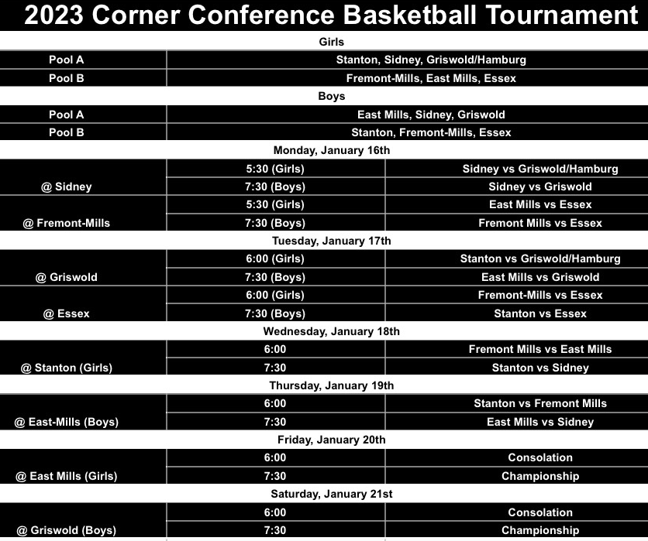

ELEMENTARY STUDENT OF THE WEEK MS/JH STUDENT OF THE WEEK

