STANTON COMMUNITY SCHOOL SEPTEMBER 23, 2022

SCHOOL ACTIVITIES
GOLD for Childhood Cancer Awareness Month
On Friday, September 30th at the football game with Murry, please wear GOLD for Childhood Cancer!!
Childhood cancer remains the #1 cause of death by disease for children in America. Each year in the US, an estimated 15,780 children aged 0-19 are diagnosed with cancer. In 2009 and 2012 we had 2 students in school that were diagnosed with cancer.
If you know anyone that has been diagnosed with Childhood Cancer, please let Katie Elwood know by next Wednesday, September 28th we would like to honor them at halftime of the football game.
We want to bring awareness, because "KIDS CAN'T FIGHT CANCER ALONE!" Please join us next Friday at 7 p.m. LET'S GO GOLD under the LIGHTS on FRIDAY NIGHT!!
Library Donation
Thank you to Janie Voss for her generous donation in memory of her mother, Doris Carlson former school secretary, to the library. We were able to purchase many “missing” books to compete some of our series. The students have been excited to see some of their favorite series now complete!
Band
The Viking Marching Band will be marching and competing the next two Saturdays. September 24th is the Shenfest Parade. The parade starts at 2pm. Next week is the Clarinda Band Jamboree. That parade starts at 9am. Stanton has participated in the Clarinda Band Jamboree marching contest every year since it started in 1963.
Our Viking Marching Band is made up of 15 7th and 8th grade students and 6 High School students. Two sixth graders will be carrying the new banner for the band. The band is working very hard on the fundamentals for marching and playing. Thanks for all the positive comments the band has received while marching in our Homecoming Parade and the Essex Labor Day parade.
If any alumni would like to participate in a community pep band for this year, please contact Mr. Lantz at llantz@stantonschools.com.
FFA Fruit Sales
The Stanton FFA Chapter will begin their annual Fruit Sale Fundraiser on Thursday, October 6th, following the Chapter’s monthly meeting. Funds raised will be used toward FFA activities and events. The Ag Business class has worked as a committee on the planning and pre-sale work to provide members and customers with what they hope will be a great experience.
FFA members are working with both of our local grocery stores to provide quality fruit again this year. In addition, members will continue to sell McCone’s pickled herring which is produced in Minnesota. The Chapter sources their meat products directly from Skoglund’s locker – an Iowa based locker – and will offer all the favorites: bacon, beef sticks, beef jerky, and summer sausage. New this year will be the addition of Skoglund’s homemade franks. Cheese, cheese spread, popcorn, candy and nuts will also be for sale. Orders will be delivered by FFA members beginning on December 5th in time for holiday parties, gifts and gatherings.
FFA members are excited to begin! The Stanton Chapter is growing with the addition of Junior High members and with that comes new activities and experiences that the Chapter would like to provide to the members. If you have any questions regarding the FFA Fruit Sale or would like to be added to the list for a member to contact you this year please contact our FFA Advisor, Mrs. Andrea Spencer, at the school – 712.829.2162. Thank you for your support!
Dance Camp
Reminder that the little girls dance cheer camp will perform at the halftime of the home game Friday, September 30th.
Music Parents Tailgate Supper
The Music parents will be hosting a Walking Taco fundraiser meal next Friday, September 30th when the football team hosts Murray for Parent’s Night. Serving will be from 5:30 to 7:00 PM in the lunchroom of the high school. Please come out and support the music parents and their students as well as the music program!

ATHLETICS
Cross Country
The Stanton Cross Country team ran in their 4th meet of the 2022 season at Lake Icaria for the Southwest Valley meet on Tuesday. This was a beautiful, hilly course that
the team took head-on. The girls had 4 high school runners, the boys had 4 high school runners, and 4 junior high runners, therefore no team points were earned.
For the high school boys, Logan McQueen (SO) crossed the finish line first for the Vikings with a season-best of 23:23. Zooey Allen (SO) was 55th followed by Eric Kutzli (FR) placing 66th. Kyle Pastore (SR) placed 59th with his season-best run 2 minutes and 34 seconds faster than his last meet.
Three of our 4 junior high runners on the boys’ team ran their first meet on Thursday. Brett Hart (7) was our first junior high Viking to cross the finish line, placing 14th with a time of 14:44. Next, was Jayden Snow (7) with a time of 15:41. Nick Herrick (8) came in 35th with a time of 17:15. Beating a personal goal by more than 30 seconds, Grant Spencer (8) ran a time of 19:24, 50 seconds better than his last meet.
We had four high school runners for the girls’ team! Addison Olson (SR) placed 18th with a time of 26:43 shaving almost a minute and a half off her best time. Hannah Olson (SO) came in at 24th with a time of 28:51, her fastest race yet! Ella Peterson (SO) also had her best time of 30:26 placing 26th! Riley Burke (SO) placed 33rd and ran her best race taking more than a minute off of her time!!
The Vikings and ViQueens continue to improve with every meet!! I am so proud of all the hard work they put in and the positive mindset that they take to every meet and practice.
Viking Football
The Vikings bettered their record to 3-1 with an Essex Homecoming win @ Essex last Friday night over Griswold. The team is working hard to improve their performance on both sides of the ball as they head to Lenox to challenge the undefeated Tigers. Kickoff is at 7 p.m.
Junior Varisty Football
The JV team dropped their second straight game with a loss on Monday to the Bedford Bulldogs. The Bulldogs jumped out to a quick lead and never looked back. The Vikings will make improvements as they prepare for the Griswold Tigers. They'll kickoff in Stanton next Monday at 6 p.m.
JH Football
The JH team was far outnumbered by a much larger and more aggressive Bedford last Monday. The team's attitude remains positive as they work to improve each week. Next Monday, they'll host Griswold in Stanton with a kickoff at 4 p.m.
Viqueen Volleyball
On Saturday, the Junior Varsity squad competed in the Griswold Junior Varsity tournament. The team had an outstanding day and finished with the first-place plaque after winning all matches in straight sets. The team secured victories over Griswold, Riverside, Creston and CAM. The girls were so much fun to watch on the court and played at a high level all tournament! The JV squad has a week off from competition due to the Conference Tournament but will return to play when we host East Mills on Tuesday, October 4th.
On Monday, the Viqueens traveled to Afton for a triangular with East Union and Southwest Valley. The Queens won straight sets with both teams (East Union 25-2 and 25-2 and Southwest Valley 25-12, 25-13).
On Saturday, the varsity Viqueens are in action at the Bedford Tournament. The Queens will play pool play in the small gym and their schedule is as follows:
8:30 Stanton v Mt. Ayr
11:00 Stanton v Lamoni
11:45 Stanton v East Mills
After pool play, the championship and consolation rounds will be held. Admission is $6.00 for adults and $4.00 for students.
Next week is the Corner Conference Tournament. The Viqueens are the #2 seed going into the tournament this season. We will be one of the host sites on Monday evening. The first game will be played at 5:30 and the Viqueens will take on Hamburg in the 7:00 match. A complete schedule is included in the bulletin. Come out and cheer the girls in purple on through a week of competitive play!
Junior High Volleyball
The Junior High volleyball team traveled to Bedford on Thursday, September 15th. We were able to get six sets of play on the court which provided the girls with some valuable experience. The team played very well and won all six sets against Bedford. On Tuesday, September 20th, the team hosted Hamburg. The team won 4 out of their five sets with the only set loss a nail-bitter two-point game at the end! The girls will be off from match play until Tuesday, October 4th when they host East Mills. The following week they will travel to Tabor on Monday, October 10th for a Junior High Jamboree and then travel to Essex the following day for a match with Essex. These young Viqueens are a lot of fun to watch so come out and cheer them on in the final part of their season!

From the Desk of the Principal
The middle school and high school midterm grade check is this Friday, September 23rd. Students and parents can check grades using JMC. If you have any questions on how to access student grades through JMC, please contact the school office. Please reach out to your child’s teacher if you have questions regarding your student’s progress in class.
Thank you to the following groups for their support during Homecoming week:
- Stanton PTSO for providing a treat for our K-12th grade students.
- Pep Club and Cheerleaders for their planning and leadership.
- The Stanton Chamber for providing the community pancake feed and parade prizes.
- Drei Hampel, Sheila Mainquist, Mickey Anderson, the Stanton American Legion, and Rick and Tammy Boyer for providing sites for our MS/HS classes to build homecoming floats.
- All participants in the Homecoming parade.
We had a fun week showing our Stanton Pride! Congratulations to the homecoming royalty:
Prince Jonan Wookey, Princess Marleigh Johnson, King Joshua Martin, and Queen Abby Burke

ANNOUNCEMENTS
5th Quarter
Our first 5th Quarter will be Friday, September 30th at Mamrelund Lutheran Church. 5th Quarter is open to any Stanton student from 7th -12th grade. It is a safe place to hang out after Friday night home games. It takes approximately $200 for each 5th Quarter to happen. We usually feed between 60-70 junior high and high school students. In order for this to continue, we need money and/or people willing to donate food. We have an account at First Interstate Bank (formerly Great Western Bank). You can go to the bank and make a deposit directly to 5th Quarter or contact Leanne Johnson at the school. Thank you for all of your help to make this happen for our kids.
YMCA Lifeguard Class
The Montgomery County YMCA, in Red Oak, is having a lifeguard class. You must be 15 yrs old by the last day of class. Go to mcymca.com to register and pay or come in person. The cost is $200. If anyone has conflicts on this night the can call Michelle Grismore, Instructor, 712-621-1552.
Wed Oct 5 5:30-9:30 PM. (If anyone has conflicts on this night they can call Michelle Grismore, Instructor, 712-621-1552.)
Sat Oct 8 8 AM- 6 PM
Sun Oct 9 8 AM- 6 PM

COMING EVENTS
Friday, 23rd 7:00 PM HS FB at Lenox
Saturday 24th 8:30 HS VB Tournament at Bedford
2:00 PM ShenFest Parade
Monday, 26th Conference Volleyball Tournament
4:00 JH/JV Football with Griswold
Tuesday, 27th Conference Volleyball Tournament
Wednesday, 28th Early Dismissal 1:05/1:15
Thursday, 29th Conference Volleyball Tournament Finals
Cross Country at Shenandoah
Friday, 30th 7:00 PM HS FB with Murray (Parents Night)
Saturday, Oct 1st 9:00 Varsity VB at Greene County Tournament
Clarinda Band Jamboree

e

BREAKFAST MENUS SEPTEMBER 26 – SEPTEMBER 30
Monday  Pop Tart  Muffin  Juice, Milk | Tuesday  Pankcake & Sausage  On a Stick  Muffin/Fruit  Juice, Milk | Wednesday  Bagel Bites  Muffin/Fruit  Juice, Milk | Thursday  Donut Holes  Muffin/Fruit  Juice, Milk | Friday  Breakfast Sandwich  Muffin/Fruit  Juice, Milk
LUNCH MENUS SEPTEMBER 26-SEPTEMBER 30
Monday  Pork Chopette/Bun  Baked Beans  Ranch Potatoes  Mixed Fruit  Apple Slices  Milk | Tuesday  Breakfast Pizza  Hashbrown  Juice  Tropical Fruit  Pears  Milk | Wednesday  Grilled Chicken/Bun  Mixed Vegetables  Cheesy Broccoli  Oranges, Peaches  Chocolate Cake  Milk | Thursday  Beef Fritter  Mashed Potatoes/Gravy  Cooked Carrots  Mixed Fruit  Mandarin Oranges, Roll  Milk | Friday  Corn Dog  Baked Beans  Sweet Potatoes  Macaroni Salad  Pineapple, Cantaloupe  Milk

Students of the Week for Week of September 19th
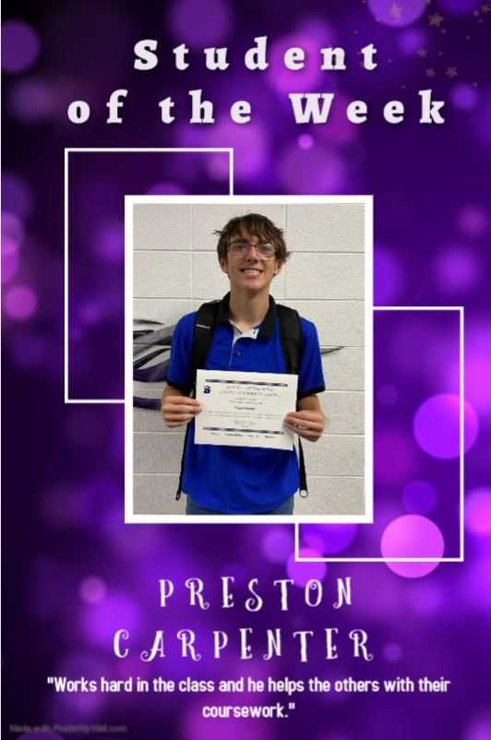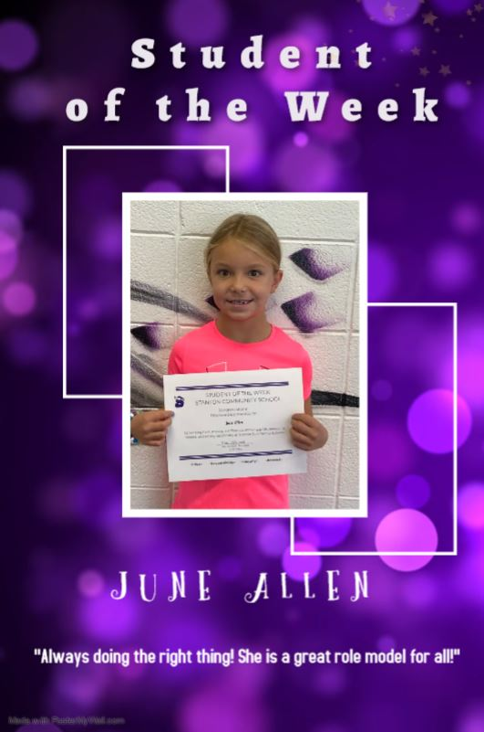

Students of the Week for the Week of September 26

