STANTON COMMUNITY SCHOOL January 6, 2023

Reminder: There will be NO SCHOOL on Monday, January 16th as stated on the school calendar.

SCHOOL ACTIVITIES
Pick Up Zone for Elementary Students
We ask that anyone picking up elementary students at dismissal use the Pickup Zone! The Pickup Zone is the wide lane between the school building and the Viking Center (the drive that is west of the school). We have noticed parents picking up students in front of the building again which is not permitted due to safety issues with students getting across the crosswalk. Please feel free to use designated Pick-Up Zone to ensure the safety of all of our students and staff. Thank you in advance!
Winter Formal
The Winter Formal Dance will be held Saturday, January 14th. The 6th - 8th grade dance will be from 6-8 pm, with 9th-12th grade from 8:30-10:30 pm. The dance will be held in the high school commons area. If you plan to bring a date from another school, you MUST go to the high school office to sign them up. Admission is $5.00 per person.
Get Your Yearbook!
Yearbooks are on sale! Yearbooks can be ordered online by clicking the Jostens banner on the school website. You may also contact a yearbook staff member to order a yearbook. Yearbooks start at $65 and can be personalized for additional cost. Yearbooks can also be ordered through the school website. Click on the Jostens banner to order your yearbook today! Contact Carli Smith, Carly Roberts, Adrian Haynie, Jasmine Osher, Grace Koppa, Kennedy King, or April Vanderholm to order a yearbook today!
National Honor Society Valentines Fundraiser
Get a CRUSH for your crush! The Stanton National Honor Society will be selling Valentine’s Day treats again this year. Options include Crush soda pop, Sweetarts, Hershey's kisses, or all three. Order forms are due January 24th. Thanks for helping us fund scholarships to our seniors!"
Community Pep Band Rehearsals
All who play musical instruments wanted! Come join us on Tuesday evenings at 7pm in the High School Music Room. We will also play at some of the upcoming basketball games. All are welcome! It's a blast!!
“Pink Out” Activities Planned
The FCCLA will be sponsoring a Pink Out on Friday, January 13. Our high school basketball teams will be hosting Griswold on this evening. Fundraising activities will include Chuck a Duck, Pass the Bucket and a
drawing for the "Guess the number Christmas lights". We will also have a 3-point shot and free throw contest. Please mark this special night on your calendar and plan to attend!

Guess the Number of Lights
Guess the correct number of Christmas lights on a 50-foot Christmas tree and win a $50 Casey's card. The
Stanton's FCCLA is sponsoring this fundraiser for Relay for Life. The winner will be drawn on Friday, January 13th during the Pink Out event. Each guess is $3.00 or 2 for $5.00. Buy your guesses at each home basketball game between now and January 13th, from the high school office, or from Mrs. Brooke.
Little Vikes Dance and Cheer
On Friday, Jan 13th the Little Vikes Dance/Cheer girls will perform at halftime of the boys’ basketball game. This is our annual "PINK OUT" Night so the girls can either wear their camp shirts OR pink shirts. Please have girls at the high school by 7:00pm, they will need to meet Miss Brooklyn, Dance team and Cheerleaders should meet in the lunchroom with 2 min left in the 2nd quarter. Any questions please reach out to Jana 712-789-0146
January is National Mentor Month

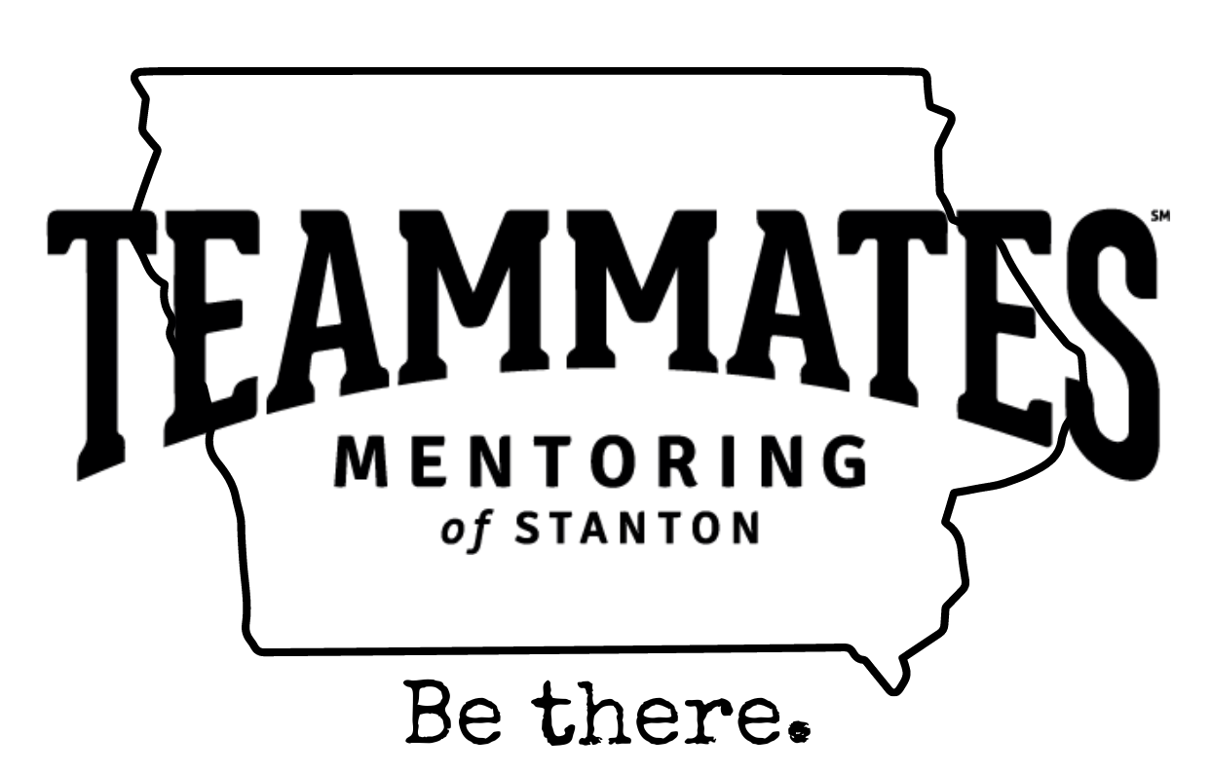

Stanton’s Teammates Mentoring program is officially up and running! The first two matches of the program were made in December, and we are happy to announce that by the beginning of February we will have at least 5 more matches in our community! We have several upcoming events that we are excited to share! On Tuesday, January 24th the local Teammates program will sponsor a fundraiser Walking Taco meal during the basketball games with East Mills. We hope to have additional activities that evening as well and will have a table set up in the concourse with informational materials for anyone wanting to know more about the program. The Teammates organization is also sponsoring an “Almost Famous Popcorn Fundraiser” in upcoming weeks. Almost Famous Popcorn is an Iowa company based in Cedar Rapids that offers the most incredible popcorn in many, many different flavors! More information to come regarding all the above upcoming events!
PEANUT/NUT AWARENESS POLICY
At Stanton Schools, it is our top priority to ensure the safety of all students, staff, and visitors. The incidence of food allergies is rising rapidly, and therefore the following policy is now in place at Stanton Schools.
- All treats brought into the school must be commercially prepared and packaged with an ingredient label. Students will not be allowed to pass out treats that do not meet these requirements.
- Students that bring “cold lunch” to school will have a designated table to sit at in the lunchroom. Note: Students are allowed to bring peanut and tree nut containing products to school for cold lunch but should not eat any nut containing products anywhere in the school other than the designated cold lunch table.
- No peanut/tree nut products will be served by staff-including ala carte items.
- All bars for sale at the concession stand must be individually bagged or wrapped.

With winter weather, please note that the district will send a text and email if we have a late start or cancellation. We will also post to the district Facebook page and notify local news and radio stations.

COMING EVENTS
Friday, Jan 6th 6:00-HS BB at Hamburg
ACT Registration date
Monday, Jan. 9th 4:00 JH BB with Hamburg
Tuesday, Jan. 10th 6:00 HS BB at Sidney
Wed., Jan. 11th EARLY DISMISSAL 1:05/1:15
Thurs., Jan. 12th Large Group Picture Day
4:00-JV BB w SWV
6:00-HS BB w SWV
Fri., Jan. 13th 5:30 FCCLA Meal in Concourse and FCCLA Pink Out event
4:00-JV BB w Griswold
6:00-
HS BB w Griswold

BREAKFAST MENUS January 9th – January 13th
Monday  Cereal  Muffin/Fruit  Juice/Milk | Tuesday  Crescent Roll  Muffin/Fruit  Juice, Milk | Wednesday  Breakfast Pizza  Muffin/Fruit  Juice, Milk | Thursday  Pancakes  Muffin/Fruit  Juice, Milk | Friday  Omelet/Toast  Muffin/Fruit  Juice, Milk
LUNCH MENUS January 9th – January 13th
Monday  Crispito/Hot Dog  Corn  Lettuce  Mandarin Oranges  Raisins, Yogurt, Goldfish  Milk | Tuesday  Chicken Nuggets  Baked Beans  Cole Slaw  Pineapple, Oranges  Banana Muffin  Milk | Wednesday  Ham & Cheese Sandwich  Peas/Green Beans  Peaches  Tropical Fruit, Rice  Milk | Thursday  Italian Pasta  Lettuce  Carrots  Pears, Applesauce  Breadstick  Milk | Friday  Chicken Wrap  Lettuce/Cheese  Mixed Veggies  Cooked Carrots  Mixed Fruit/Pineapple  Milk

ANTI-BULLYING/HARASSMENT POLICY
Harassment and bullying of students and employees are against federal, state and local policy, and are not tolerated by the board. The board is committed to providing all students with a safe and civil school environment in which all members of the school community are treated with dignity and respect. To that end, the board has in place policies, procedures, and practices that are designed to reduce and eliminate bullying and harassment as well as processes and procedures to deal with incidents of bullying and harassment. Bullying and harassment of students by other students, by school employees, and by volunteers who have direct contact with students will not be tolerated in the school or school district.
The board prohibits harassment, bullying, hazing, or any other victimization, of students, based on any of the following actual or perceived traits or characteristics, including but not limited to, age, color, creed, national origin, race, religion, marital status, sex, sexual orientation, gender identity, physical attributes, physical or mental ability or disability, ancestry, political party preference, political belief, socioeconomic status, or familial status. Harassment against employees based upon the employee’s race, color, creed, sex, sexual orientation, gender identity, national origin, religion, age or disability is also prohibited.

