STANTON COMMUNITY SCHOOL DECEMBER 17, 2021

PRINCIPAL
Wednesday, December 22nd will be the end of the second quarter and first semester. Stanton Community School District will have a 2-hour early dismissal on December 22nd for the holiday break. We will resume classes on Tuesday, January 4th. We want to wish all of our students, families, staff, and community a Happy Holiday!

The district currently has a job opening for a food service kitchen assistant. Please submit application materials to Katie Elwood, K-12 Principal, at kelwood@stantonschools.com or you may mail materials to 605 Elliott Street, PO Box 400, Stanton, IA 51573. We are also currently looking for additional substitute teachers, substitute paras, substitute bus drivers, and substitute kitchen staff. If you are interested in being a substitute for the district, please contact Mrs. Elwood.

SCHOOL ACTIVITIES
FCCLA/Red Cross Blood Drive
FCCLA/Red Cross Blood Drive will be held on Friday, December 17th, in the Viking Center Gymnasium, 8:00 a.m. to 2:00 p.m.
PUBLIC - Please call the school office at 829-2162 or visit RedCrossBlood.org and enter Vikings to schedule an appointment.
STUDENTS - Please stop in the office to make an appointment
By donating blood at the Stanton High School drive, not only are you helping save lives, you are also helping the school earn a scholarship for one or more of their graduating seniors.
Pink Out
Friday, December 17th is the FCCLA sponsored Pink Out to raise money for Pediatric Cancer. The evening events will start with a lasagna supper and will conclude with several activities for the young and old to celebrate and to raise money. Wear your pink, enjoy a good meal and have some fun on the 17th.
Give the Gift That Keeps on Giving
The yearbook staff is offering gift certificates for the 2022 yearbook, “LIFE, CAMERA, ACTION”. The cost of the book is $45.00, icons are $3.65, and personalization is $6.25.
Give the perfect gift–a memory album of all the moments of this school year! Contact Tammy Boyer, Christi Elwood, or Stacey Lihs at 829-2162 to get your yearbook gift certificate.
FIRST LEGO League
FIRST LEGO League introduces science, technology, engineering, and math (STEM) to children ages 4-16 through fun, exciting hands-on learning. Participants gain real-world problem-solving experiences through a guided, global robotics program, helping today’s students and teachers build a better future together. Eight Stanton students competed in Villisca on Sunday, December 12th. The teams were the Radical Warheads: Addy Gettler, Corinne Hopf, Elaina Utecht, and Matthew Utecht and the Curley Fries: Eric Kutzli, Alizabeth Maranville, Meredith Roberts and Will Roberts. The Radical Warheads were recognized as an Iowa Global Innovation Award Qualifier Nominee and will be showcased at a later date. They are also advancing to the state competition on January 22nd. Congratulations to these students and their hard work!
Food Drive
The 5th graders along with Student Council members, would like to have a Holiday Food Drive to help area families. We want to have a contest for all K-5 classes, to see who can collect the most points from now until December 22nd.
The following point system will be used and allow us to see which class can earn the most points. The class with the most points will earn a movie and pizza party in January!
5 Points: Cereal, Peanut Butter, Toilet Paper, Laundry Detergent
4 Points: Flour, Sugar, Canned Meat (chicken/tuna), Spaghetti Sauce, Canned Meals (spaghettios, ravioli, stew, or chili), and Soups
3 Points: Hamburger/Tuna Helper, Macaroni and Cheese, Cake/Brownie/Muffin Mixes, Instant Mashed Potatoes, Beans, Oatmeal, Crackers, Rice, Paper Towels, Kleenex, and Juice
2 Points: Dish Soap, Hand Soap, Body Soap, Shampoo, Toothpaste, Toothbrushes, Mouthwash, Pizza Sauce, Pasta, Pie Filling, Popcorn
1 Point: Any Canned Good (fruits and vegetables), Boxed Jello, Boxed Pudding
Please, when donating items, make sure they are not outdated! We look forward to helping the people in our community and having a fun

contest while doing it. Thank you to everyone in advance for the generous donations and support!

GUIDANCE
Scholarships
Darryl Jahn Memorial Scholarship-due Jan 5
FFA Scholarships–due Jan 15
-information available at http://scholarships.ffa.org and click on the “scholarship” link
Robert E. Byers Scholarship Trust–January 30
-applications are available online at www.keepiowabeautiful.com
Tribute Award–January 31
-To apply online, go to https://www.discover.com/student-loans/college-planning/scholarships/award

ATHLETICS
Viqueen Basketball
Two more Corner Conference wins keeps the Queen’s win streak alive.
Stanton 47 East Mills 34
Stanton traveled to Malvern to take on East Mills on Friday. An outstanding defensive effort allowed the Queens to end the night with a decisive victory holding the Wolverines to 22% shooting while forcing 16 turnovers. Coach Dave Snyder said, “Once we tightened up our zone defense and slowed down their lane penetration we defended quite well.” Things did not look so good to start the contest as East Mills jumped out to a 12-1 lead. “Offensively we had a slow start, we got some really nice shots but failed to convert, we did not panic and stayed with the game plan and managed a 12-12 tie by the quarters end,” said Coach Snyder. Stanton was then able to gain a halftime lead and extend that lead on some excellent shooting, Abby Burke hit 5 3 pointers on 10 attempts while Marleigh Johnson went 8-11 from the free throw line. The Queen’s put the game away in the fourth quarter out scoring East Mills 11-3.
Stanton 65 Essex 33
The Queen’s cruised to a 39-15 halftime lead and never looked back. “Offensively we shot the ball well, but at times we got sloppy with the passing game, 25 turnovers will not win games down the stretch,” said Coach Snyder. The Queen’s collected 27 defensive rebounds while only giving up 2 offensive boards to Essex.
Viking Basketball
The high school boys’ basketball team is 5 games into their season and sitting at a record of 2-3. Last week the Vikings lost a conference game to East Mills but were able to bounce back with a demanding win over Essex on Tuesday night. They will host Fremont-Mills tonight in what will be a big conference game. They wrap up with Bedford before Christmas Break. If you're in town and looking for something to do Friday night, head on down to the gym and support the teams. Thank you and Go Vikes!
JV Girls Basketball
JV girls hosted the Bedford Bulldogs on Monday, December 13th. The JV Viqueens got their 3rd win of the season against the Bulldogs 65-26. The Viqueens were led by Kyla Hart with 19 points, 6 assists and 2 steals. Lauren Johnson had 16 points and 4 steals. Hannah Olson had 11 points, 7 rebounds and 3 steals. Riley Burke had 10 points and Carly Roberts finished with 9 points.

ANNOUNCMENTS

5th Quarter

There will be a 5th quarter Friday for any student 7th through 12th grade and we will be serving super nachos.

5th Quarter Donations

5th Quarter is asking for donations! After home football or basketball games, 5th Quarter provides food and a safe place to hang out for students in 7th-12th grade. It's at Mamrelund Lutheran Church. There will be one this Friday, December 17th from after the game until 11:00 PM. Sixty to seventy-five students usually attend and donations would go towards food. If you are interested in donating, please talk to Leanne Johnson or drop off money at Great Western Bank. Checks can be made out to 5th Quarter.

COMING EVENTS
Friday, 17th 8:00-2:00-FCCLA/Red Cross Blood Drive
4:00-Junior High Basketball with Fremont-Mills
Girls-There, Boys-Here
5:00-Lasagna Supper
6:00-Varsity Basketball with Fremont-Mills
Pink Out-Money going towards Pediatric Cancer
Monday, 20th 4:00-Junior Varsity Boys Basketball at Bedford
6:00-Varsity Basketball at Bedford
Tuesday, 21st 6:30-Yearbook Christmas Party
Wednesday, 22nd 1:05/1:15-Early Dismissal
Thursday, 23rd-3rd NO SCHOOL
Tuesday 4th 6:00-Junior Varsity/Varsity Girls Basketball with
Audubon, Here
Wednesday, 5th NO EARLY DISMISSAL
Thursday, 6th 4:00-Junior High Girls at Clarinda Lutheran
6:00-Junior Varsity/Varsity Girls Basketball at
AHSTW

BREAKFAST MENUS DECEMBER 20-24
Monday  Cereal Bar  Muffin/Fruit  Juice/Milk | Tuesday  Bosco Stick  Muffin/Fruit  Juice/Milk | Wednesday  Cookie  Muffin/Fruit  Juice/Milk | Thursday  NO SCHOOL | Friday  NO SCHOOL

LUNCH MENUS DECEMBER 20-24
Monday  Deep Dish Pizza  Lettuce  Carrots  Pears  Applesauce  Milk | Tuesday  Creamed Turkey  Mashed Potatoes  Green Beans  Sweet Potatoes  Peaches/Mixed Fruit  Jello/Rye Bread  Milk | Wednesday  Taquito/Hot Dog  Corn  Tri-Tater  Mandarin Oranges  Pineapple  Goldfish  Milk | Thursday  NO SCHOOL | Friday  NO SCHOOL

BREAKFAST MENUS JANUARY 3-7
Monday  NO SCHOOL | Tuesday  Cereal  Muffin/Fruit  Juice/Milk | Wednesday  Breakfast Boat  Muffin/Fruit  Juice/Milk | Thursday  Breakfast Pizza  Muffin/Fruit  Juice/Milk | Friday  Pancakes  Muffin/Fruit  Juice/Milk

LUNCH MENUS JANUARY 3-7
Monday  NO SCHOOL | Tuesday  Cheesy Pull-AParts  Lettuce  Corn  Applesauce  Pears  Milk | Wednesday  Rib/Hot Dog  Baked Beans  Tri-Tater  Mandarin Oranges  Pineapple  Milk | Thursday  Chicken Pattie/Bun  Mixed Vegetables  Corn  Peaches  Mixed Fruit  Milk | Friday  Pizzaboli  Lettuce  Celery  Applesauce  Pears  Milk

Menus Subject to Change

MS/HS STUDENT OF THE WEEK ELEMENTARY STUDENT OF THE WEEK
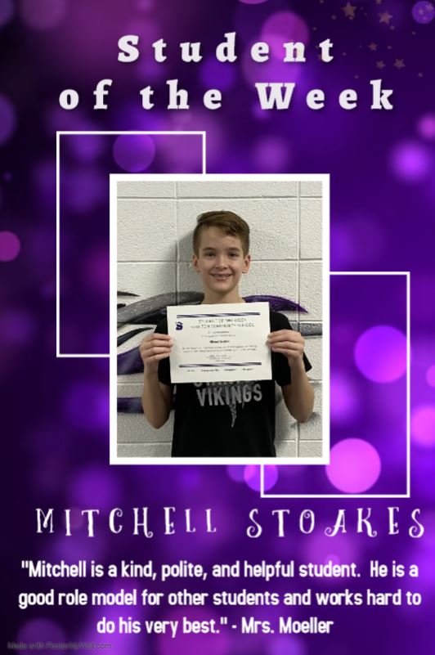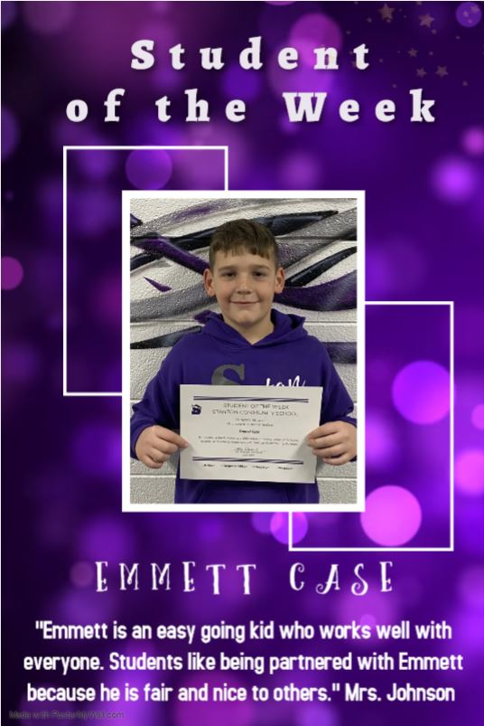

It is the policy of the Stanton Community School District not to discriminate on the basis of race, color, national origin, sex, disability, religion, creed, age (for employment), marital status (for programs), sexual orientation, gender identity and socioeconomic status (for programs) in its educational programs and its employment practices. There is a grievance procedure for processing complaints of discrimination. If you have questions or a grievance related to this policy please contact Mrs. Sheila Mainquist, 605 Elliott St., Stanton, Iowa 51573, smainquist@stantonschools.com, (712) 829-2162.

