STANTON COMMUNITY SCHOOL DECEMBER 10, 2021

PRINCIPAL
The 2nd quarter and 1st semester will end on Wednesday, December 22nd. Stanton Community School District will have a 2-hour early dismissal on December 22nd for the holiday break. We will resume classes on Tuesday, January 4th.

The district currently has a job opening for a food service kitchen assistant. Please submit application materials to Katie Elwood, K-12 Principal, at kelwood@stantonschools.com or you may mail materials to 605 Elliott Street, PO Box 400, Stanton, IA 51573. We are also currently looking for additional substitute teachers, substitute paras, substitute bus drivers, and substitute kitchen staff. If you are interested in being a substitute for the district, please contact Mrs. Elwood.

SCHOOL ACTIVITIES
FCCLA/Red Cross Blood Drive
FCCLA/Red Cross Blood Drive will be held on Friday, December 17th, in the Viking Center Gymnasium, 8:00 a.m. to 2:00 p.m.
PUBLIC - Please call the school office at 829-2162 or visit RedCrossBlood.org and enter Vikings to schedule an appointment.
STUDENTS - Please stop in the office to make an appointment
By donating blood at the Stanton High School drive, not only are you helping save lives, you are also helping the school earn a scholarship for one or more of their graduating seniors.
Pink Out
Friday, December 17th is the FCCLA sponsored Pink Out to raise money for Pediatric Cancer. The evening events will start with a lasagna supper and will conclude with several activities for the young and old to celebrate and to raise money. Wear your pink, enjoy a good meal and have some fun on the 17th.
Give the Gift That Keeps on Giving
The yearbook staff is offering gift certificates for the 2022 yearbook, “LIFE, CAMERA, ACTION”. The cost of the book is $45.00, icons are $3.65, and personalization is $6.25.
Give the perfect gift–a memory album of all the moments of this school year! Contact Tammy Boyer, Christi Elwood, or Stacey Lihs at 829-2162 to get your yearbook gift certificate.
Food Drive
The 5th graders along with Student Council members, would like to have a Holiday Food Drive to help area families. We want to have a contest for all K-5 classes, to see who can collect the most points from now until December 22nd.
The following point system will be used and allow us to see which class can earn the most points. The class with the most points will earn a movie and pizza party in January!
5 Points: Cereal, Peanut Butter, Toilet Paper, Laundry Detergent
4 Points: Flour, Sugar, Canned Meat (chicken/tuna), Spaghetti Sauce, Canned Meals (spaghettios, ravioli, stew, or chili), and Soups
3 Points: Hamburger/Tuna Helper, Macaroni and Cheese, Cake/Brownie/Muffin Mixes, Instant Mashed Potatoes, Beans, Oatmeal, Crackers, Rice, Paper Towels, Kleenex, and Juice

2 Points: Dish Soap, Hand Soap, Body Soap, Shampoo, Toothpaste, Toothbrushes, Mouthwash, Pizza Sauce, Pasta, Pie Filling, Popcorn
1 Point: Any Canned Good (fruits and vegetables), Boxed Jello, Boxed Pudding
Please, when donating items, make sure they are not outdated! We look forward to helping the people in our community and having a fun contest while doing it. Thank you to everyone in advance for the generous donations and support!

GUIDANCE
Scholarships
Christina Hixson Opportunity Award Due December 15

ATHLETICS
Viqueen Basketball
Viqueens Move to 3-0 with Two Corner Conference Wins
Stanton 61-Sidney 32
A supreme defensive effort set the tone for the Viqueen rout of the Cowgirls. Sidney struggled to get anything going offensively against the Queen’s box and one attack. Coach Dave Snyder said, “Brooklyn Silva did a fantastic job of guarding their best player most of the night, and when Brook took a break, Hannah Olson maintained the pace”. The team defensive effort showed by holding Sidney to 18% field goal shooting for the night while forcing 21 turnovers. Offensively the Queen’s did not disappoint shooting 41% from the field including 4-8 from 3-point range.
Stanton 58-Griswold 47
The Queens traveled to Griswold on Tuesday. “We came out a step slow defensively; we just did not give them just respect as far as their shooting ability and ball handling”, said Coach Snyder. As the Tigers gained confidence against the highly favored Queen’s the Queens stepped up opening up a 17 point lead. In the end the Queens secured the victory and remain undefeated.
Viking Basketball
The high school boys basketball team are off to a 1-2 start on the season. With loses to Coon Rapids Bayard and Sidney to start the year, the Vikes got their first win of the season Tuesday night at Griswold. The Viking defense held the Tigers to 27 points. They are back in action tonight in a big conference game at East Mills. Thank you for your continued support and Go Vikes.
JV Girls Basketball
The JV girls fought a good battle with the Fremont-Mills Knights on Monday but came up just short losing 18-20 in 2 quarters of play. JV Viqueens were led by Riley Burke with 11 points and followed by Hannah Olson with 7 points.
The JV girls dominated the Griswold Tigers winning 54-7. Lauren Johnson led the JV Viqueens with 29 points. Great job girls!

ANNOUNCMENTS

Open House

Join us as we thank Dr. Eric Paulson-Stanton City Council, Brian Bates-Stanton School Board, Norm Larson-City of Stanton and meet Bret Sheppard, City of Stanton Employee for a celebration on Monday, December 13th after the Stanton City Council Meeting (around 6:30 p.m.) at the FMTC Tech Center. Stop by for appetizers and thank them for their service!

Santa Lucia Bake Sale

The Santa Lucia Bake Sale Committee would greatly appreciate community members to donate baked goods to the bake sale. Please bring items to the school concourse on Saturday, December 11, before 6:00 p.m.
Stanton’s Legion Santa Claus
Stanton children up to and including second grade are invited to drive thru and see Santa Claus at the Stanton Old Lumber Yard Event Center in Stanton on Saturday, December 18th, from 5:00 p.m.-7:00 p.m. Anyone is welcome to drive through and see Santa but only those who call Santa’s helpers will receive gifts.
Santa’s helpers will be waiting to talk on the telephone (829-2687) to the children on Wednesday, December 15^{h}, and Thursday, December 16th, from 5:30 p.m.-7:30 p.m. Be sure to tell Santa each child’s name. Give this information clearly in order that Santa will not forget anyone.

COMING EVENTS
Friday, 10th 4:00-Junior High Basketball with East Mills
Girls-There, Boys-Here
6:00-Varsity Basketball at East Mills
Saturday, 11th 7:00-Santa Lucia
Monday, 13th 4:00-Junior High Boys Basketball with
Shenandoah, Here
5:30-Junior Varsity Basketball with Bedford, Here
Tuesday, 14th 3:30-Junior High Basketball with Essex, Here
5:00-Senior Meal
6:00-Varsity Basketball with Essex, Here
Wednesday, 15th 1:05/1:15-Early Dismissal
Thursday, 16th 7:00-Christmas Concert
Friday, 17th 8:00-1:00-FCCLA/Red Cross Blood Drive
4:00-Junior High Basketball with Fremont-Mills
Girls-There, Boys-Here
5:00-Lasagna Supper
6:00-Varsity Basketball with Fremont-Mills
Pink Out-Money going towards Pediatric Cancer

BREAKFAST MENUS DECEMBER 13-17
Monday  Cereal  Muffin/Fruit  Juice, Milk | Tuesday  French Toast  Muffin/Fruit  Juice, Milk | Wednesday  Bacon & Egg Pizza  Muffin/Fruit  Juice, Milk | Thursday  Breakfast Sandwich  Muffin/Fruit  Juice, Milk | Friday  Crescent Roll  Muffin/Fruit  Juice, Milk

LUNCH MENUS DECEMBER 13-17
Monday  Cheesy Pull-Aparts  Corn  Lettuce  Raisins  Applesauce  Milk | Tuesday  Tuna Noodle Casserole  Pears  Green Beans  Oranges/Peaches  Roll  Milk | Wednesday  Sloppy Joe  Baked Beans  Tater Twisters  Pineapple  Apple Crisp  Milk | Thursday  Mashed Potato Bowl  Corn  Mandarin Oranges  Mixed Fruit  Roll  Milk | Friday  Chicken Fried Steak/Bun  Lettuce/Tomato  Sweet Potatoes  Baked Beans  Pears/Mixed Berries  Milk

Menus Subject to Change

MS/HS STUDENT OF THE WEEK ELEMENTARY STUDENT OF THE WEEK
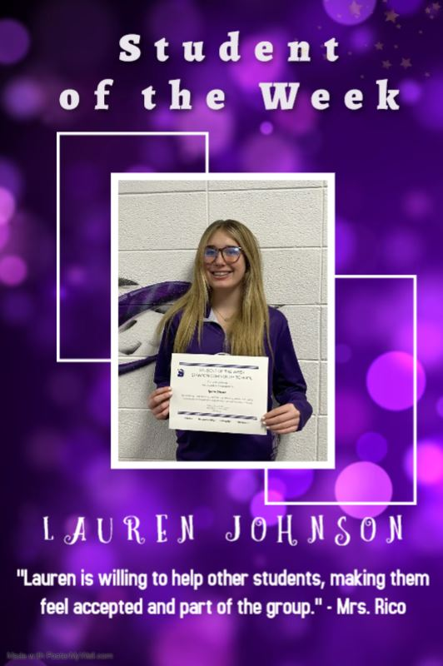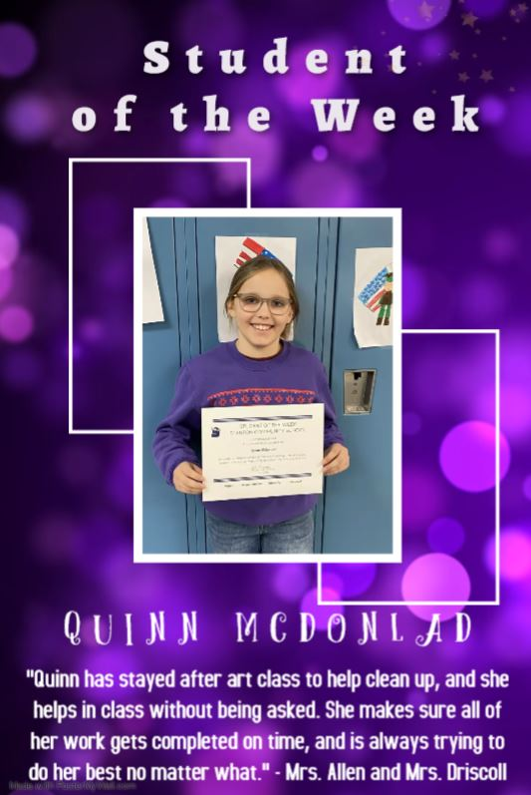

It is the policy of the Stanton Community School District not to discriminate on the basis of race, color, national origin, sex, disability, religion, creed, age (for employment), marital status (for programs), sexual orientation, gender identity and socioeconomic status (for programs) in its educational programs and its employment practices. There is a grievance procedure for processing complaints of discrimination. If you have questions or a grievance related to this policy please contact Mrs. Sheila Mainquist, 605 Elliott St., Stanton, Iowa 51573, smainquist@stantonschools.com, (712) 829-2162.

