STANTON COMMUNITY SCHOOL NOVEMBER 19, 2021

PRINCIPAL
Congratulations to Mrs. Sandy Allen on being awarded the Staff Member of the Month by the Pella Corporation! Mrs. Allen was presented with this award on Tuesday, November 16th. Congratulations Mrs. Allen and thank you for all that you do!

Stanton Schools will have a 2-hour early out on Wednesday, November 24th for the Thanksgiving holiday. We will not have school on Thursday, November 25th or Friday, November 26th. We hope all of our students, staff, and families have a wonderful holiday break!

The district currently has a job opening for a food service kitchen assistant. Please submit application materials to Katie Elwood, K-12 Principal, at kelwood@stantonschools.com or you may mail materials to 605 Elliott Street, PO Box 400, Stanton, IA 51573. We are also currently looking for additional substitute teachers, substitute paras, substitute bus drivers, and substitute kitchen staff. If you are interested in being a substitute for the district, please contact Mrs. Elwood.

SCHOOL ACTIVITIES
Give the Gift That Keeps on Giving
The yearbook staff is offering gift certificates for the 2022 yearbook, “LIFE, CAMERA, ACTION”. The cost of the book is $45.00, icons are $3.65, and personalization is $6.25.
Give the perfect gift–a memory album of all the moments of this school year! Contact Tammy Boyer, Christi Elwood, or Stacey Lihs at 829-2162 to get your yearbook gift certificate.
Corner Conference Science Fair Participants
Congratulations to the following students for being selected to attend the Corner Conference Science Fair on Tuesday, November 23rd. This year’s science fair will take place in Hamburg with judging beginning at 9:00 AM. Students will enjoy a presentation by Wildlife Encounters during lunch, followed by the awards presentation.
Students attending the Corner Conference Science Fair will need to leave the school by 8:00 AM and will need to bring a sack lunch with them. They will return by the end of the school day.
7th Grade: Oliver Dykes, Lilly Ford, David Helberg, Nicholas Herrick, Corinne Hopf, Treyton Jordan, Caed Olson, Elaina Utecht, and Adrianna Valdez
8th Grade: Jailyn Beacham, Eric Kutzli, Elizabeth Maranville, Jasmine Osher, Meredith Roberts, Brodee Sowers, and Taylor Valdez
Science Fair Judges Needed
The Corner Conference Science Fair will be held at Hamburg on Tuesday, November 23rd. Each school is asked to bring five judges to help evaluate the projects. Typically, judging takes place in the morning with lunch provided. If you are interested in helping out, please contact Mrs. Erickson (cerickson@stantonschools.com), or Mrs. Embray (aembray@stantonschools.com).

GUIDANCE
Scholarships
The Hagan Scholarship Due December 1
Christina Hixson Opportunity Award Due December 15

ATHLETICS
Viqueen Volleyball Post-Season Honors
Congratulations to Juniors, Marleigh Johnson and Jenna Stephens who were recently named to the IGCA All-District 1A volleyball team. We are very proud of both of you!

ANNOUNCMENTS

Celebration

Join us as we thank Dr. Eric Paulson-Stanton City Council, and

Brian Bates-Stanton School Board Member for their many years of service to the Stanton Community! A celebration will be held on Monday, December 13th after the Stanton City Council Meeting (around 6:30 p.m.) at the FMTC Tech Center. Stop by for appetizers and thank them for their service!

No Bible Club or Youth Group

There will be no Bible Club or Youth Group November 24th! Both will resume the next week! Happy Thanksgiving!

Reconciled Concert and Fundraiser

The Evangelical Covenant Church will be hosting Reconciled on November 28th, at 3:00 P.M. with coffee and dessert following the concert. All donations will go to Bible Camp and Youth Events!
The Viking Center is Hiring a Custodian
Viking Center lower-level custodian is responsible for cleaning and caring for the lower level of the Viking Center to ensure that the building and grounds are maintained in a safe and healthy manner. This position best fits the facility with between five and ten hours a week.
If you are interested, please contact the Viking Center -Phone: 712-829-2900 Email: vikingcenter@myfmtc.com
Swedish Holiday Meal
Join us in Stanton this Saturday, November 20th for all of your favorites at the Swedish Holiday Meal! This annual event will be hosted at the Stanton Community Room (205 Broad) from 5:00 PM-7:00 PM. The meal prepared by Cathy Hart includes ham, creamed lutfisk, mashed potatoes, rye bread and ostkaka. Appetizers will consist of Swedish meatballs, pickled herring, cheese, crisp bread, lingonberries and glogg. Cost is $12/person and all proceeds go to the Swedish Heritage and Cultural Center.
3rd Annual Marketplace Off Main Vendor Show
Do you still have some holiday shopping to do? Grab your family and friends and head on over to Stanton for the 3rd Annual Marketplace Off Main Vendor Show this Sunday, November 21st. A variety of vendors will be located at the Stanton Old Lumber Yard Event Center from 1:00 PM-4:00 PM. You can also stop by Fika Coffee Hus or grab drinks at Gibbs Chophouse during that time. See you in Stanton this Sunday!
PTSO Meeting
The Stanton PTSO will have a board meeting on Tuesday, November 23rd, at 6:00 PM in the high school library. Anyone is welcome to attend! Please email ptso@stantonschools.com if you have any questions or would like to get involved!

COMING EVENTS
Monday 22nd 4:00-Junior High Boys Basketball at East Mills
Tuesday, 23rd Junior High Science Fair at Hamburg
Wednesday, 24th 1:05/1:15-Early Dismissal
Thursday, 25th NO SCHOOL, Happy Thanksgiving
Friday, 26th NO SCHOOL
Monday, 29th 4:00-Junior High Basketball at Lenox
Tuesday, 30th 4:00-Junior Varsity Basketball with Coon Rapids
Bayard, Here
5:00-Senior Class Meal
6:00-Varsity Basketball with Coon Rapids
Bayard, Here
Wednesday, 1st 1:05/1:15-Early Dismissal
Friday, 3rd 4:00-Junior High Basketball with Sidney
Girls-There, Boys-Here
6:00-Varsity Basketball at Sidney

BREAKFAST MENUS NOVEMBER 22-26
Monday  Breakfast Brownie  Muffin/Fruit  Juice, Milk | Tuesday  Sliders  Muffin/Fruit  Juice, Milk | Wednesday  Cookie  Muffin/Fruit  Juice, Milk | Thursday  NO SCHOOL  Happy Thanksgiving | Friday  NO SCHOOL
LUNCH MENUS NOVEMBER 22-26
Monday  Fiestada  Lettuce  Corn  Pears  Applesauce  Milk | Tuesday  Creamed Turkey  Mashed Potatoes  Green Beans  Sweet Potatoes/Stuffing  Peaches/Mixed Fruit  Pumpkin Dessert/Milk | Wednesday  Burrito/Hot Dog  Corn  Tomato Juice  Mandarin Oranges  Pears  Milk | Thursday  NO SCHOOL  Happy Thanksgiving | Friday  NO SCHOOL

BREAKFAST MENUS NOVEMBER 29-DECEMBER 3
Monday  Banana Oatmeal Bar  Muffin/Fruit  Juice, Milk | Tuesday  Breakfast Pizza  Muffin/Fruit  Juice, Milk | Wednesday  Pancakes  Muffin/Fruit  Juice, Milk | Thursday  Cinni Minis  Muffin/Fruit  Juice, Milk | Friday  Donut  Muffin/Fruit  Juice, Milk

LUNCH MENUS NOVEMBER 29-DECEMBER 3
Monday  Hamburger/Bun  Potato Smiles  Baked Beans  Mixed Fruit  Cherry Crisp  Milk | Tuesday  Chicken Strips  Mashed Potatoes/Gravy  Green Beans  Oranges  Pineapple  Roll  Milk | Wednesday  Siracha Honey Chicken  Fried Rice  Cooked Carrots  Egg Roll  Peaches  Ice Cream  Milk | Thursday  Corn dog  Cheesy Broccoli  Sweet Potatoes  Macaroni Salad  Applesauce  Pineapple  Milk | Friday  Pork Chopette/Bun  Baked Beans  Ranch Potatoes  Apple Slices  Mixed Fruit  Milk

Menus Subject to Change

MS/HS STUDENT OF THE WEEK ELEMENTARY STUDENT OF THE WEEK
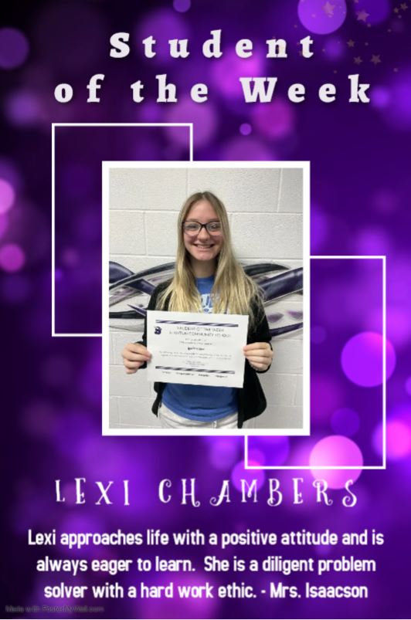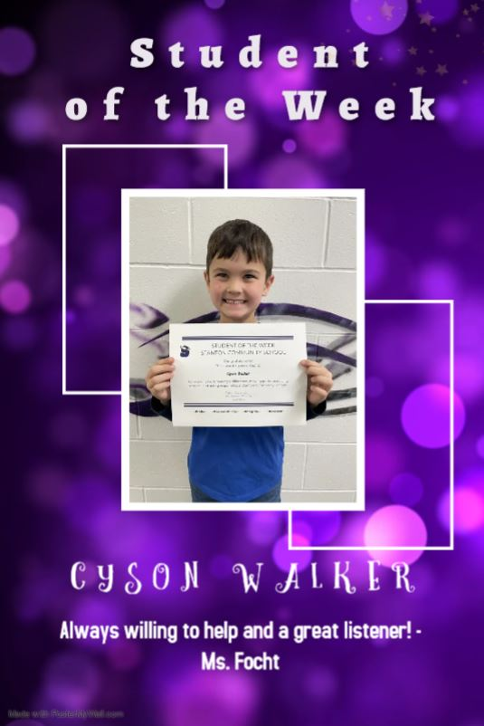

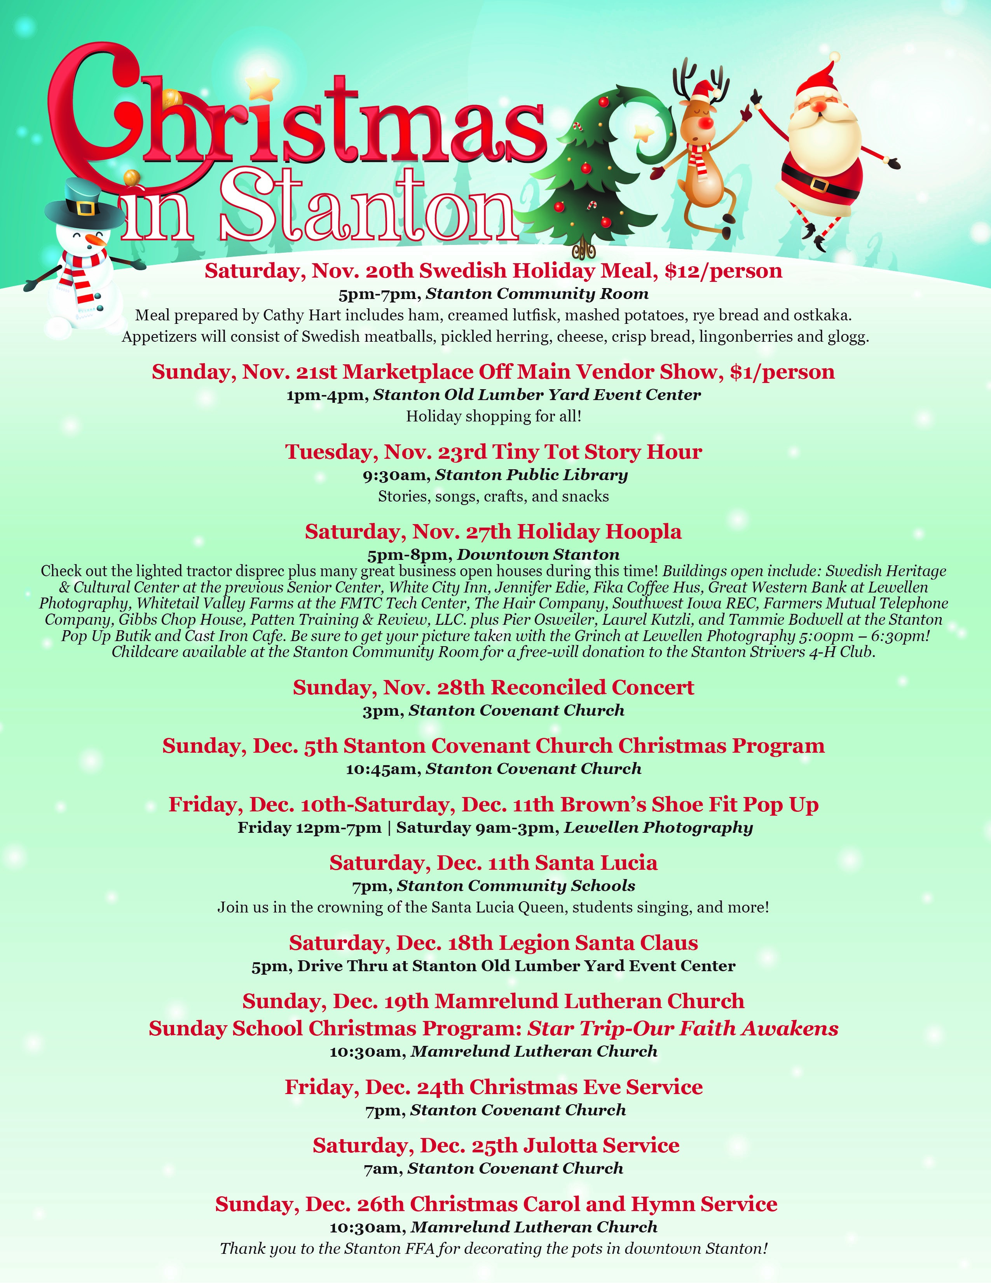

It is the policy of the Stanton Community School District not to discriminate on the basis of race, color, national origin, sex, disability, religion, creed, age (for employment), marital status (for programs), sexual orientation, gender identity and socioeconomic status (for programs) in its educational programs and its employment practices. There is a grievance procedure for processing complaints of discrimination. If you have questions or a grievance related to this policy please contact Mrs. Sheila Mainquist, 605 Elliott St., Stanton, Iowa 51573, smainquist@stantonschools.com, (712) 829-2162.

