STANTON COMMUNITY SCHOOL NOVEMBER 12, 2021

PRINCIPAL
The Stanton Community School District wants to thank all veterans for their service to our country.

With winter weather just around the corner, please note that the district will send a text and email if we have a late start or cancellation. We will also post to the district Facebook page and notify local news and radio stations. Please let the office know if you have any questions.

The district currently has a job opening for a food service kitchen assistant. Please submit application materials to Katie Elwood, K-12 Principal, at kelwood@stantonschools.com or you may mail materials to 605 Elliott Street, PO Box 400, Stanton, IA 51573. We are also currently looking for additional substitute teachers, substitute paras, substitute bus drivers, and substitute kitchen staff. If you are interested in being a substitute for the district, please contact Mrs. Elwood.
Upcoming Dates:
Wednesday, November 17th - 1:05/1:15 early dismissal
Wednesday, November 24th - 1:05/1:15 early dismissal
Thursday, November 25th - No School
Happy Thanksgiving!
Friday, November 26th – No School

GUIDANCE
Scholarships
Elks National Most Valuable Student Scholarship Contest
Due November 15, must start online
The Hagan Scholarship Due December 1
Christina Hixson Opportunity Award Due December 15

ANNOUNCMENTS

Celebration

Join us as we thank Dr. Eric Paulson-Stanton City Council, and Brian Bates-Stanton School Board Member for their many years of service to the Stanton Community! A celebration will be held on Monday, December 13th after the Stanton City Council Meeting (around 6:30 p.m.) at the FMTC Tech Center. Stop by for appetizers and thank them for their service!
The Viking Center is Hiring a Custodian
Viking Center lower-level custodian is responsible for cleaning and caring for the lower level of the Viking Center to ensure that the building and grounds are maintained in a safe and healthy manner. This position best fits the facility with between five and ten hour a week.
If you are interested, please contact the Viking Center -Phone: 712-829-2900 Email: vikingcenter@myfmtc.com

COMING EVENTS
Monday 15th Conference Vocal Festival at Fremont-Mills
Wednesday, 17th 1:05/1:15-Early Dismissal
Thursday, 18th 4:00-Junior High Basketball with Bedford
Girls-Here, Boys-There

BREAKFAST MENUS NOVEMBER 15-19
Monday  Cereal Bar  Muffin/Fruit  Juice, Milk | Tuesday  Breakfast Sandwich  Muffin/Fruit  Juice, Milk | Wednesday  Oatmeal Bar  Muffin/Fruit  Juice, Milk | Thursday  Bacon & Egg Pizza  Muffin/Fruit  Juice, Milk | Friday  French Toast  Muffin/Fruit  Juice, Milk

LUNCH MENUS NOVEMBER 15-19
Monday  Chicken Taquito/Hot Dog  Lettuce/Corn  Mandarin Oranges/Raisins  Cheese Stick  Graham Crackers  Milk | Tuesday  Ham & Potato Casserole  Peas/Green Beans  Mixed Fruit  Pears  Roll  Milk | Wednesday  Stadium Dog  Chili/Cheese  Potato Wedges  Baked Beans  Applesauce/Pears  Milk | Thursday  Walking Taco  Lettuce/Cheese  Diced Tomatoes  Refried Beans  Corn/Goldfish  Pineapple/Oranges  Milk | Friday  Beef Stew  Cooked Carrots  Peaches  Apple Slice  Biscuit/Churro  Milk

Menus Subject to Change

MS/HS STUDENT OF THE WEEK ELEMENTARY STUDENT OF THE WEEK
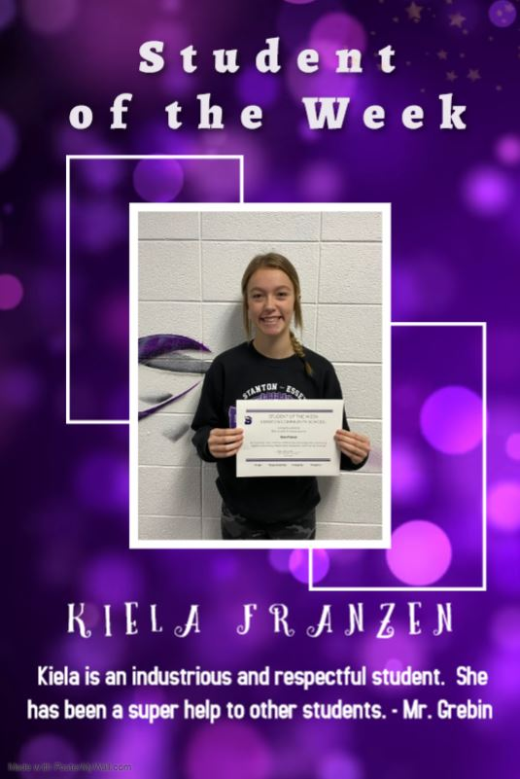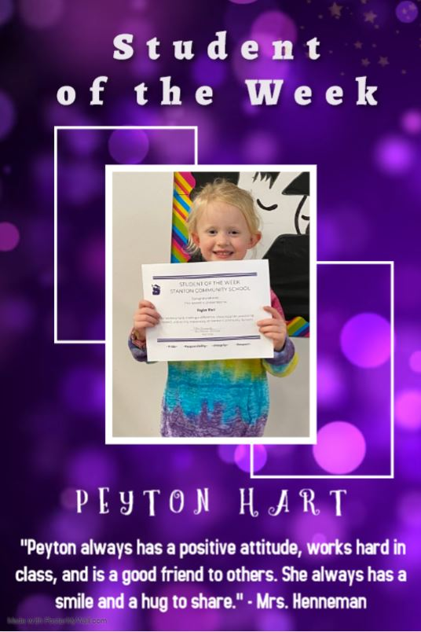



It is the policy of the Stanton Community School District not to discriminate on the basis of race, color, national origin, sex, disability, religion, creed, age (for employment), marital status (for programs), sexual orientation, gender identity and socioeconomic status (for programs) in its educational programs and its employment practices. There is a grievance procedure for processing complaints of discrimination. If you have questions or a grievance related to this policy please contact Mrs. Sheila Mainquist, 605 Elliott St., Stanton, Iowa 51573, smainquist@stantonschools.com, (712) 829-2162.

