STANTON COMMUNITY SCHOOL OCTOBER 28, 2021

SCHOOL ACTIVITIES
Spanish Senior Class Field Trip
The Spanish senior class will be visiting Omaha's Museo Latino on Friday Nov 5th. They will learn about latino culture, history and arts. The main exhibition at this time is Day of The Dead (Dia de los Muertos) which is a lively Mexican holiday that draws on Indigenous and European traditions. After the tour the students will be engaged in an art activity: making Papel Picado (kind of typical Latin-American Origami crafting) Then they will have lunch at the Latin-American restaurant: El Chinchorro Boricua, located at the Old Market.
4th Grade Project
The 4th graders are collecting items in honor of Veteran's Day. This is the fourth year we have donated items to the Veterans Community Project in Kansas City. We will be collecting items from October 25th-November 5th. Items can be left in the black totes outside the school or given to any 4th grader to deliver. Items we are collecting this year: hand warmers for feet and toes, individual beef sticks, individual pudding and fruit cups, breakfast or granola bars, individual trail mix, individual peanut butter cups.
Thank you to those who have supported this project in the past and continue to support this project.
https://www.veteranscommunityproject.org/

ATHLETICS
Viking Football
The Vikings took their regular season momentum into the playoffs vs Audubon to take on BC Moore's #3 team in the state for the first round of the playoffs. The Vikings held the Audubon Wheelers to open the first quarter and then answered with a Viking TD to take an early 8-0 lead. The Wheelers responded with 7 of their own, but the Vikings scored again adding to their 8-7 lead to make it 14-7 at the end of the first quarter. The Vikings found the endzone 1 more time

in the third quarter to close the gap to 4 points to make it 20-24. The 4th quarter was all Audubon despite the Vikings hard fought efforts.
I'd like to thank the parents, the booster club, the administration, and all of the special people who take care of all of the work and the fine details that make our games and record-keeping go so smoothly! The football team is blessed and appreciates all of the outstanding positive support! Go Vikings!

GUIDANCE
Scholarships
Elks National Most Valuable Student Scholarship Contest
-due November 15, must start online
-Forms available in the office or at www.elks.org
https://www.elks.org/scholars/scholarships/mvs.cfm

ANNOUNCEMENTS
Trick or Treat on the Trail
Stanton Chamber of Commerce’s 15th Annual Trick or Treat on the Trail will be held on October 30th from 3:00-5:00 PM. They are in need of groups to pass out candy, hayrack ride helpers and approximately 400 little goblins. To sign up or for further information, call Jacque Bates at 829-2814 or email her at batesjnb@myfmtc.com. No dogs please.

COMING EVENTS
Thursday, 28th NO SCHOOL
8:00-8:00-Parent/Teacher Conferences
Friday, 29th NO SCHOOL
State Football Playoff
Tuesday, 2nd School Board Elections
Wednesday, 3rd 1:05/1:15-Early Dismissal
Thursday, 4th Picture Retake Day

BREAKFAST MENUS NOVEMBER 1-5
Monday  Cereal  Muffin/Fruit  Juice, Milk | Tuesday  Omelet  Toast  Muffin/Fruit  Juice, Milk | Wednesday  Waffle  Muffin/Fruit  Juice, Milk | Thursday  Donut Holes  Muffin/Fruit  Juice, Milk | Friday  Bosco Stick  Muffin/Fruit  Juice, Milk

LUNCH MENUS NOVEMBER 1-5
Monday  Deep Dish Pizza  Lettuce  Carrots  Applesauce  Pears  Milk | Tuesday  Teriyaki Bites  Fried Rice  Egg Roll  Cooked Carrots  Peaches/Apple Slices  Fortune Cookie  Milk | Wednesday  Sloppy Joe  Cheesy Broccoli  Tri-Tater  Pineapple  Apple Crisp  Milk | Thursday  Tuna Noodle Casserole  Peas  Green Beans  Oranges  Peaches  Roll  Milk | Friday  Chicken Fried Steak  Sweet Potatoes  Baked Beans  Mandarin Oranges  Mixed Fruit  Pumpkin Bar  Milk

MS/HS STUDENT OF THE WEEK
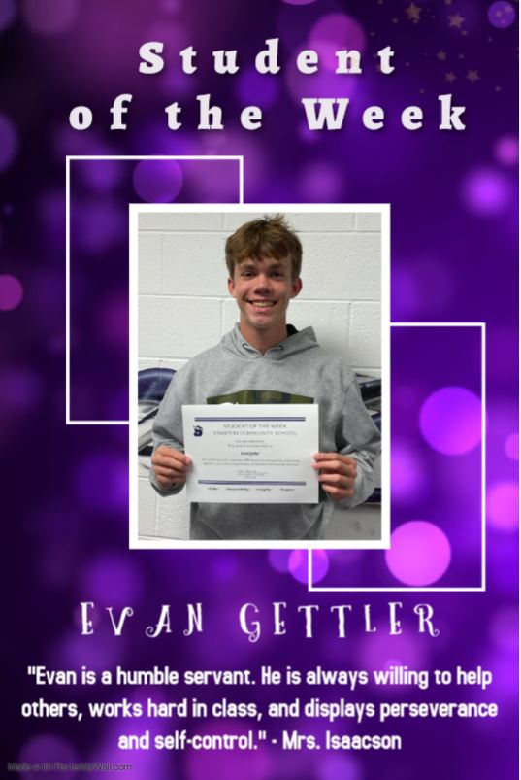

ELEMENTARY STUDENT OF THE WEEK
