STANTON COMMUNITY SCHOOL OCTOBER 15, 2021

PRINCIPAL
The end of the first quarter will be next Friday, October 22nd.
Congratulations to our Students of the Week: Cailex Williams and Axel King. This award is presented to students for working hard, making a difference, showing pride, and practicing respect at Stanton Community School.
Parent-Teacher Conferences will be held on Thursday, October 28th, from 8:00 am-8:00 PM.
- Elementary teachers will be scheduling conference times with parents. Elementary parents, please check your email for instructions on how to sign up online between Monday, October 18th and Wednesday, October 27th.
- MS/HS parent teacher conferences will be located in classrooms from 8:00 AM-4:00 PM. All MS/HS teachers will be in a central location in the library from 4:00 PM-8:00 PM.
- Please note that due to conferences, we will not have school on Thursday, October 28th, or Friday, October 29th.
Upcoming Dates:
- October 22nd-End of 1st Quarter
- October 25th-National Honor Society Induction
- October 27th-No Early Release
- October 28th-Parent Teacher Conferences
- October 29th-No School

SCHOOL ACTIVITIES
National Honor Society
Congratulations to Abby Burke, Addison Olson, Brooklyn Silva, and Jenna Stephens for being selected for induction into the National Honor Society. The ceremony is open to the public and will take place on October 25th at 10:00 AM in the gym.
Schedule Elementary Parent/Teacher Conferences
Parent/Teacher Conferences are scheduled for Thursday, October 28th, from 8:00 AM to 8:00 PM. There will be no school for students on Thursday, October 28th, and Friday, October 29th. To schedule your Elementary Parent/Teacher Conference please go to https://www.stantonschools.com/profile/?TARGET=Front_Login
and follow the directions that are below.
If you are having trouble signing up or have questions, please contact the office at 712-829-2171.
Where to Start
• Sign In: If you previously signed up for SOCS calendar reminders, you are already a registered user for Parent Teacher Conference (PTC) and will use your email and the same password used for calendar reminders.
• Sign Up NOW! If you have not yet registered, you will complete the registration screen that asks for name, email and password. Upon completion, you will have password protected login access and will receive an email confirming your registration and login credentials. You will also have access to create calendar reminders.
YOU ARE NOW AT THE PTC SCREEN
Signing Up for Parent-Teacher Conferences
Important: This site will be open from October 18th through October 27th.
Step 1: Choose the conference you wish to attend. Once you have chosen the conference you will be taken to a list of teachers associated with the conference.
Step 2: Select the teacher(s) from the list or by typing a last name in the "Search Teacher" field. You can reserve time with up to eight teachers. You can register for additional teachers once you complete the current process.
Step 3: Enter the student's name.
Step 4: Click continue.
Step 5: Check the box next to the conference time you wish to reserve.
Step 6: Click Update (the timeframe you chose will be colored green).
At this point you may sign up for conferences for additional teachers or additional students by clicking on the “Teacher Selection” button.
• Choose additional teachers OR
• Repeat the process you just completed for additional student/s choosing new teacher/s and entering the additional student/s name/s
• Click Update.

• The timeframe you chose is colored green (registration for the additional teachers or student/s is added to your Confirmation Registration Report).
At the bottom of the screen you will see a confirmation of your conference registration. You will have the option to "click here to print" to get a copy of your Conference Registration Report

ATHLETICS
Regional Volleyball Tickets
The Viqueens will host Bedford in the opening round of Regional Volleyball on Monday, October 18th. The match will begin at 7:00 PM.
Earlier this month the IGHSAU announced that all ticket sales for regional volleyball games must be sold through online ticketing. There will not be an option to pay in cash at any of the regional volleyball games.
To buy tickets for any of the regional games you can visit the Varsity Bound tickets sales website (https://ia.varsitybound.com/sports/vb/2021-22/tickets) or purchase tickets through the Varsity Bound app. If you do not have a profile (username & password) you will need to create one to purchase tickets. Once tickets are purchased you will be given a QR code and that code (paper or electronic) must be presented at the gate of the contest you are attending.
We understand this may be frustrating for some spectators but the last thing we want is for someone to not attend because they don't know how to purchase a ticket. Jake Lord has offered help to anyone who needs it so please reach out to jlord@stantonschools.com if you need assistance.
Thank you and we hope to see you on Monday as the Viqueens begin their postseason run!
Viqueen Volleyball
On Saturday, the junior varsity squad participated in the Red Oak tournament. The team played awesome and came away from the day with a 3-1 match record. They recorded victories against Atlantic, Glenwood and Fremont-Mills. Their only loss was to tournament winner, Red Oak. The Queens placed second overall for the day.
On Tuesday, October 12th, the Viqueens hosted Essex for their last regular season match of the year. The junior varsity team had another successful showing taking their match with scores of 21-12 and 21-5. The varsity Queens were victorious with set scores of 25-13, 25-7 and 25-14. Regional pairings were released and posted in last week’s bulletin. The varsity team will head into regional action at home on Monday, October 18th, as we host Bedford for round one of regionals. Game time 7:00 PM. Admission for regional games will be handled in an on-line format. (Additional information in this bulletin.) A huge “Thank You” to everyone who follows the team whether in the stands or watching from home! We appreciate our wonderful base of supporters!
On Saturday, October 16th, the varsity team travels to Council Bluffs for the Lewis Central tournament. The schedule is as follows and admission is $5.00. Stanton’s games are in the small gym.
Game #2 Stanton v Glenwood
Game #3 Stanton v Abraham Lincoln
Game #5 Stanton v Tri-Center
Semifinal and championship rounds to follow.
Viking Football
The Vikings outscored Bedford 42-14 in the second half last Friday for a dominant Essex Homecoming victory! The Vikings are now faced with their third game in a row that is a must win to qualify for the playoffs. Tonight, the team will travel to Malvern to take on the Wolverines of East Mills. The winning team places 3rd in our district and qualifies for the state playoffs. The Vikings are excited for the challenge! See you in Malvern. Go Vikings!
Junior High Volleyball
The junior high volleyball team played their last matches of the season this week. On Monday, the team traveled to Tabor for a Junior High Jamboree. The team played six matches and ended the evening with a 3-3 record. The girls played very well and it was fun to see so many improvements in their level of play. On Tuesday, October 12th, the team hosted Essex for their last match of the season. The team won the match with scores of 21-8, 21-4, 21-18, 13-21 and 15-5. A special “Thank You” to the Stanton Booster Club for providing the team cookies after the last match of the season. We appreciate all you do for the athletes and programs at Stanton!
Congratulations girls on a strong finish to a fun season!
The team and their coach would like to thank all of the parents, grandparents and friends who came out to support the junior high team throughout the season. Thank you to Mrs. Lacey Stephens who officiated all of our home matches, the high school volleyball players who ran the score table, line judged and helped with officiating at home events and to our bus drivers who made sure we got to where we were going and home safely.
Softball Pitchers and Catchers
The softball pitchers and catchers have started preseason work. Any girls interested in pitching and/or catching for softball in grades 5th and up please contact Coach Brandie at 712-370-7801.

GUIDANCE
Scholarships
Elks National Most Valuable Student Scholarship Contest
-due November 15, must start online
-Forms available in the office or at www.elks.org
https://www.elks.org/scholars/scholarships/mvs.cfm

ANNOUNCEMENTS

COMING EVENTS
Friday, 15th 7:00-High School Football at East Mills
Saturday, 16th Lewis Central Volleyball Tournament
Monday, 18th 7:00-Regional Volleyball, Here
Stanton vs Bedford
Tuesday, 19th Junior High Conference Vocal Festival at
South Page
Wednesday, 20th 1:05/1:15-Early Dismissal
7:00-Regional Volleyball at Sidney
Friday, 22nd State Football Playoffs

BREAKFAST MENUS OCTOBER 18-22
Monday  French Toast  Muffin/Fruit  Juice, Milk | Tuesday  Crescent Roll  Muffin/Fruit  Juice, Milk | Wednesday  Donut  Muffin/Fruit  Juice, Milk | Thursday  Breakfast Pizza  Muffin/Fruit  Juice, Milk | Friday  Cereal Bar  Muffin/Fruit  Juice, Milk

LUNCH MENUS OCTOBER 18-22
Monday  Pizzaboli  Lettuce  Broccoli  Applesauce  Pears  Milk | Tuesday  Chicken Nuggets  Baked Beans  Coleslaw  Pineapple/Oranges  Banana Muffin  Milk | Wednesday  Ham & Cheese Sandwich  Peas/Green Beans  Peaches  Strawberries  Rice  Milk | Thursday  Beef Fritter  Mashed Potatoes/Gravy  Cooked Carrots  Mixed Fruit  Mandarin Oranges/Roll  Milk | Friday  Fish Sandwich  Tater Twisters  Baked Beans  Pineapple  Apple Slices  Milk

MS/HS STUDENT OF THE WEEK ELEMENTARY STUDENT OF THE WEEK

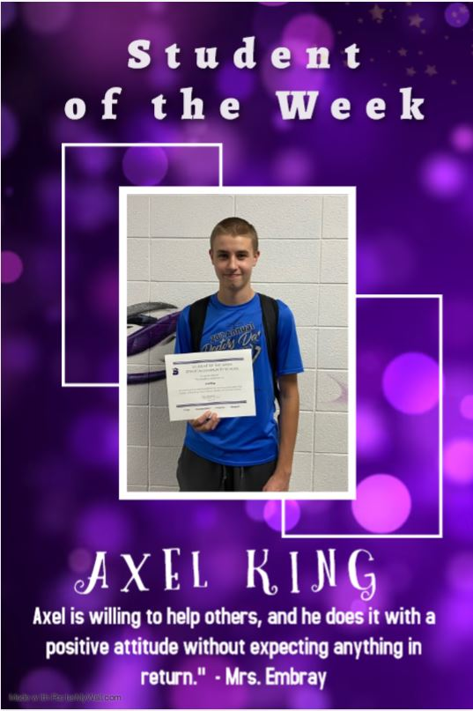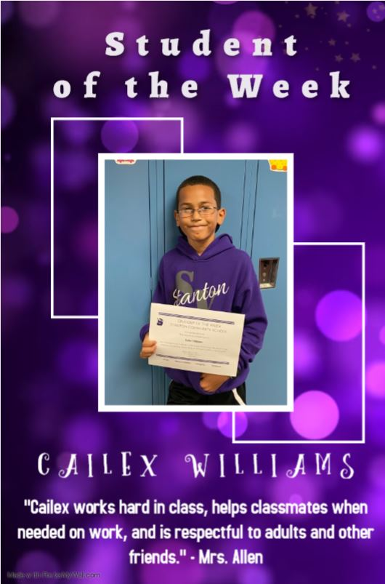

GO VIQUEENS AND VIKINGS

