STANTON COMMUNITY SCHOOL OCTOBER 8, 2021

There will be NO SCHOOL on Monday, October 11th and NO EARLY DISMISSAL on Wednesday, October 13th.

Reminder: The water fountains are only open to fill bottles. Please remember to send a water bottle with your child to school each day.

PRINCIPAL
Congratulations to Mrs. Leanne Johnson, the 2021 recipient of the Mabel Griffith Excellence in Teaching Award!
The Coburg Historical Association has presented its second annual Mabel Griffith Excellence in Teaching Award to Leanne Johnson, a 4th grade teacher at Stanton Elementary School. Mrs. Johnson was selected as someone who shares Mrs. Griffith’s love of teaching and shares many of her values and characteristics. The award is named in honor of Mabel Griffith, a beloved and long-term teacher at the Coburg Consolidated School District. Mrs. Griffith taught for several years during the district’s existence from 1921 to 1969. After closing, the district’s land was absorbed by the neighboring districts in Essex, Stanton and Red Oak. At a meeting of association members two years ago, alumni of the old Coburg school discussed their recollections of the many fine teachers who had positively impacted their lives. Mrs. Griffith was on nearly all of their lists. When asked why she was remembered with such fondness, common responses were that she made each child feel special and important, and that she had high expectations for all of them. The Award is meant to honor Mrs. Griffith and other elementary teachers for their commitment to students and to their profession. Last year’s recipient was Vicki Hume, a 5th grade teacher in the Essex School District. Next year’s recipient will be an elementary teacher in the Red Oak Community School District.
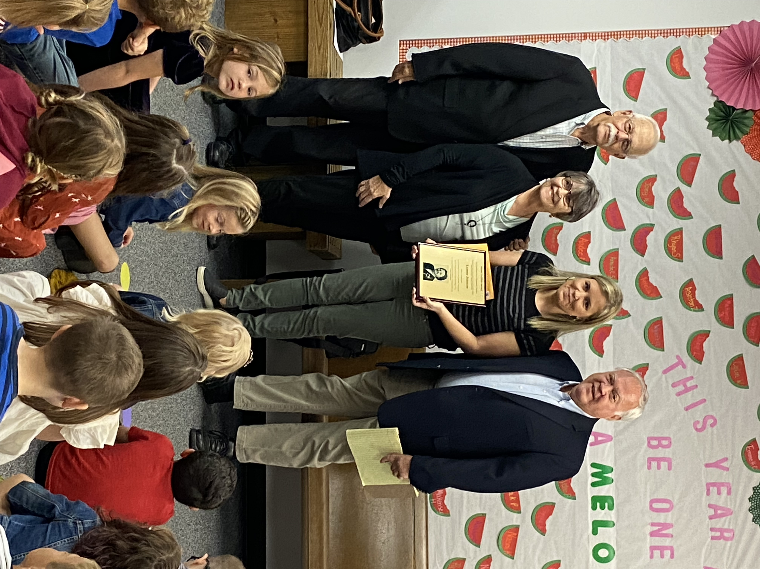
Thank you to Iowa State University for bringing their mobile classroom to Stanton on Thursday, October 7th. Our kindergarten through 5th grade students enjoyed their “Water Rocks!” presentation and outdoor classroom visit!
Saturday, October 2nd, was National School Custodian Day. We want to thank our custodial staff of Bob Reed and Sandy Allen for all they do to keep our school clean and safe!

Next week is National School Lunch Week. Thank you to our kitchen staff: Mindy Strough, Tammy Magneson, Stormey Dykes, Frannie Allen, and Deb Helm for all they do to provide breakfast and lunch for the students and staff!
Parent-Teacher Conferences will be held on Thursday, October 28th, from 8:00 AM-8:00 PM.
- Elementary teachers will be scheduling conference times with parents in the next few weeks.
- MS/HS parent teacher conferences will be located in classrooms from 8:00 AM -4:00 PM. All MS/HS teachers will be in a central location in the library from 4:00 PM -8 PM.
- Please note that due to conferences, we will not have school on Thursday, October 28th, or Friday, October 29th.
The Iowa Youth Survey will be given to students in 6th, 8th, and 11th grade on Monday, October 18th. The purpose of the survey is to collect information from Iowa youth so we can better understand their behaviors, experiences, and beliefs about what makes them feel
secure, strong, and safe in their communities, schools, and families. This information helps state planning agencies, schools, and local
community task forces seek funding, set policy, and provide programs to improve the lives of Iowa’s young people. Asking young people about their experiences and opinions is a valued part of these processes. If you do not want your child to participate in the survey, please complete the refusal form and submit to Mrs. Elwood by Friday, October 15th. This refusal form was included in the parent email that was sent last week. If you need an additional copy, please contact the MS/HS office. Thank you,
Upcoming Dates:
- October 11th -No School - Professional Development
- October 13th -No Early Dismissal
- October 22nd -End of 1st Quarter
- October 25th -National Honor Society Induction
- October 28th -Parent Teacher Conferences
- October 29th -No School

ATHLETICS
Viqueen Volleyball
On Saturday, the varsity Viqueens traveled to the Greene County Tournament in Jefferson. In pool play the Queens went 2-2 for the day with victories over Grinnell, and Des Moines Hoover and had losses to Boone and South Hardin. The team played well and it was a great experience for the Queens to play against teams from larger schools.
On Tuesday, the Queens traveled to Malvern to take on the Wolverines in a corner conference match. In JV action, the Viqueens came out on top with scores of 21-14 and 21-16 in the first match and 24-26, 26-16 and 15-6 in the second match. In varsity action, it was another full count match for the Queens as they won the first two sets 25-17 and 25-18, dropped two close sets 21-25 and 24-26 and then won the deciding match 15-12. The team will be in action on Tuesday night as they host Essex for the final conference game of the season. We will also be honoring our three seniors as well as all players and managers for Parents Night. Come out and cheer on the Queens in their last regular season home match this season!
The junior varsity squad is in action this Saturday in the Red Oak tournament. The schedule is as follows:
9:50 Stanton v Fremont Mills
11:40 Stanton v Atlantic
12:30 Stanton v Glenwood
1:20 Stanton v Red Oak
Admission is $5.00 and will be held in both the orange and black gym at Red Oak high school.
Viking Football
The Vikings regrouped and put together a win in Murray last Friday with a nail-biting 24-22 win! The team converted all three 2-pt conversions and held Murray to only one 2-pt conversion but gave up a safety in the second quarter following a snap that went through the endzone. The Vikings will be playing in their third homecoming game of the season this Friday as they take on a tough district opponent, Bedford at Essex. Kickoff in Essex will be at 7:00 PM.
JV Viking Football
The JV team lost for the first time this season while suffering one season ending injury and 4 concussions. The scrappy Vikings were outscored 50-28 by Knights of Fremont-Mills. The JV Viking’s last home game is schedule for Monday at 6:00 PM.
Junior High Volleyball
The junior high team was in action with Clarinda Lutheran on Monday, October 4th, and traveled to take on the East Mills junior high team on Tuesday, October 5th. The Queens dropped their match against Clarinda Lutheran and split matches with East Mills. The junior Queens are in action on Monday, October 11th as they travel to Tabor for a Junior High Jamboree and will finish their regular season of play when they host Essex on Tuesday, October 12th.
Softball Pitchers and Catchers
The softball pitchers and catchers have started preseason work. Any girls interested in pitching and/or catching for softball in grades 5th and up please contact Coach Brandie at 712-370-7801.

GUIDANCE
Scholarships
Elks National Most Valuable Student Scholarship Contest
-due November 15, must start online
-Forms available in the office or at www.elks.org
https://www.elks.org/scholars/scholarships/mvs.cfm

ANNOUNCEMENTS
Hart Fundraiser
Join in on the fun for the “Strides for Stacy” walk, supper, and auction fundraiser! Stacy Hart was recently diagnosed with breast cancer. The following events will be on Saturday, October 9th:
- 5:00 PM-Walk in honor of Stacy on the Greenbelt Trail (Meet at Stanton Viking Center).
- 5:30 PM-7:00 PM-Sit down or to go supper at the Stanton Old Lumber Yard Event Center. Meal includes pulled pork sandwich, baked beans, coleslaw, homemade cookie/bar, and bottled water for a free will donation.
- 6:00 PM-Live auction at the Stanton Old Lumber Yard Event Center. Drop off auction donations at Farmers Mutual Telephone Company in Stanton.
For questions, contact Kassie Houdek, Aubrey Dreyer, Katie Hart, Ashley McDonald, Rachelle Focht or Jenna Ramsey.

COMING EVENTS
Friday, 8th 7:00-High School Football with Bedford at Essex
Saturday, 9th 9:00-Red Oak Junior Varsity Volleyball
Tournament
Monday, 11th NO SCHOOL
Teacher Inservice
4:00-Fremont-Mills Junior High Volleyball
Jamboree
4:00-Junior High Football with Lenox, Here
6:00-Junior Varsity Football with Lenox, Here
Tuesday, 12th 4:00-Junior High Volleyball with Essex, Here
6:00-High School Volleyball with Essex, Here
Parents’ Night
Wednesday, 13th NO EARLY DISMISSAL
PSAT/NMSQT-Juniors
Friday, 15th 7:00-High School Football at East Mills
Saturday, 16th Lewis Central Volleyball Tournament

BREAKFAST MENUS OCTOBER 11-15
Monday  NO SCHOOL  Teacher Inservice | Tuesday  Breakfast Burrito  Muffin/Fruit  Juice, Milk | Wednesday  English Muffin Sandwich  Muffin/Fruit  Juice, Milk | Thursday  Oatmeal Bar  Muffin/Fruit  Juice, Milk | Friday  Bacon & Egg Pizza  Muffin/Fruit  Juice, Milk

LUNCH MENUS OCTOBER 11-15
Monday  NO SCHOOL  Teacher Inservice | Tuesday  Pork Chopette/Bun  Baked Beans  Ranch Potatoes  Apple Slices  Mixed Fruit  Milk | Wednesday  Grilled Chicken/Bun  Mixed Vegetables  Garbonzo Beans  Peaches/Raisins  Chocolate Cake  Milk | Thursday  Pizza  Lettuce  Carrots  Applesauce  Pears  Milk | Friday  Corn Dog  Baked Beans  Sweet Potatoes  Goldfish/Pineapple  Mandarin Oranges  Milk

j GO VIQUEENS AND VIKINGS

