STANTON COMMUNITY SCHOOL MAY 20, 2022

We’re hiring for the 2022-2023 school year:

- K-12 Music Teacher
- K-12 Part Time TAG Teacher
- K-12 Certified Teacher Librarian
- Paraeducator
- JH Girls Basketball Coach
- Concession Stand Manager
- Cheerleading Sponsor

To apply for any of these positions, please go to www.teachiowa.gov, or contact Mrs. Elwood at kelwood@stantonschools.com or 712-829-2162.

PRINCIPAL
Congratulations to our 8th grade students who celebrated their 8th grade graduation on Monday, May 16th.

Our senior commencement ceremony will be held on Saturday, May 21st at 7:00 p.m. in the Stanton School Gymnasium. Congratulations to all of our graduates!

Please note the following events for our students as we wrap up the 2022-23 school year:
- May 20th-Elementary Reading Reward Trip at the Zoo
- May 21st-Graduation at 7:00 p.m.
- May 24th-Last Day of School
- Elementary dismissed at 10:50 a.m.; MS/HS dismissed at 11:00 a.m.

Thank you to all of our students, staff, parents, families, and community members for all of your positive support this school year. We are very proud of our students and staff for everything they did to help make this a very successful year. We want to wish everyone a safe and happy summer break!!

SCHOOL ACTIVITIES

The June 10th Red Cross Blood Drive has been postponed until Tuesday, July 5th. It will be held at the Viking Center from 12:30-5:30. To make appointments go to: redcrossblood.org. Hope to see you there.
Talent Show
There will be a 3rd-5th grade Talent Show on Monday in the high school gym. It starts at 9:15 a.m.

GUIDANCE
Class Schedules for Next Year
All class schedules for next year for students currently in 9th, 10th, and 11th grades need to be turned in as soon as possible. These schedules need to be signed by parents, so if you haven’t seen your child’s schedule for next year, please ask them about it!

ATHLETICS
Viqueen Track
The high school girls track team finished up their season scoring 66 points at Monday's meet at Fremont-Mills. The girls were back at

Fremont-Mills on Thursday for the State Qualifying Meet. The team competed very well and season best marks in almost every event were earned during these two meets. The entire track squad should feel very good about their accomplishments during the season. Special congratulations to the state qualifiers! The shuttle hurdle relay team (Elly McDonald, Addison Olson, Hannah Olson, and Kyla Hart) and the 4 X 200 relay team (Kyla Hart, Hannah Olson, Brooklyn Silva, and Lauren Johnson) will represent Stanton at the State Track Meet. The shuttle hurdle team will run at 9:00 a.m. Thursday, and the 4 X 200 will be on the track at 10:50 on Friday morning. Good Luck to those girls at the State Meet. Coach Subbert would like to thank the parents, other family members, and all the fans that supported the track girls this season.
Viking Track
The Vikings finished 6th overall out of the 13 teams competing in last week's state qualifier. The team did not have any individual or relay champions, but Jackson Roberts' performance qualified in the high jump for the second year in a row. Thank you for all of the positive support and encouragement throughout the season. Good Luck to Jack and the Viqueens at the state meet this week!
Junior High Girls Track
The Stanton Junior High girls track team closed out their season on Friday, May 13th as they traveled to Griswold for the Junior High Corner Conference meet. Once again, the team saw improved performances all the way around! Individuals and events earning placings in the top three for the evening were: Meredith Roberts in the 800 – 3rd place, Meredith Roberts in the 1500 – 2nd place, 4 x 100 (Lilly Ford, Addy Gettler, Meredith Roberts, Britney Silva) – 2nd place and Shuttle Hurdle Relay (Lilly Ford, Addy Gettler, Kennedy King, Britney Silva) – 2nd place. Congratulations to all eleven junior high girls on a great season! Thank you to all of the supporters of the junior high tracksters this year!

ANNOUNCEMENTS
Swedish School
Svenska Skolan (Swedish School) is being offered at the Stanton Heritage & Cultural Center June 13-17 from 9:00-12:00 a.m. The class is open to children who have completed 1st through 6th grade. A $10.00 fee will be charged to cover the cost of materials. Call Yvonne Johnson at 586-4504 to register.
The curriculum will include beginning language, culture, songs, dances, games, and arts and crafts. The children will participate in the Midsummar activities on June 18th.

COMING EVENTS
Friday, 20th Elementary Reading Reward Trip to the Zoo
State Track
5:30-High School Junior Varsity/Varsity Baseball
at AHSTW
Saturday, 21st 7:00-Senior Graduation
Monday, 23rd 5:30-High School Softball/Baseball at SW Valley
Tuesday, 24th 10:50/11:00-Early Dismissal-Last Day of School
Friday, 27th 5:30-High School Softball/Baseball at Griswold
Saturday, 28th 9:00-Shenandoah Softball Tournament

BREAKFAST MENUS MAY 23-24
Monday  Cook’s Choice | Tuesday  Cook’s Choice

LUNCH MENUS MAY 23-24
Monday  Cook’s Choice  Milk | Tuesday  Cook’s Choice  Milk

Menus Subject to Change

MS/HS STUDENT OF THE WEEK ELEMENTARY STUDENT OF THE WEEK 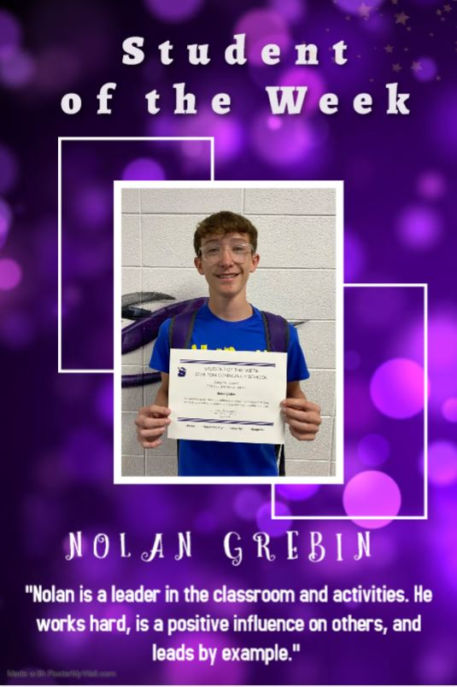 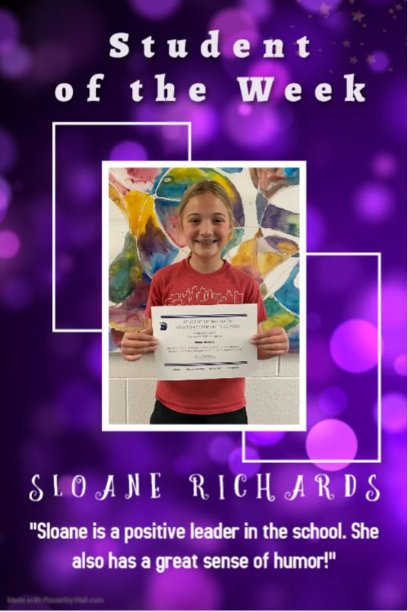

It is the policy of the Stanton Community School District not to discriminate on the basis of race, color, national origin, sex, disability, religion, creed, age (for employment), marital status (for programs), sexual orientation, gender identity and socioeconomic status (for programs) in its educational programs and its employment practices. There is a grievance procedure for processing complaints of discrimination. If you have questions or a grievance related to this policy, please contact Mrs. Sheila Mainquist, 605 Elliott St., Stanton, Iowa 51573, smainquist@stantonschools.com, (712) 829-2162.

