STANTON COMMUNITY SCHOOL MAY 13, 2022

We’re hiring for the 2022-2023 school year:

- K-12 Music Teacher
- K-12 Part Time TAG Teacher
- K-12 Certified Teacher Librarian
- Paraeducator
- JH Girls Basketball Coach
- Concession Stand Manager
- Cheerleading Sponsor

To apply for any of these positions, please go to www.teachiowa.gov, or contact Mrs. Elwood at kelwood@stantonschools.com or 712-829-2162.

PRINCIPAL
Please note the following events for our students as we wrap up the 2021-2022 school year:

- May 15th-Baccalaureate at Mamrelund Church
- May 16th-18th-Senior class trip
- May 16th-8th Grade Graduation at 7:00 p.m.
- May 18th-Seniors last day and graduation practice
- May 20th-Elementary Reading Reward Trip at the Zoo
- May 21st-Graduation at 7:00 p.m.
- May 24th -Last Day of School - Elementary dismissed at 10:50 a.m., MS/HS dismissed at 11:00 a.m.

GUIDANCE
Awards Day Thanks
We would like to express the gratitude of our school to donors of scholarships awarded to our Stanton seniors. We would also like to thank the presenters for your participation in our Awards Day program on May 5th. Congratulations to all of the winners of scholarships!
Class Schedules for Next Year
All class schedules for next year for students currently in 9th, 10th, and 11th grades need to be turned in as soon as possible. These schedules need to be signed by parents, so if you haven’t seen your child’s schedule for next year, please ask them about it!

ATHLETICS
Viking Track
The HS boys' team competed Monday in Tabor in a last chance effort to prepare for the state qualifier meet to also be held in Tabor. Weather-permitting, all state qualifier meets for every class will take place on Thursday, May 12th. The Vikings will compete in a lineup that will put their best efforts in a position to qualify. The first place winner in each event qualifies from our 13 team qualifier meet. The remaining spots in the top 24 will be the next 14 best performances statewide. State qualifiers will be posted online within 24 hours after the completion of the last qualifying meet.
Junior High Girls Track
The Stanton Junior High girls track team continues to improve at their meets every week. On Friday, May 6th, the team traveled to Corning. All running events with the exception of one, posted season

best times! On Tuesday, May 10th, the team traveled to Griswold for a very warm evening on the track. The team placed 6th overall but again were able to post some great times and results. The Jr. Viqueens will close out their season this Friday, May 13th as they travel to Griswold for the Junior High Conference meet. What a fun and growth-centered season it has been for this mighty group of eleven girls! A huge “Thank You” to the parents, relatives and friends who fill the stands every meet night!

ANNOUNCEMENTS
Stanton PTSO Themed Baskets Are Here!!
Grades K-5 have put together some amazing, themed baskets to help raise money for field trips and projects around school!! Tickets are going to be sold 1 for $1 or 6 for $5. Each elementary teacher has tickets in their classroom, or you may find tickets in the elementary office to purchase. The raffle ends the day of the golf tournament which is when names will be drawn-May 15th.
Basket themes include:
KinderGARDEN-Gardening, 1st grade-Summer Fun,
2nd grade-Family Fun Night, 3rd grade-Arts and Crafts,
4th grade-Dog Basket, 5th grade-Camping
Swedish School
Svenska Skolan (Swedish School) is being offered at the Stanton Heritage & Cultural Center June 13-17 from 9:00-12:00 a.m. The class is open to children who have completed 1st through 6th grade. A $10.00 fee will be charged to cover the cost of materials. Call Yvonne Johnson at 586-4504 to register.
The curriculum will include beginning language, culture, songs, dances, games, and arts and crafts. The children will participate in the Midsummar activities on June 18th.
Stanton Annual Chamber Meeting/Varfest
It’s that time of year again! The Stanton Chamber of Commerce Annual Meeting/Varfest will be held on Saturday, May 14th at the Stanton Old Lumber Yard Event Center. A meal by Gibbs Chophouse and Kustom Sweets & Eats will be held at 6:00 p.m. along with Stanton Trivia. The meal includes a ribeye sandwich and chips or ham balls and green beans. The cost is $20 and tickets can be purchased at Gibbs Chophouse, Fika coffee Hus, Great Western Bank, Farmers Mutual Telephone Company and Cast Iron Café. At 7:00 p.m., there will be a Stanton Community Update presentation and project presentations by Stanton Community School Students. We hope to see you there!

COMING EVENTS
Friday, 13th 4:00-Junior High Conference Track at Griswold
Girls Regional Golf at Mount Ayr
Sunday, 15th 7:00-Baccalaureate at Mamrelund
Monday, 16th 7:00-8th Grade Graduation
Senior Trip
Tuesday, 17th Senior Trip
Wednesday, 18th 1:05/1:15-Early Dismissal
Senior last day and graduation practice
Thursday, 19th State Track
Friday, 20th Elementary Reading Reward Trip to the Zoo
State Track
Saturday, 21st 7:00-Senior Graduation

BREAKFAST MENUS MAY 16-20
Monday  Brownie  Muffin/Fruit  Juice/Milk | Tuesday  Breakfast Bagel  Muffin/Fruit  Juice/Milk | Wednesday  Donut  Muffin/Fruit  Juice/Milk | Thursday  Waffle  Muffin/Fruit  Juice/Milk | Friday  Cook’s Choice

LUNCH MENUS MAY 16-20
Monday  Taquito/Hot Dog  Corn  Lettuce  Mandarin Oranges  Apple Slices  Goldfish  Milk | Tuesday  French Bread Pizza  Lettuce  Cauliflower  Fruit Medley  Applesauce  Milk | Wednesday  Chicken Strips  Green Beans  Potato Wedges  Peaches  Ice Cream  Animal Crackers  Milk | Thursday  Mac & Cheese  Mini Corn Dogs  Corn  Potato Spudsters  Mi9xed Fruit  Pineapple  Milk | Friday  Cook’s Choice

Menus Subject to Change

MS/HS STUDENT OF THE WEEK ELEMENTARY STUDENT OF THE WEEK
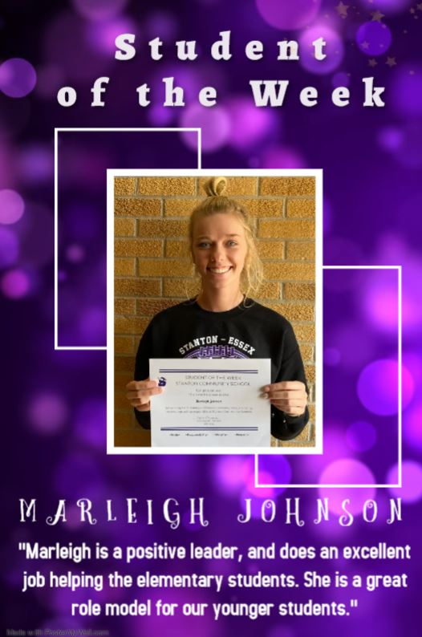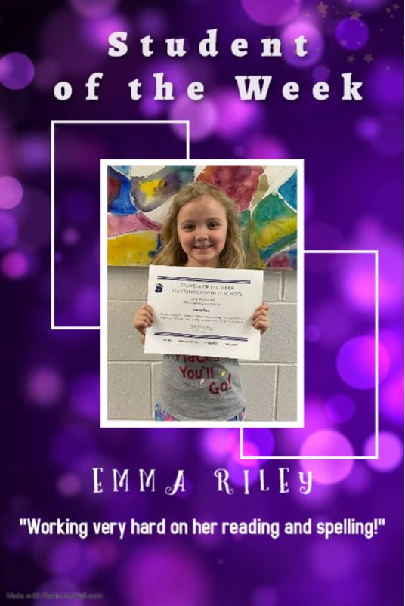

It is the policy of the Stanton Community School District not to discriminate on the basis of race, color, national origin, sex, disability, religion, creed, age (for employment), marital status (for programs), sexual orientation, gender identity and socioeconomic status (for programs) in its educational programs and its employment practices. There is a grievance procedure for processing complaints of discrimination. If you have questions or a grievance related to this policy, please contact Mrs. Sheila Mainquist, 605 Elliott St., Stanton, Iowa 51573, smainquist@stantonschools.com, (712) 829-2162.

