STANTON COMMUNITY SCHOOL MAY 6, 2022

We’re hiring for the 2022-2023 school year:
- K-12 Music Teacher
- K-12 Part Time TAG Teacher
- K-12 Certified Teacher Librarian
- Paraeducator
- JH Girls Basketball Coach
- Concession Stand Manager
- Cheerleading Sponsor
- Temporary summer mowing and grounds maintenance
- Temporary summer custodial assistant

To apply for any of these positions, please go to www.teachiowa.gov, or contact Mrs. Elwood at kelwood@stantonschools.com or 712-829-2162.

PRINCIPAL
Thank you to the members of the Junior class, Mrs. Druivenga, Mrs. Stephens, and our junior and senior parents for helping to plan a successful prom for our students last Saturday!
Senior class parents - please check your email for information regarding end-of-year activities and events for our seniors. If you have any questions, please contact Mrs. Elwood.
Thursday, May 5th, was our Scholarship and Awards day for MS and HS students. Thank you to everyone who helped present these awards. We appreciate everyone taking time out of their day to recognize the accomplishments of our students. Congratulations to all of our scholarship and award recipients!!

Please note the following events for our students as we wrap up the 2022-23 school year:

- May 15th-Baccalaureate at Mamrelund Church
- May 16th-18th-Senior class trip
- May 16th -8th Grade Graduation at 7 p.m.
- May 18th-Seniors last day and graduation practice
- May 20th-Elementary Reading Reward Trip to the Zoo
- May 21st-Graduation at 7 p.m.
- May 24th-Last Day of School - Elementary dismissed at 10:50 a.m., MS/HS dismissed at 11 a.m.

SCHOOL ACTIVITIES
2022 Stanton Jr-Sr Prom Royalty
Congratulations to Mackenzie Rocha and Roary Blair for being named Prom Queen and King of the Stanton Jr.-Sr. Prom last Saturday night.
Jr-Sr Prom Thank You
Even though the weather was a little on the cool side and last minute changes had to be set in action for the Walk-In, the 2022 Jr.-Sr. Prom was a huge success on Saturday evening, April 30th. The Walk-In and Prom were held at the beautiful OLY event center in Stanton. The Junior Class and their sponsors would like to extend a HUGE “Thank You” to the following who helped make our evening special: Julie Strickland of Strickland Photography for taking prom photos, Liz Brittan for taking “action” shots of the prom-goers during prom, John Mainquist for emceeing the walk-in, Sarah Culver, Jenny Gettler, the Evangelical Covenant Church for decorations, Dan & Katie Elwood for their support and helping with prom night festivities,
Stephanie & Mike Burke, Lauren Stephens and Tom Weis for their assistance with decorating and preparing for the walk-in. The students and guests enjoyed a delicious meal catered by Gibbs Chophouse. We would like to thank and recognize our servers for the evening: Ella Peterson, Devon Taylor, Gavin Ford and Logan McQueen. Thank you to all of the helped park vehicles and everyone who helped with prom clean up. A very special “Thank You” to Tim Johnson of the OLY, who went above and beyond to assist the class with decorating on Friday and helped with every aspect of prom and clean up–we could not have done it without you Tim! We cannot thank everyone enough for making our prom a very special evening!
Attention Prom Goers and Family:
The 'roving photographer' that the Junior Class had at prom is getting all the pictures ready! Pictures include walk-in, dinner, dance, and fun shots of all prom-goers. If you would like access to these photos please send $15 cash or a check made payable to Elizabeth Brittan. Once she has completed her editing and we have received your payment you will receive access to all of her photos taken prom

night. Cash or check may be dropped off to Mrs. Stephens or in one of the Stanton School offices.

ATHLETICS
Viqueen Track
The Viqueens finished a busy week as they competed against some very good teams last Thursday at Griswold. On Tuesday the team traveled to Fremont-Mills to take part in the Corner Conference Meet. The girls performed very well scoring 105 points to finish second. The team had season best marks in almost every event. Lauren Johnson earned gold in the long jump. The Viquuens also won gold in the 4 X 100 relay (Elly McDonald, Kyla Hart, Lauren Johnson, Brooklyn Silva) and the 4 X 200 Relay(Ella Peterson, Kyla Hart, Hannah Olson, Brooklyn Silva). Congratulations to the entire team on a great performance at the conference meet. The girls will finish up their season next week with a meet Monday at Fremont-Mills, and then they will travel back to Fremont-Mills on Thursday for their Regional Meet.
Viking Track
The HS boys' have been busy and competing well! Jackson Roberts qualified as a top high jumper (all Classes) and competed in the Drake Relays last Friday in the high jump. Congratulations Jack!
This past Tuesday, the team competed for the conference track meet championship and scored 119 points to take second place overall to East Mills' 141 points. The coaching staff couldn't be more proud of each and everyone's effort and performances. With very few exceptions, everyone performed a season best! There were many gutty performances that will help toughen us for the next competition!
As we close our last regular season meet Monday, May 9th, at F-M, we hope to be fine-tuned, primed and ready to outperform our season bests so far. The state qualifying meet will be at F-M, next Thursday, May 12th. The winners of each event in the 10 districts advance to the state meet, plus the next 14 best performances across the state also qualify to fill the 24 total spots per event. It will be an exciting week! Go Vikings and Viqueens!!
Junior High Girls Track
The Stanton Junior High girls track team competed in their second and third meets of the season this past week. On Thursday, April 28th the team traveled to Essex and placed second overall for the evening from the six teams in competition. The Viqueens scored a total of 101 points. On Thursday, April 29th, the team traveled to Tabor for a 7-team meet and finished in 5th place overall. The girls continue to improve each and every time they are on the track and it will be exciting to see them compete in the last two weeks of the season! The girls are in action on Friday, May 6th in Corning and next week they travel to Griswold on Tuesday and finish their season at Griswold on Friday, May 13th at the Corner Conference JH meet. Thank you to all who support and cheer for the team from the stands!

ANNOUNCEMENTS
Stanton PTSO Themed Baskets Are Here!!
Grades K-5 have put together some amazing, themed baskets to help raise money for field trips and projects around school!! Tickets are going to be sold 1 for $1 or 6 for $5. Each elementary teacher has tickets in their classroom, or you may find tickets in the elementary office to purchase. The raffle ends the day of the golf tournament which is when names will be drawn-May 15th.
Basket themes include:
KinderGARDEN-Gardening, 1st grade-Summer Fun,
2nd grade-Family Fun Night, 3rd grade-Arts and Crafts,
4th grade-Dog Basket, 5th grade-Camping
Swedish School
Svenska Skolan (Swedish School) is being offered at the Stanton Heritage & Cultural Center June 13-17 from 9:00-12:00 a.m. The class is open to children who have completed 1st through 6th grade. A $10.00 fee will be charged to cover the cost of materials. Call Yvonne Johnson at 586-4504 to register.
The curriculum will include beginning language, culture, songs, dances, games, and arts and crafts. The children will participate in the Midsummar activities on June 18th.
Stanton Annual Chamber Meeting/Varfest
It’s that time of year again! The Stanton Chamber of Commerce Annual Meeting/Varfest will be held on Saturday, May 14th at the Stanton Old Lumber Yard Event Center. A meal by Gibbs Chophouse and Kustom Sweets & Eats will be held at 6:00 p.m. along with Stanton Trivia. The meal includes a ribeye sandwich and chips or hamballs and green beans. The cost is $20 and tickets can be purchased at Gibbs Chophouse, Fika coffee Hus, Great Western Bank, Farmers Mutual Telephone Company and Cast Iron Café. At 7:00 p.m., there will be a Stanton Community Update presentation and project presentations by Stanton Community School Students. We hope to see you there!

COMING EVENTS
Friday, 6th Kindergarten Round-Up
There be NO School for the Kindergarten class
4:15-Junior High Track at SW Valley
State Large Group Music Festival at Atlantic
Monday, 9th 4:30-High School Girls/Boys Track at SW Valley
Tuesday, 10th 4:00-Junior High Track at Griswold
6:30-Yearbook End of the Year Party
Wednesday, 11th 1:05/1:15-Early Dismissal
10:00-Boys Sectional Golf at Sidney
Thursday, 12th 4:00-Girls Regional/Boys District Track at
Fremont-Mills
Friday, 13th 4:00-Junior High Conference Track at Griswold
Girls Regional Golf at Mount Ayr
Sunday, 15th 7:00-Baccalaureate

BREAKFAST MENUS MAY 9-13
Monday  Pop-Tart  Muffin/Fruit  Juice/Milk | Tuesday  Pancakes  Muffin/Fruit  Juice/Milk | Wednesday  Breakfast Sandwich  Muffin/Fruit  Juice/Milk | Thursday  Churro  Muffin/Fruit  Juice/Milk | Friday  Cinni Mini  Muffin/Fruit  Juice/Milk

LUNCH MENUS MAY 9-13
Monday  Stuffed Crust Pizza  Lettuce  Celery  Applesauce  Pears  Milk | Tuesday  Hamburger/Bun  Tater Twisters  Baked Beans  Apricots  Mixed Fruit  Milk | Wednesday  Chicken Pattie/Bun  Mixed Vegetables  Tomato Juice  Strawberries  Pears  Milk | Thursday  Meatloaf  Cheesy Mashed Potatoes  Green Beans  Peaches  Mandarin Oranges/Roll  Milk | Friday  Grilled cheese  Tomato Soup  Tri-Tater  Pineapple  Mixed Fruit  Milk

Menus Subject to Change

MS/HS STUDENT OF THE WEEK ELEMENTARY STUDENT OF THE WEEK
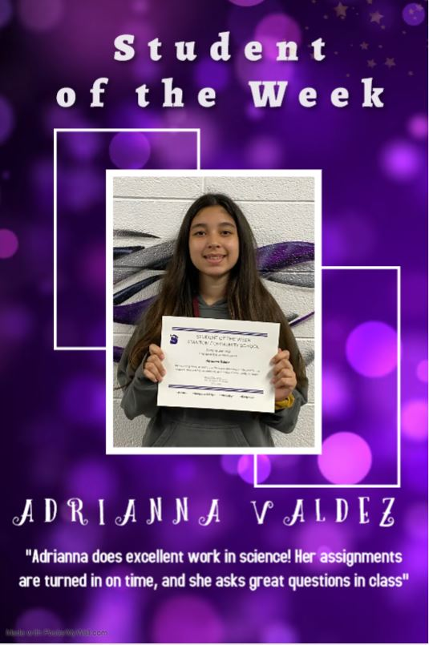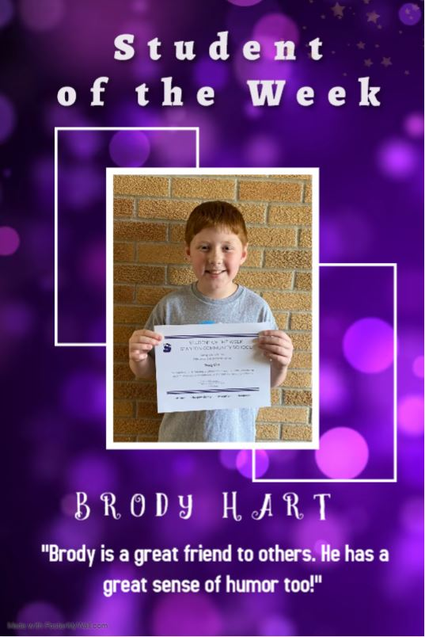

It is the policy of the Stanton Community School District not to discriminate on the basis of race, color, national origin, sex, disability, religion, creed, age (for employment), marital status (for programs), sexual orientation, gender identity and socioeconomic status (for programs) in its educational programs and its employment practices. There is a grievance procedure for processing complaints of discrimination. If you have questions or a grievance related to this policy, please contact Mrs. Sheila Mainquist, 605 Elliott St., Stanton, Iowa 51573, smainquist@stantonschools.com, (712) 829-2162.

