STANTON COMMUNITY SCHOOL APRIL 8, 2022

SUPERINTENDENT
Dear Parents/Guardians;

These last two-plus years have been a grind with COVID mitigation strategies, decisions, and the unknown. It has been a pleasant winter in regards to zero-missed school days due to inclement weather. With that in mind, and after visiting with school board members, we are planning to add a day to our upcoming spring break on Wednesday, April 20th. This means we will get out of school Thursday, April 14^{th,} at 1:05/1:15 p.m. and NO school from Friday, April 15th through Wednesday, April 20th. School will resume on Thursday, April 21st. This is intended as a thank you to everyone for staying with us on the challenging journey. We know nothing about it was perfect, but hopefully, we are near the end. We will not plan to make this day up.
Sincerely,
David Gute, Superintendent

PRINCIPAL
Conditions for Learning Survey
Our 3rd-12th grade students will be taking the Conditions for Learning Survey on Tuesday, April 26th. All students in Iowa in grades 3-12 take the Conditions for Learning Survey annually in the spring. The Survey is designed to measure their engagement in school, safety and overall learning environment. The Survey is part of Iowa’s plan to meet the federal Every Student Succeeds Act (ESSA). The Surveys give students and parents a voice in school improvement efforts. It’s also actionable information for schools to use to improve the learning environment. Research shows students thrive academically when they feel safe, actively engaged in their learning, and when they have positive relationships with adults and other students at school. Survey results are completely anonymous. No names are recorded, and no identifying information will be attached to specific responses. Parents, please check your email for additional information regarding both the student and parent surveys. If you have any questions, please contact Mrs. Elwood at 712-829-2162 or kelwood@stantonschools.com.
Midterm Grade Check
The MS/HS midterm grade check will be Thursday, April 14th. Please contact your child’s teacher or the office at 712-829-2162 if you have any questions regarding your student’s progress in school.
Iowa Statewide Assessment of Student Progress (ISASP)
Our 3rd-11th grade students have completed the Iowa Statewide Assessment of Student Progress. When the district receives the test results, we will send them home to students and parents. Thank you for your support during testing week and great job by all of our students!
Calendar Reminders
- Thursday, April 14th-1:05/1:15 p.m. early dismissal
- Friday, April 15th-Wednesday, April 20th -No School
- Thursday, April 21st-Classes Resume

SCHOOL ACTIVITIES
State FFA Leadership Conference
The following FFA members will be participating at the 94th Iowa FFA State Leadership Conference on April 10th -12th.
Ashley Henneman

-Iowa FFA Degree
-Iowa FFA Proficiency Award in Agricultural Education, 1st place
-Teach Ag Signing Day
-State Officer Candidate
-Academic Achievement
Allie Sandin
-Iowa FFA Degree
-Delegate
-Chapter Activity Display
-Academic Achievement
Leah Sandin
-Delegate
-Chapter Activity Display
Ella Peterson
-Greenhand Quiz
Clark Spencer
-Greenhand Quiz
Slade Graham
-Iowa FFA Degree
Carston Johnson
-Iowa FFA Degree
John Peterson
-Iowa FFA Degree
Also attending through their participation in Leadership Development Events and participating in workshops, tours, and a community service activity while at the conference:
Dacey Henneman - Chapter President
Stephanie Bair
Alice Duckett
Jayden Schwery
Marissa Strough
Memory Project
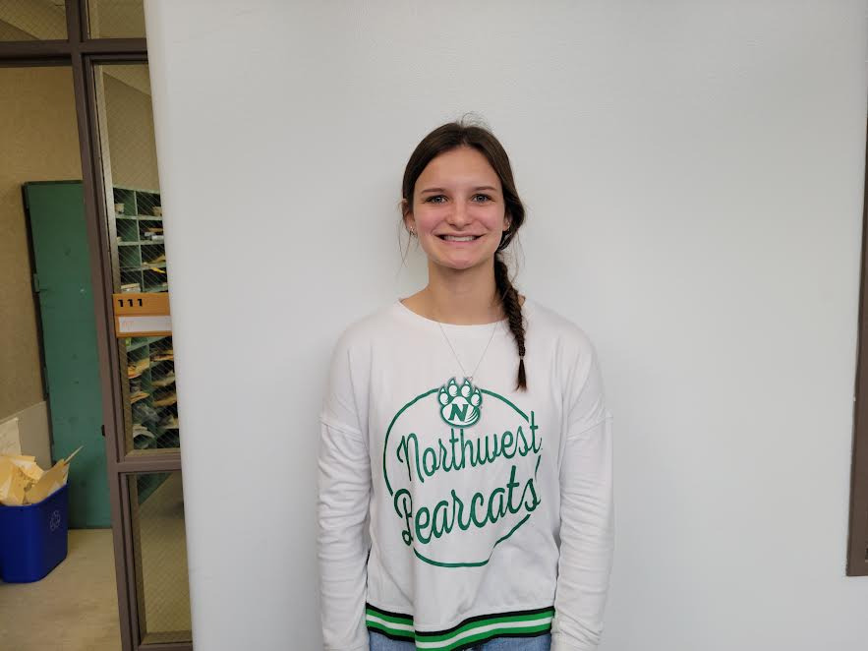
Abby Burke participated in the Memory Project. The Memory Project provides handmade, heartfelt portraits as special memories to children in orphanages and to touch the lives of youth around the world facing many types of challenges.
Abby and Mrs. Driscoll had the privilege of drawing the portraits for two children from Nigeria.
If you are an artist and would like to draw portraits for children who are facing challenges around the world go to memoryproject.org.
Conference Art Awards
This year the Conference Art Fair was held in Griswold and Stanton students received 74 awards. They are as follows:
Advanced Art-27 art awards this year
Abby Burke- 5-1st place Crayon, Pencil, Collage, Book art, Oil Pastel, 1-2nd place Black charcoal, 1- HM Acrylic paint
Aiden Graham- 2-1st place Graphic art, Cardboard art, 5-2nd place Felt Pen, Pencil, Scratch Art, Soft Pastel, Acrylic paint
Marissa Strough-4-1st place Felt Pen, Scratch art, Cut Paper, 3rd Place -Mixed Media
Alice Duckett-1st place-Pencil, and 3rd place-Micro Pen
Mackenzie Rocha-2-1st place Cartoon Color Pencil, Decorative Art 2nd place-Pencil
Sami Jo Helberg-2-1st place-Acrylic, Paper Mache, 3rd place-Acrylic Paint
Beginning Art-20 Awards
Hannah Olson-1st place- Pencil
Eli Davis-2-3rd place-Pencil, Soft Pastel, HM-Soft Pastel
Beau Sallach-3rd place-Pencil
Brianna Mitchell-2nd place-Printmaking, HM-Pencil
Kiela Franzen-2nd place-Micro Pen
Adam Benson-HM-Micro Pen
Alli Baker-5-1st place-Paper Mache, Pencil, Felt Pen, Relief Sculpture, Soft Pastel, 2-3rd place, Micro Pen and Pen and Ink
Kyla Hart-1st Printmaking, 2nd place-Soft Pastel
Anna Peterson-1st place-Calligraphy
Riley Burke-3rd place-Printmaking
Middle School-27 Art Awards
7th grade
Addi Getter-1st place-Mixed Media String Art
Nicholas Herrick-2-3rd place Pencil and String Painting
Lilly Ford -2nd place-Mixed Media String Painting, 3rd place-Color Pencil
Oliver Dykes-3rd place-Cut Paper
Elaina Utecht-2nd place-Cut Paper, HM Pencil
Caed Olson-1st place-Cut Paper
Treyton Jordan-2nd place-Pencil
8th grade
Jasmine Osher-1st place-Micro Pen, 2nd place-Pencil, 3-3rd place-Cut Paper, Pencil, Mixed Media Watercolor,
Meredith Roberts-1st place-Cut Paper, 2nd place-Pencil
Britney Silva-2nd place-Cut Paper
Taylor Valdez-2-1st place-Bookmark and Mixed Media Watercolor
Alizabeth Maranville-1st place-Pencil, 3rd place-Bookmark
Eric Kutzli-2nd place-Watercolor Bookmark
Will Roberts-2nd place-Pencil
Brodee Sowers-2nd place-Mixed Media Watercolor
Kennedy King-1st place -Pencil
Ethyn Jordan-1st place-Felt Pen
Stanton’s Kindergarten Round-Up
Stanton Elementary School will conduct kindergarten assessments on Friday, May 6th, for any child who will be five years of age on or before September 15, 2022.

On Thursday, May 5th, parents of incoming kindergarten students will meet at 5:30 in the elementary concourse. Our kindergarten teacher, Ms. Henneman and our principal, Mrs. Elwood will present information about the kindergarten curriculum, school policies, etc. Mrs. Melissa Mixan, the school nurse, will also be present to go over health requirements and paperwork needed for incoming kindergarten students. At this time, parents will sign up for a time to return the following day, May 6th, with their child for the Kindergarten screening. The screening process and follow-up with parents should take approximately 20-25 minutes on this date. Registration forms will be sent home with pre-school students the week before the assessment date. We ask that the paperwork in the packets be returned on the screening date of May 6th. We will also require that a current record of immunizations and a copy of the student’s birth certificate be provided on May 6th.
Please call Jody at the elementary office at 829-2171 as soon as possible to sign up your child for Kindergarten Round Up and to answer any questions you might have regarding the format for the above dates. If your child will begin kindergarten in the fall and does not currently attend the local pre-school, we ask that you call the above number prior to April 29th so that your child can be added to our student list.

ATHLETICS

Athletic Banquet

The Athletic Banquet is Friday, April 22nd, at 6:00 p.m. in the high school gym. There is a signup sheet in the high office for students, coaches, parents, etc. The Booster Club will be serving smoked pork chop, party potatoes, green beans, roll and drink. The cost is $8 for adults. High school student athletes and cheerleaders eat for free. Please sign up by Friday, April 13th.
Viqueen Track
The high school girls track team participated in the Cardinal Relays at Clarinda on Tuesday. The girls competed very well in the less than ideal weather conditions. The Viqueens medaled in many events. The only gold was won in the Shuttle Hurdle Relay. (Elly McDonald, Addison Olson, Hannah Olson, and Kyla Hart)
These girls are working very hard and are fun to watch, so come out and support our track team. Thy run at Creston on Monday and Shenandoah on Thursday next week.
Junior High Girls Track Junior High Girls Track
The Stanton Junior High girls track team will compete in their first meet of the season as they host the Jr. Viqueen and Viking Relays on Tuesday, April 12th. The eleven 7th & 8th grade girls have been working very hard in practice and are looking forward to their first competition of the season. The meet will begin at 4:00 p.m. with field events followed by running events. On Thursday, April 14th, the team will travel to Griswold for a meet that will begin at 4:00 p.m.

GUIDANCE
Scholarships
Montgomery County Memorial Hospital Auxiliary Scholarship – Postmarked by April 15
Don & Ken Schenck Scholarship Trust – April 15
Ashley and Brooke Maley Memorial Scholarship – April 15
John F. Hossle 4-H / FFA Scholarship – April 15
Mills-Montgomery County Cattlemen’s Association Scholarship - due April 15
Reifel-Ellwood Education Fund - due April 15
Montgomery County Memorial Hospital Employee-Sponsored Scholarship - due April 22
Jim Logan Scholarship – April 20
Iowa Western Community College Foundation Scholarship – due April 22
Good Samaritan Society Healthcare or Spiritual Ministries Scholarship April 30
Pearl Hull Falk Scholarship – May 1

ANNOUNCEMENTS
Booster Club Clothing Sale!
Booster Club is having a sale on their inventory. Items are located in the elementary office and can be purchased during school hours. T-shirts are $10, hoodies are $18, crews are $15, long sleeve tees are $12.
Stanton kicks off 2022 Community Visioning Program
Stanton is participating in the 2022 Iowa’s Living Roadways Community Visioning Program. Community Visioning is a transportation enhancement planning process that serves Iowa communities under 10,000 in population.
The program helps community volunteers envision aesthetic and ecological improvements along roadsides and related landscapes by blending environmental stewardship with community improvement projects. Stanton is one of ten communities selected to participate in this award-winning program.
At its first two meetings, the Stanton visioning committee learned public involvement techniques that they will use in the visioning process to assess local resources and identify community needs. The information gathered will be used to develop a transportation concept plan.
The next step in the process will be a focus group workshop on Saturday, April 9th, from 9:00 a.m.-11:00 a.m. at Stanton Community Schools. Residents will be invited to share their ideas regarding transportation opportunities and needs in Stanton in a small group setting.
The workshop will consist of six focus groups for each of the following demographics: steering committee members, older adults (65 years old and older), those with limited mobility, active recreationists, parents, and children (6 years old and older). Each focus group will take approximately one hour.
To participate in one of the focus groups, go to www.communityvisioning.org/Stanton and click on “Public Input.”
For further information about participating in a focus group or the overall visioning process, please contact us:
Jenna Ramsey, Stanton Community Development Director, (712)829-7340, jramsey@fmtcnet.com
Brad Riphagen, Trees Forever Field Coordinator, (515)370-1291
briphagen@treesforever.org
The Iowa’s Living Roadways Community Visioning Program is sponsored by the Iowa Department of Transportation in partnership with Iowa State University Extension Landscape Architecture and Trees Forever, an Iowa-based nonprofit organization with a mission to plant trees and care for the environment.

2022 Stanton Community Garden
Interested in renting a garden plot at the Stanton Community Garden? Anyone is welcome! Garden plots are rented on a first come basis. These are located just North of the Stanton Community Room/Fire Station. The cost per bed is $15. All gardeners must agree to and abide by the 2022 Stanton Community Garden Gardener’s Agreement. Each gardener will decide on what annual crops to plant. No perennials, please. Water will be on site and provided by the City of Stanton. The Stanton Strivers 4-H Club will have a Pollinator Garden in conjunction with the Community Garden. A coalition of volunteers will be tending to a Giving Garden raised bed; all produce will be donated to local food pantries. If you have any extra produce you would like to donate, we would be happy to help coordinate this with you! Contact Kati Seifert at 712-829-2900 or email at vikingcenter@myfmtc.com or Jenna Ramsey at jramsey@fmtcnet.com or 712-829-7340. The Stanton Community Garden is in conjunction with Live Well Montgomery County.

COMING EVENTS
Friday, 8th 4:00-High School Girls/Boys Golf at
Shenandoah
4:30-High School Boys Track at Clarinda
Saturday, 9th State Solo/Ensemble Contest at Lenox
Monday, 11th 4:30-High School Girls/Boys Track at Creston
4:30-High School Girls/Boys Golf at Corning
Tuesday, 12th 12:30-High School Boys Golf at
Shenandoah
4:00-Jr. Viqueen/Viking Relays, Here
Wednesday, 13th NO EARLY DISMISSAL
Thursday, 14th 12:30-High School Girls Golf at Shenandoah
4:00-Junior High Track at Griswold
4:00-High School Boys Golf at Clarinda
4:30-High School Girls Track at Shenandoah
Friday, 15th-Wednesday, 20th-Spring Break

BREAKFAST MENUS APRIL 11-15
Monday  Cereal  Muffin/Fruit  Juice/Milk | Tuesday  Omelet/Toast  Muffin/Fruit  Juice/Milk | Wednesday  Pancakes  Muffin/Fruit  Juice/Milk | Thursday  Breakfast Boat  Muffin/Fruit  Juice/Milk | Friday  NO SCHOOL  Spring Break

LUNCH MENUS APRIL 11-15
Monday  Pork Chopette/Bun  Baked Beans  Ranch Potatoes  Mixed Fruit  Pineapple  Milk | Tuesday  Burrito/Hot dog  Corn  Tomato Juice  Mandarin Oranges  Strawberries  Milk | Wednesday  Creamed Turkey  Mashed Potatoes  Green Beans/Peaches  Applesauce/Roll  Strawberry Shortcake  Milk | Thursday  Corn Dog  Baked Bans  Cheesy Broccoli  Macaroni Salad  Pineapple/Mixed Fruit  Milk | Friday  NO SCHOOL  Spring Break

Menus Subject to Change

MS/HS STUDENT OF THE WEEK ELEMENTARY STUDENT OF THE WEEK

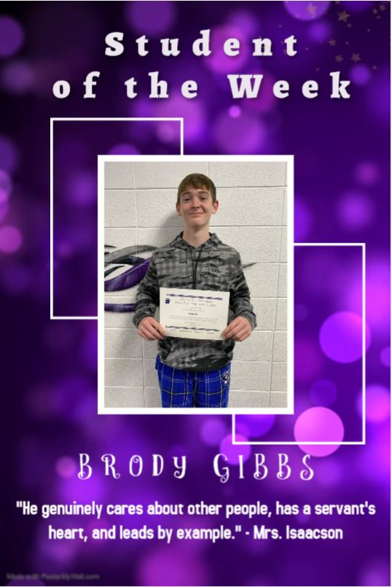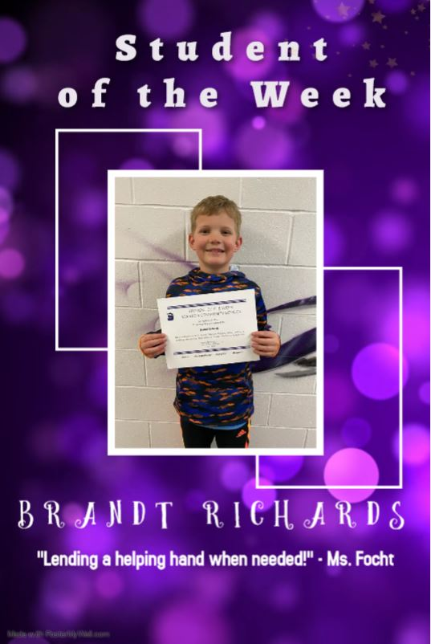



It is the policy of the Stanton Community School District not to discriminate on the basis of race, color, national origin, sex, disability, religion, creed, age (for employment), marital status (for programs), sexual orientation, gender identity and socioeconomic status (for programs) in its educational programs and its employment practices. There is a grievance procedure for processing complaints of discrimination. If you have questions or a grievance related to this policy, please contact Mrs. Sheila Mainquist, 605 Elliott St., Stanton, Iowa 51573, smainquist@stantonschools.com, (712) 829-2162.

