STANTON COMMUNITY SCHOOL APRIL 29, 2022

Join our team! We’re hiring for the 2022-2023 school year:

- K-12 Music Teacher
- K-12 Part Time TAG Teacher
- K-12 Certified Teacher Librarian
- JH Girls Basketball Coach
- Concession Stand Manager
- Cheerleading Sponsor
- Temporary summer mowing and grounds maintenance
- Temporary summer custodial assistant

To apply for any of these positions, please go to www.teachiowa.gov, or contact Mrs. Elwood at kelwood@stantonschools.com or 712-829-2162.

SCHOOL ACTIVITIES
State FFA
Over 6,600 FFA members, advisors, and guests attended the 94th Iowa FFA State Leadership Conference in Ames, Iowa, April 10th–12th. Thirteen Stanton FFA members, one advisor and 20 guests represented our community at the event. On Sunday night students registered and set up their Chapter Activity Display which was designed by Leah Sandin and built by John Peterson. The Chapter Activity Display received a bronze at state.
Monday, students attended various tours, connected with others at the Career Show and watched a number of Leadership Development Events. Students were also able to participate in the Meals from the Heartland Service Project. As part of their service they helped package a protein rich mixture in bags for distribution. These meals will help people both in the U.S. and abroad. Allie Sandin and Leah Sandin served as our Chapter Delegates during the Business Session. During the 1st General Session, Ashley Henneman and Allie Sandin were presented with the new Stanton FFA Charter. The Honorary Iowa FFA Degree was awarded to Mrs. Andrea Spencer.
During the 2nd General Session, on Tuesday, April 12th, Ashley Henneman was presented her Agricultural Education Proficiency Award by Dr. Michael Retallick on behalf of the Agricultural Education Studies department at Iowa State University. Ashley was named the state winner in this proficiency award area. During this session Ashley was also recognized as a State FFA Officer Candidate and recognized on stage for her commitment to teach agricultural education. After the session, Ashley was recognized at the Teach Ag Signing Day event and was an honored guest at the Proficiency Award Luncheon.
Ella Peterson and Clark Spencer were both recognized on stage during the 3rd General Session. Both students completed the 100 question Greenhand Quiz covering FFA history, parliamentary procedure, and general FFA knowledge. Both were awarded medallions for placing in the top ten. Ella placed third and Clark placed fifth overall.
Stanton FFA had five students receive their Iowa FFA Degree during the 4th General Session. Congratulations to our seniors who earned their degrees – Slade Graham, Carston Johnson, Ashley Henneman, John Peterson, and Allie Sandin. To earn their Iowa FFA Degrees students had to invest over 375 hours of work outside of classroom instructional time, complete 25 hours of community
service, document skills obtained and have active participation in and above the local Chapter.
2022 Junior/Senior Prom
The Junior Class has been busy planning the big night of prom for the past several months. Prom will be held this Saturday evening, April 30th. This year, prom will be held at the Old Lumber Yard. Prom Walk-In will begin at 5:30 p.m. at the intersection of Thorn Street and Broad Avenue (Main Street). Everyone is invited to watch walk-in. Please feel welcome to bring a lawn chair (there will not be bleachers!) to watch as the Juniors and Seniors and their dates make their entrance for Prom 2022. The Prom King and Queen will be crowned immediately following the Walk-In. Julie Strickland of Strickland Photography will take pictures following the crowning of King and Queen at the Lewellen Photograpy building. Class pictures will be taken first followed by couple pictures. We ask that no parents, siblings or friends are in the picture area when the couples are being photographed. Parents are invited to mingle on Main Street from 6:15 to 6:50 to take pictures of their prom goers. The meal at the OLY will be served at approximately 7:00 p.m. with the dance to

begin at 8:00. We ask that only prom-goers and invited guests are in OLY at this time. At 10:30, students will be bused to the high school for after-prom activities which will conclude the evening. The Juniors and Seniors are looking forward to a fun-filled and safe evening and hope to see you all at walk-in!
Stanton’s Kindergarten Round-Up
Stanton Elementary School will conduct kindergarten assessments on Friday, May 6th, for any child who will be five years of age on or before September 15, 2022.

On Thursday, May 5th, parents of incoming kindergarten students will meet at 5:30 in the elementary concourse. Our kindergarten teacher, Ms. Henneman and our principal, Mrs. Elwood will present information about the kindergarten curriculum, school policies, etc. Mrs. Melissa Mixan, the school nurse, will also be present to go over health requirements and paperwork needed for incoming kindergarten students. At this time, parents will sign up for a time to return the following day, May 6th, with their child for the Kindergarten screening. The screening process and follow-up with parents should take approximately 20-25 minutes on this date. Registration forms will be sent home with pre-school students the week before the assessment date. We ask that the paperwork in the packets be returned on the screening date of May 6th. We will also require that a current record of immunizations and a copy of the student’s birth certificate be provided on May 6th.
Please call Jody at the elementary office at 829-2171 as soon as possible to sign up your child for Kindergarten Round-Up and to answer any questions you might have regarding the format for the
above dates. If your child will begin kindergarten in the fall and does not currently attend the local pre-school, we ask that you call the
above number prior to April 29th so that your child can be added to our student list.
Kindergarten Students Reminder
Reminder: There will be NO class for Kindergarten students only Friday, May 6th due to Kindergarten Round-Up! Ms. Henneman will be screening the incoming kindergarten class for next school year on this date. Class will resume as normally scheduled on Monday, May 9th for the kindergarteners. We appreciate your understanding of this schedule change.

ATHLETICS
Viqueen Track
The Viqueens have been very busy on the track. The girls competed in the CAM meet which was held at Atlantic on the 19th and the weather shortened Southwest Valley meet on the 21st. The Viqueens scored 158 points to win the Essex meet on Monday night. On Tuesday night the girls scored 75 points at their meet at Fremont-Mills. Last night the team traveled to compete against a very tough group of teams at Griswold. The girls keep showing improvement as they work towards the Corner Conference meet which will be held Tuesday, May 3rd, at Fremont-Mills.
Viking Track
The HS boys' track team is beginning to show signs of more records to come. Performances are improving and so is the competition! Jackson Roberts will be competing today at the Drake Relays in the high jump. Last year at the state meet he broke James Stephens' record set 33 years ago! This season Jack broke his own record eclipsing the 6' 4" mark. The shuttle hurdle relay is currently in the top 25 in 1A and the 800m and 4x400 are continuing to improve! A busy week the past week with 3 meets (Essex, FM, and Griswold). Next Tuesday is the Corner Conference meet in Tabor followed by a meet at SW Valley, Corning on Thursday night. Go Vikings!
Junior High Girls Track
The Stanton Junior High girls track team competed in their first meet of the season on Thursday, April 21st. The team scored 102 points and placed second overall in the six team meet. Placings in the field events were as follows: Long Jump–Meredith Roberts (3rd), Lilly Ford (4th). High Jump–Kennedy King (4th), Addy Gettler (5th). Shot Put– Adrian Haynie (4th) and Discus–Corinne Hopf (5th). Britney Silva raced to a first-place finish in the 100m dash and Lilly Ford placed fifth in the 200m dash. Meredith Roberts placed third in the 400m while also coming away with second place in the 800m. Jasmine Osher placed third in the 1500m in her first time time running the event. Addy Gettler placed third in the 100 meter hurdles while Kennedy King placed third in the 200m hurdle event. The Shuttle Hurdle team of Lilly Ford, Kennedy King, Addy Gettler and Britney Silva raced to a first place finish and the 4 x 100 relay team (Ford, Gettler, Roberts, Silva) finished in second place. The Distance Medley team (Osher, Valdez, Hopf, Valdez) placed third in the event. The 4 x 200 team (King, A. Valdez, Hopf, Maranville) and the 4 x 400 team (Maranville, Hopf, T. Valdez, Osher) finished in fourth. The Sprint Medley Team (Maranville, Haynie, Valdez, Valdez) placed in 5th. Overall, it was a strong first effort for the girls this season! The team travels to Essex on Thursday and are scheduled to be in action in Tabor on Friday of this week.
SOFTBALL INFO
6th-12th grade girls Softball open gym will be on Sunday, May 1st. We will be outside on the softball field if the weather permits. This is for all girls in 6th-12th grades.
- Here is the tentative schedule:
- 2:45pm-3:30pm – Pitchers and Catchers
- 3:30pm-4:30pm – Everyone else
- Parent/Player meeting at 4:35pm in the high school concourse
HS Softball practice for 7th-12th grade girls starts on Monday, May 2nd. The practice schedule and game schedule is on Varsity Bound. Monday, May 2nd, practice will be from 6:00 p.m.-7:30 p.m. at the softball field, Tuesday, May 3rd, practice will be in the AM from 6:15 a.m.-7:30 a.m. location TBD. The girls will receive a copy of the schedule next week sometime.

GUIDANCE
Scholarships
Good Samaritan Society Healthcare or Spiritual Ministries Scholarship April 30
Pearl Hull Falk Scholarship – May 1

ANNOUNCEMENTS
Swedish School
Svenska Skolan (Swedish School) is being offered at the Stanton Heritage & Cultural Center June 13-17 from 9:00-12:00 a.m. The class is open to children who have completed 1st through 6th grade. A $10.00 fee will be charged to cover the cost of materials. Call Yvonne Johnson at 586-4504 to register.
The curriculum will include beginning language, culture, songs, dances, games, and arts and crafts. The children will participate in the Midsummar activities on June 18th.
SW Iowa REC Job
SW Iowa REC is looking for summer help to assist our line crews in Corning, Mount Ayr, and Stanton. If interested, please stop in or call to request an application. The applicant must be at least 18 years old. The job is only for the summer months of 2022. For more information-please call 888-220-4869 and press option #1 for Corning, option #2 for Mount Ayr or option #3 for Stanton.

COMING EVENTS
Friday, 29th 4:00-Junior High Track at Fremont-Mills
Saturday, 30th Jr/Sr Prom
Tuesday, 2nd 4:00-High School Girls/Boys Conference Track
at Fremont-Mills
Wednesday, 4th 9:30-Corner Conference Golf at Sidney
1:05/1:15-Early dismissal
Thursday, 5th 1:00-Scholarship & Awards Program
4:30-High School Boys Track at SW Valley
5:30-Kindergarten Round-Up Parent Meeting
Friday, 6th Kindergarten Round-Up
There be NO School for the Kindergarten class
4:15-Junior High Track at SW Valley
State Large Group Music Festival at Atlantic

BREAKFAST MENUS MAY 2-6
Monday  Cereal  Muffin/Fruit  Juice/Milk | Tuesday  Mini Pancake & Sausage  Muffin/Fruit  Juice/Milk | Wednesday  Oatmeal Bar  Muffin/Fruit  Juice/Milk | Thursday  Breakfast Bar  Muffin/Fruit  Juice/Milk | Friday  Donut Holes  Muffin/Fruit  Juice/Milk

LUNCH MENUS MAY 2-6
Monday  Rib/Hot Dog  Potato Smiles  Baked Beans  Fruit Medley  Applesauce  Milk | Tuesday  Chicken Fajita  Corn  California Vegetables  Peaches  Mandarin Oranges  Milk | Wednesday  Sloppy Joe  Baked Beans  Cheesy Broccoli  Mixed Berries  Pineapple  Milk | Thursday  Breakfast Pizza  Hashbrown  Juice  Tropical Fruit  Pears  Milk | Friday  Walking Taco  Corn  Lettuce  Apple Slices  Mixed Fruit/Goldfish  Milk

Menus Subject to Change

MS/HS STUDENT OF THE WEEK ELEMENTARY STUDENT OF THE WEEK 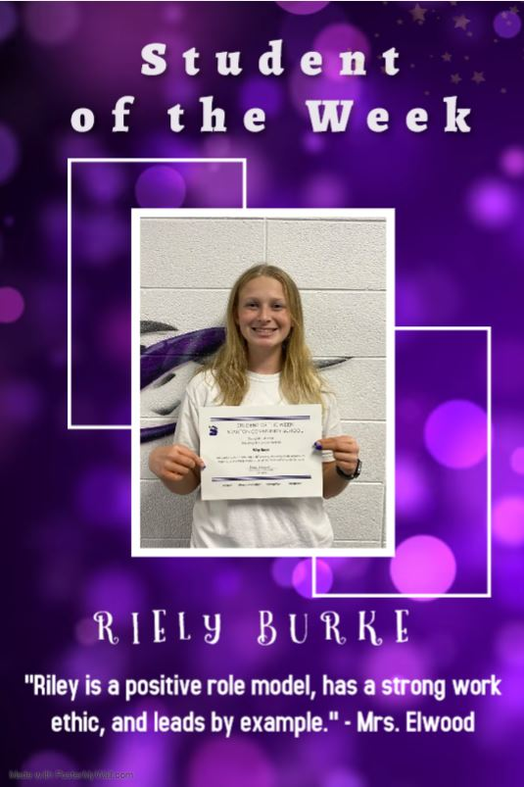 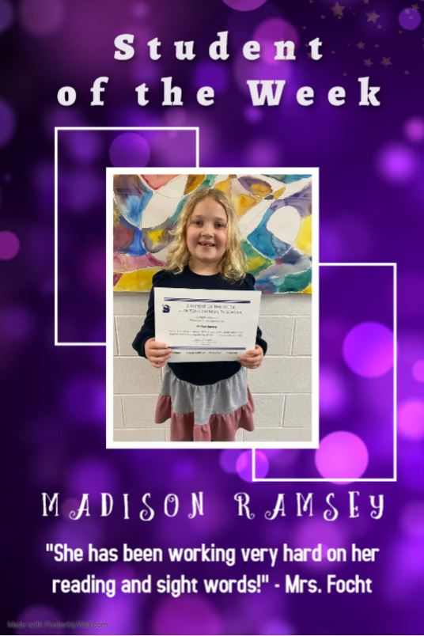

It is the policy of the Stanton Community School District not to discriminate on the basis of race, color, national origin, sex, disability, religion, creed, age (for employment), marital status (for programs), sexual orientation, gender identity and socioeconomic status (for programs) in its educational programs and its employment practices. There is a grievance procedure for processing complaints of discrimination. If you have questions or a grievance related to this policy, please contact Mrs. Sheila Mainquist, 605 Elliott St., Stanton, Iowa 51573, smainquist@stantonschools.com, (712) 829-2162.

