STANTON COMMUNITY SCHOOL APRIL 1, 2022

SUPERINTENDENT
Dear Parents/Guardians;

These last two-plus years have been a grind with COVID mitigation strategies, decisions, and the unknown. It has been a pleasant winter in regards to zero-missed school days due to inclement weather. With that in mind, and after visiting with school board members, we are planning to add a day to our upcoming spring break on Wednesday, April 20th. This means we will get out of school Thursday, April 14^{th,} at 1:05/1:15 p.m. and NO school from Friday, April 15th through Wednesday, April 20th. School will resume on Thursday, April 21st. This is intended as a thank you to everyone for staying with us on the challenging journey. We know nothing about it was perfect, but hopefully, we are near the end. We will not plan to make this day up.
Sincerely,
David Gute, Superintendent

SCHOOL ACTIVITIES

Iowa FFA Agriscience Fair

Congratulations to the Stanton FFA students that participated in the Iowa FFA Agriscience Fair in Ames, Iowa last Thursday. Alice Duckett and Marissa Strough presented a team project titled “Perceptions of Food Product Labels.” Their research placed first in the category of Social Systems in Division 6 (11th and 12th grade teams). They will be able to submit their paperwork to be considered for the National FFA Agriscience Fair held in Indianapolis, Indiana this October.
Clark Spencer placed second in the category of Food Products and Processing Systems in Division 3 (9th and 10th grade individuals). He presented his project entitled, “Tangzhong Technique to Improve Heritage Bread Roll Shelf Life.
These students also participated in the State Science + Technology Fair of Iowa (SSTFI) which is held together with the Iowa FFA Agriscience Fair. Clark earned 3rd place in the Chemistry category at the SSTFI.
Mills-Montgomery County Cattlemen's Banquet
Three Stanton FFA members attended and assisted at the Mills-Montgomery County Cattlemen's Banquet this past weekend. Ashley Henneman, Dacey Henneman and Ella Peterson helped with serving the meal and presenting baked goods prepared by our members at the auction. Auction funds will come back to the Chapter in support of FFA activities and scholarships. Thank you to our County Cattlemen for their support!

GUIDANCE
Scholarships
Montgomery County Memorial Hospital Auxiliary Scholarship – Postmarked by April 15
Don & Ken Schenck Scholarship Trust – April 15
Ashley and Brooke Maley Memorial Scholarship – April 15
John F. Hossle 4-H / FFA Scholarship – April 15
Mills-Montgomery County Cattlemen’s Association Scholarship - due April 15
Reifel-Ellwood Education Fund - due April 15
Montgomery County Memorial Hospital Employee-Sponsored Scholarship - due April 22
Jim Logan Scholarship – April 20
Iowa Western Community College Foundation Scholarship – due April 22
Good Samaritan Society Healthcare or Spiritual Ministries Scholarship April 30
Pearl Hull Falk Scholarship – May 1

ANNOUNCEMENTS
Booster Club Clothing Sale!
Booster Club is having a sale on their inventory. Items are located in the elementary office and can be purchased during school hours. T-shirts are $10, hoodies are $18, crews are $15, long sleeve tees are $12.
Good Shepherd Christian Preschool Registration
Registration materials for enrolling preschoolers in Good Shepherd Christian Preschool (GSCP) for the 2022-2023 school year are now available. Children from any school district who will be four years old on or before September 15, 2022, are eligible to attend this FREE

preschool program. Registration materials may be picked up at the preschool during class hours or from the Viking Center office, the Stanton Child Resource Center, Stanton Elementary School, or the
Stanton Public Library. The preschool is located on the upper level of the Viking Center which is next door to Stanton Schools. Feel free to contact Janell Frey, preschool director and lead teacher, at GSCPstanton@gmail.com or 712-829-2421 with questions. Registration materials should be turned in ASAP to secure your child’s place.
The Good Shepherd Christian Preschool will be holding a Preschool Exploration Hour for incoming preschoolers and their parents on Monday, April 4th from 6:00-7:00 p.m. or Tuesday, April 5th from 6:00-7:00 p.m. Teachers will be available to answer questions and children will be free to explore the classroom. Registration materials may be picked up or dropped off at that time.
Stanton kicks off 2022 Community Visioning Program
Stanton is participating in the 2022 Iowa’s Living Roadways Community Visioning Program. Community Visioning is a transportation enhancement planning process that serves Iowa communities under 10,000 in population.
The program helps community volunteers envision aesthetic and ecological improvements along roadsides and related landscapes by blending environmental stewardship with community improvement projects. Stanton is one of ten communities selected to participate in this award-winning program.
At its first two meetings, the Stanton visioning committee learned public involvement techniques that they will use in the visioning process to assess local resources and identify community needs. The information gathered will be used to develop a transportation concept plan.
The next step in the process will be a focus group workshop on Saturday, April 9th, from 9:00 a.m.-11:00 a.m. at Stanton Community Schools. Residents will be invited to share their ideas regarding transportation opportunities and needs in Stanton in a small group setting.
The workshop will consist of six focus groups for each of the following demographics: steering committee members, older adults (65 years old and older), those with limited mobility, active recreationists, parents, and children (6 years old and older). Each focus group will take approximately one hour.
To participate in one of the focus groups, go to www.communityvisioning.org/Stanton and click on “Public Input.”
For further information about participating in a focus group or the overall visioning process, please contact us:
Jenna Ramsey, Stanton Community Development Director, (712)829-7340, jramsey@fmtcnet.com
Brad Riphagen, Trees Forever Field Coordinator, (515)370-1291
briphagen@treesforever.org
The Iowa’s Living Roadways Community Visioning Program is sponsored by the Iowa Department of Transportation in partnership with Iowa State University Extension Landscape Architecture and Trees Forever, an Iowa-based nonprofit organization with a mission to plant trees and care for the environment.
2022 Stanton Community Garden

Interested in renting a garden plot at the Stanton Community Garden? Anyone is welcome! Garden plots are rented on a first come basis. These are located just North of the Stanton Community Room/Fire Station. The cost per bed is $15. All gardeners must agree to and abide by the 2022 Stanton Community Garden Gardener’s Agreement. Each gardener will decide on what annual crops to plant. No perennials, please. Water will be on site and provided by the City of Stanton. The Stanton Strivers 4-H Club will have a Pollinator Garden in conjunction with the Community Garden. A coalition of volunteers will be tending to a Giving Garden raised bed; all produce will be donated to local food pantries. If you have any extra produce you would like to donate, we would be happy to help coordinate this with you! Contact Kati Seifert at 712-829-2900 or email at vikingcenter@myfmtc.com or Jenna Ramsey at jramsey@fmtcnet.com or 712-829-7340. The Stanton Community Garden is in conjunction with Live Well Montgomery County.

COMING EVENTS
Friday, 1st Elementary Iowa Assessments
4:00-Girls/Boys Golf at Sidney
Monday, 4th 4:00-High School Girls/Boys Golf at Griswold
Tuesday, 5th 4:30-High School Girls Track at Clarinda
Wednesday, 6th 1:05/1:15-Early Dismissal
Thursday, 7th 4:30-High School Girls Track at Red Oak
Friday, 8th 4:30-High School Boys Track at Clarinda
Saturday, 9th State Solo/Ensemble Contest at Lenox

BREAKFAST MENUS APRIL 4-8
Monday  Cereal Bar  Muffin/Fruit  Juice/Milk | Tuesday  Breakfast Sandwich  Muffin/Fruit  Juice/Milk | Wednesday  Oatmeal Bar  Muffin/Fruit  Juice/Milk | Thursday  French Toast  Muffin/Fruit  Juice/Milk | Friday  Breakfast Pizza  Muffin/Fruit  Juice/Milk

LUNCH MENUS APRIL 4-8
Monday  Hamburger/Bun  Potato Smilies  Baked Beans  Mixed Fruit  Cherry Crisp  Milk | Tuesday  Chicken Strips  Mashed Potatoes/Gravy  Cooked Carrots  Oranges/Pineapple  Roll  Milk | Wednesday  Chicken Panini  Lettuce  Celery  Pears  Ice Cream  Milk | Thursday  Beef Fritter  Mashed Potatoes/Gravy  Green Beans  Applesauce/Mixed Berries  Roll  Milk | Friday  Grilled Cheese  Tomato Soup  Tri-Tater  Apple Slices  Mixed Fruit  Milk

Menus Subject to Change

MS/HS STUDENT OF THE WEEK ELEMENTARY STUDENT OF THE WEEK 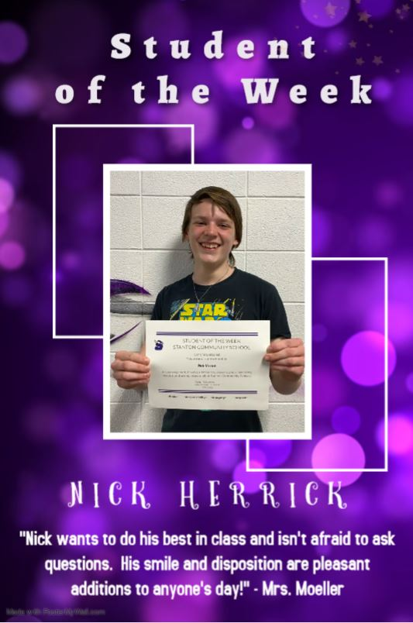 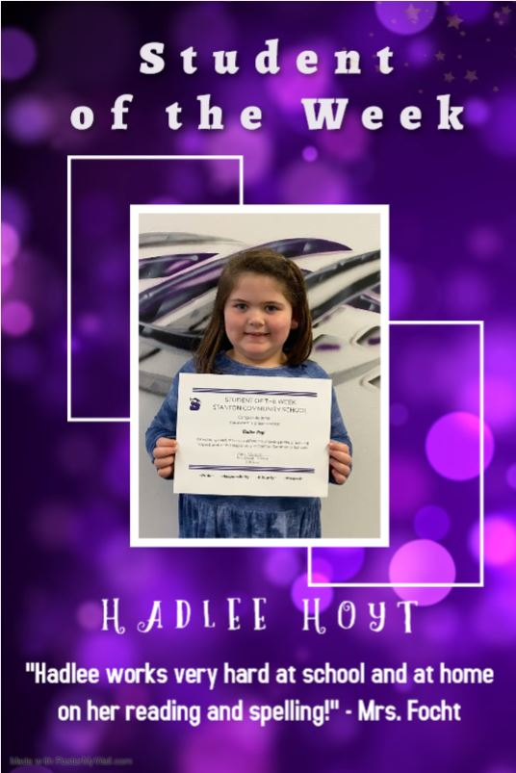



It is the policy of the Stanton Community School District not to discriminate on the basis of race, color, national origin, sex, disability, religion, creed, age (for employment), marital status (for programs), sexual orientation, gender identity and socioeconomic status (for programs) in its educational programs and its employment practices. There is a grievance procedure for processing complaints of discrimination. If you have questions or a grievance related to this policy, please contact Mrs. Sheila Mainquist, 605 Elliott St., Stanton, Iowa 51573, smainquist@stantonschools.com, (712) 829-2162.

