STANTON COMMUNITY SCHOOL MARCH 25, 2022

SUPERINTENDENT
Dear Parents/Guardians;
These last two-plus years have been a grind with COVID mitigation strategies, decisions, and the unknown. It has been a pleasant winter in regards to zero-missed school days due to inclement weather. With that in mind, and after visiting with school board members, we are planning to add a day to our upcoming spring break on Wednesday, April 20th. This means we will get out of school Thursday, April 14^{th,} at 1:05/1:15 p.m. and NO school from Friday, April 15th through Wednesday, April 20th. School will resume on Thursday, April 21st. This is intended as a thank you to everyone for staying with us on the challenging journey. We know nothing about it was perfect, but hopefully, we are near the end. We will not plan to make this day up.
Sincerely,
David Gute, Superintendent

PRINCIPAL
Iowa Statewide Assessment of Student Progress
Our 3rd-5th grade students will be taking the ISASP (Iowa Statewide Assessment of Student Progress) next week (March 28th- April 1st). Just as in our everyday school activities, you can help your child do their best by seeing that he/she is fully rested. Breakfast will be served to all 3rd-5th grade students prior to testing. Please contact Mrs. Elwood or Mrs. Mainquist if you have any questions regarding this statewide assessment.

SCHOOL ACTIVITIES
Conference Quiz Bowl
Stanton hosted the Corner Conference Quiz Bowl on Wednesday, March 9th. Six teams competed with 2 teams from Griswold and Stanton, and 1 team each from East Mills and Fremont Mills.
Congratulations to all teams participating, everyone did a great job! Congratulations to Griswold’s B Team and Griswolds’s A Team on winning their brackets in the Quiz Bowl.
Representing Stanton on the A Team was Amanda Benson, Roary Blair, Tristan Frank, Axel King, and Levi Martin. Stanton’s B Team was made up of Abby Burke, Preston Carpenter, Evan Hopf, Elly McDonald, Addison Olson, and Jenna Stephens.
We would like to thank our “Quiz Masters” who read questions to the students; Charmla Carpenter, Barb Allen and Elitha Bruning. Thank you also to the score keepers and timers; Riley Burke, Keila Franzen, Kyla Hart, Lauren Johnson, James McDonald, Hannah Olson, Simon Showalter, and Devon Taylor.
A big thank you also to staff and students who helped with the event from moving chairs and tables to setting up buzzer systems. We could not have pulled it off without your help!
March Mayhem
March Mayhem starts tonight. The following is the schedule.
Tonight:
Coed Volleyball at 7:00 p.m.
Saturday:
5K Fun Run/Walk at 8:15 a.m.
3 on 3 basketball at 8:40 a.m.
Smoked Brisket sandwiches at 11 a.m.
Slam Dunk Contest at 1:20 p.m.
3-Point Shooting Contest at 1:45 p.m.
Hot Dog Eating Contest at 5:45 p.m.
Dodgeball at 6:00 p.m.
Check us out and sign up to participate either on the school website under "New & Events" or follow us on Instagram at marchmayhem2022. If you have any questions, please do hesitate to contact Mr. Grebin.
Scholastic Book Fair
A great big thank you to all who purchased books making the Scholastic Book Fair a success. The school was able to purchase over $1,000 in scholastic dollars’ worth of books for our school library.

GUIDANCE
Scholarships
Page County Cattlemen Scholarship – due March 30
The Iowa Arts Scholarship for the Arts - due April 1
Professional Educators of Iowa - due April 1
Montgomery County Pheasants Forever Scholarship - due April 1
Ray and Ruth Wallin Scholarship - due April 1
Mamrelund Scholarship - due April 1
Farmers Mutual Telephone Company - due April 1
Montgomery County 4-H County Council Scholarship - April 1

Fremont-Page Corn/Soybean Growers Association Scholarship April 1
Iowa Pork Foundation President’s Scholarship – April 1
Altrusa International Inc. of Red Oak and Altrusa-Nellie Nelson Scholarship - April 2
Meredith Communications Southwest Iowa Scholarship–due April 2

ANNOUNCEMENTS
Good Shepherd Christian Preschool Registration
Registration materials for enrolling preschoolers in Good Shepherd Christian Preschool (GSCP) for the 2022-2023 school year are now available. Children from any school district who will be four years old on or before September 15, 2022, are eligible to attend this FREE preschool program. Registration materials may be picked up at the preschool during class hours or from the Viking Center office, the Stanton Child Resource Center, Stanton Elementary School, or the Stanton Public Library. The preschool is located on the upper level of the Viking Center which is next door to Stanton Schools. Feel free to contact Janell Frey, preschool director and lead teacher, at GSCPstanton@gmail.com or 712-829-2421 with questions. Registration materials should be turned in ASAP to secure your child’s place.
The Good Shepherd Christian Preschool will be holding a Preschool Exploration Hour for incoming preschoolers and their parents on Monday, April 4th from 6:00-7:00 p.m. or Tuesday, April 5th from 6:00-7:00 p.m. Teachers will be available to answer questions and children will be free to explore the classroom. Registration materials may be picked up or dropped off at that time.
Stanton kicks off 2022 Community Visioning Program
Stanton is participating in the 2022 Iowa’s Living Roadways Community Visioning Program. Community Visioning is a transportation enhancement planning process that serves Iowa communities under 10,000 in population.
The program helps community volunteers envision aesthetic and ecological improvements along roadsides and related landscapes by blending environmental stewardship with community improvement projects. Stanton is one of ten communities selected to participate in this award-winning program.
At its first two meetings, the Stanton visioning committee learned public involvement techniques that they will use in the visioning process to assess local resources and identify community needs. The information gathered will be used to develop a transportation concept plan.
The next step in the process will be a focus group workshop on Saturday, April 9th, from 9:00 a.m.-11:00 a.m. at Stanton Community Schools. Residents will be invited to share their ideas regarding transportation opportunities and needs in Stanton in a small group setting.
The workshop will consist of six focus groups for each of the following demographics: steering committee members, older adults (65 years old and older), those with limited mobility, active recreationists, parents, and children (6 years old and older). Each focus group will take approximately one hour.
To participate in one of the focus groups, go to www.communityvisioning.org/Stanton and click on “Public Input.”
For further information about participating in a focus group or the overall visioning process, please contact us:
Jenna Ramsey, Stanton Community Development Director, (712)829-7340, jramsey@fmtcnet.com
Brad Riphagen, Trees Forever Field Coordinator, (515)370-1291
briphagen@treesforever.org
The Iowa’s Living Roadways Community Visioning Program is sponsored by the Iowa Department of Transportation in partnership with Iowa State University Extension Landscape Architecture and Trees Forever, an Iowa-based nonprofit organization with a mission to plant trees and care for the environment.
2022 Stanton Community Garden
Interested in renting a garden plot at the Stanton Community Garden? Anyone is welcome! Garden plots are rented on a first come basis. These are located just North of the Stanton Community Room/Fire Station. The cost per bed is $15. All gardeners must agree to and abide by the 2022 Stanton Community Garden Gardener’s Agreement. Each gardener will decide on what annual crops to plant. No perennials, please. Water will be on site and provided by the City of Stanton. The Stanton Strivers 4-H Club will have a Pollinator Garden in conjunction with the Community Garden. A coalition of volunteers will be tending to a Giving Garden raised bed; all produce will be donated to local food pantries. If you have any extra produce you would like to donate, we would be happy to help coordinate this with you! Contact Kati Seifert at 712-829-2900 or email at vikingcenter@myfmtc.com or Jenna Ramsey at jramsey@fmtcnet.com or 712-829-7340. The Stanton Community Garden is in conjunction with Live Well Montgomery County.

COMING EVENTS
Friday, 25th MS/HS Iowa Assessments
Conference Art Fair at Griswold
March Mayhem
Saturday, 26th March Mayhem
Monday, 28th Elementary Iowa Assessments
Conference Art Fair at Griswold
Tuesday, 29th Elementary Iowa Assessments
Wednesday, 30th 1:05/1:15-Early Dismissal
Thursday, 31st Elementary Iowa Assessments
4:30-HS Girls/Boys Track at Griswold
Friday, 1st Elementary Iowa Assessments

BREAKFAST MENUS MARCH 28-APRIL 1
Monday  Brownie  Muffin/Fruit  Juice/Milk | Tuesday  Pancakes  Muffin/Fruit  Juice/Milk | Wednesday  Breakfast Pizza  Muffin/Fruit  Juice/Milk | Thursday  Biscuits with Gravy  Muffin/Fruit  Juice/Milk | Friday  Donut Holes  Muffin/Fruit  Juice/Milk

LUNCH MENUS MARCH 28-APRIL 1
Monday  Rib/Hot Dog  Baked Beans  Tri-Tater  Mandarin Oranges  Pineapple  Milk | Tuesday  Ham & Potato Casserole  Peas  Green Beans  Peaches  Mixed Fruit  Roll  Milk | Wednesday  Stadium Dog  Chili/Cheese  Potato Wedges  Baked Beans  Strawberries & Bananas  Pears  Milk | Thursday  Chicken Alfredo  Lettuce  California Vegetables  Mixed Fruit  Ice Cream  Breadstick  Milk | Friday  Potato Bar/Hot Dog  Assorted Toppings  Corn  Applesauce  Pears  Milk

Menus Subject to Change

MS/HS STUDENT OF THE WEEK ELEMENTARY STUDENT OF THE WEEK
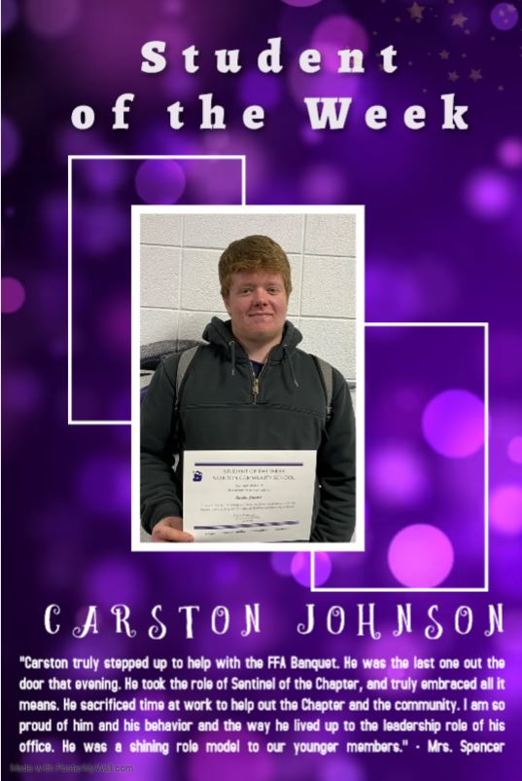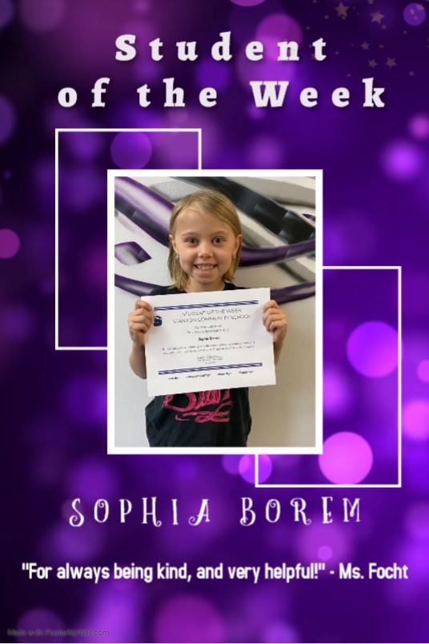



The Stanton Community School District offers career and technical programs in the following areas of study:
Business Education
Agriculture Education
Industrial Education
Family and Consumer Science Education
It is the policy of the Stanton Community School District not to discriminate on the basis of race, color, national origin, sex, disability, religion, creed, age (for employment), marital status (for programs), sexual orientation, gender identity and socioeconomic status (for programs) in its educational programs and its employment practices. There is a grievance procedure for processing complaints of discrimination. If you have questions or a grievance related to this policy please contact Mrs. Sheila Mainquist, 605 Elliott St., Stanton, Iowa 51573, smainquist@stantonschools.com, (712) 829-2162.

