STANTON COMMUNITY SCHOOL MARCH 11, 2022

PRINCIPAL
Iowa Statewide Assessment of Student Progress
Our 6th-11th grade students will be taking the Iowa Statewide Assessment of Student Progress (ISASP) the week of March 22nd- 25th. Our 3rd-5th grade students will be taking the ISASP the week of March 28th-April 1st. While seniors do not take the statewide assessment, they will be taking CPR training during the week of March 22nd. Please note that CPR training is a requirement for graduation. Please contact Mrs. Elwood or Mrs. Mainquist if you have any questions regarding this statewide assessment or the CPR requirement.
Reminders:.
- Parent Teacher Conferences will be held on Thursday, March 17th from 8:00 a.m.-8:00 p.m.
  - Elementary parents, we ask that you please check your email for information on how to sign up for conferences.
  - MS/HS parents, please note that conferences will be in classrooms from 8:00 a.m. to 4:00 p.m., and teachers will be in the library from 4:00 p.m. until 8:00 p.m.
- We will not have school on Thursday, March 17th or Friday, March 18th.

SCHOOL ACTIVITIES
FCCLA/Red Cross Blood Drive
FCCLA/Red Cross Blood Drive will be held on Wednesday, March 16th, in the Viking Center Gymnasium, 8:00 a.m. to 2:00 p.m.
PUBLIC - Please call the school office at 829-2162 or visit RedCrossBlood.org and enter Vikings to schedule an appointment.
STUDENTS - Please stop in the office to make an appointment
By donating blood at the Stanton High School drive, not only are you helping save lives, you are also helping the school earn a scholarship for one or more of their graduating seniors.
All School Play
The Stanton High School actors and actresses will be performing Buckshot and Blossoms by Tim Kelly. The performance has been moved to Monday, March 14th at 7:00 p.m. at the Wilson Performing Arts Center. Please plan on attending the show and supporting the great work of our students! It's a rip-roaring spoof of the Old West sure to delight audiences of all ages. This west is not only wild, it’s hysterically funny! Down at the Trail Dust Hotel, the villainous Whip of the Whip Lash Gang is concocting nasty schemes to rob citizens while his partner-in-crime, Pearl of Pecos, deals marked cards. Meanwhile, the town has a new sheriff, our hero Johnny Wright, also known as “The Fastest Gun in the West.” Alas! The lovely Annabelle Rawlins, the owner, of the mine that Whip is trying to claim as his own, turns up with her campaign against guns inside town limits. She favors blossoms over bullets. We guarantee that you will be rolling in the aisles when The Durango Kid (the meanest gunslinger alive) and the Sheriff play High Noon in the hotel lobby...without a single shot being fired! You’ll find action, comedy, and romance for entertainment that never stops! Heck, there’s even a wedding!
FFA News
SW District FFA Convention was held in Carroll, Iowa on Saturday, March 5th. Congratulations to all the Stanton FFA Members that participated!

Arc Welding: John Peterson-3rd Place, Gold
Chapter Website: Dacey Henneman-Silver
The Chapter Website event is provided to encourage the development of a website to promote the local FFA chapter. It is designed to stimulate the technological implementation of computer skills and webpage design. Dacey created a website for the Stanton FFA Chapter and presented her work.
Experience the Action Tean: Jayden Schwery, Zooey Allen, Clark Spencer, Ella Peterson, and Stephanie Bair -Silver
The Experience the Action event is designed to emphasize the major exciting aspects of Agricultural Education and the FFA. Students work together to develop enthusiastic presentations, which market Ag Ed/FFA. The main purpose is to motivate students to enroll in Ag Ed programs and become FFA members.
Greenhand Quiz: Clark Spencer-Gold, Ella Peterson-Gold, Caden Sallach-Gold, James McDonald-Silver, Adam Benson-Silver
The Greenhand Quiz is an event that is only open to 9th grade students. It tests their overall knowledge of the FFA, FFA Officers, and FFA history.
Academic Achievement Award: Ashley Henneman & Allie Sandin
The Academic Achievement Award is given to students who are currently seniors, have been enrolled in an Agricultural Education class for at least three years, and have a cumulative GPA of 3.5 or higher.
Ashley Henneman received her Retiring Officer plaque for her year of dedicated service as the SW District FFA Secretary.
March Mayhem
The Mayhem is back in 2022! The last weekend of March things will kick off with volleyball Friday night, March 25th. Events planned so far: 5K Fun Run/Walk, 4 divisions of Co-ed volleyball, 6 divisions of 3 on 3 basketball, 1 division of dodge ball, 3 divisions of 3-point shooting contest, 1 division of slam dunk contest, and of course, a super concession stand in HS concourse. Check us out and sign up on the school website under "New & Events" or follow us on Instagram at marchmayhem2022.
Scholastic Book Fair is Coming
The Scholastic Book Fair is coming and will be held Monday, March 14th-Thursday, March 17th. Come and visit the fair during Parent/Teacher Conferences, or after school until 3:45 p.m. Our goal is to encourage all students to read.
Elementary Musical
Join Stanton’s kindergarten through third grade students on Friday, March 11th, for a rollicking western musical adventure entitled “Yee-Haw!” You will see what it really takes to be a cowgirl and cowboy here in Stanton, Iowa. There is horseback riding, chores, and of course you can’t forget a good old fashioned ghost story from the wild west. Their performance will begin at 6:00 p.m. at The Wilson Performing Arts Center in Red Oak. Admission is $5 for adults and $3 for students.
The fine town of Hamelin has been overrun with rats! The townspeople are looking to the mayor and his town council to solve the problem. They have tried setting traps and even playing loud music but still they cannot get rid of their rodent problem. When they are at their wits end, a strange man from a mystical land appears with a pipe claiming he can get rid of the rats. Will he rid Hamelin of their rats for good or is Hamelin doomed forever? Come join Stanton’s fourth through sixth grade students on March 11th and find out. Their performance of “Rats! The Story of the Pied Piper” will begin at 7:00 p.m. at The Wilson Performing Arts Center in Red Oak. Admission is $5 for adults and $3 for students.

GUIDANCE
LOCAL STANTON SCHOLARSHIPS - due March 14
Double Dozen Scholarship-Academics, character, leadership and potential for growth and success.
Duane Falk Scholarship-Based on academics, leadership, and participation in school and community activities. Number and amount designated annually.
Larmon Scholarship-Based on academic excellence and achievement in school and community activities. Number and amount designated annually.
American Legion Scholarship-Sponsored by the American Legion and Legion Auxiliary. Based on academic and leadership accomplishments.
National Honor Society Scholarship-One member---one non-member. Based on classes taken and grades. $100.00 each
Stanton Faculty and Administrators Scholarship-Must be going into an education field.
Stephanie (Peterson) and Christopher Stein Scholarship-Must be attending Iowa State University. Based on moral character, attitude, leadership, activities in school, and community service. Number of scholarships designated annually. $500
The Stephanie (Peterson) and Christopher Stein Scholarship was established in the spring of 2001 in memory of Stephanie (Peterson) and Christopher Stein. Stephanie was a 1991 graduate of Stanton High School. Stephanie and Christopher were 1996 graduates of Iowa State University.
1. The scholarship(s) shall be awarded to graduating seniors of Stanton Community Schools.
2. Applicants shall pursue a four-year degree at Iowa State University.
3. Applicants will submit a local scholarship application, which includes a written letter containing personal information, post-secondary education plans, and the need for the scholarship.
4. Applicants shall have been accepted at Iowa State University and plan to attend in the fall of the current year.
5. Applicants shall be judged as follows:
50% Good moral character, attitude, and leadership
50% Activities in school and community service
Special consideration will be made for students majoring in entomology.
Ashley and Brooke Maley Memorial Scholarship-Amount to be determined yearly. Open to all senior students. Students may be pursuing any type of post-secondary education.
Class of 1963–One scholarship given to a graduating senior from Stanton Community High School. Students may be pursuing any type of post-secondary education.
Stewart Sisters Scholarship-As alumnae of Stanton H. S., Shauna, Shalée, and ShaRee value the education they received here and feel it is important to give back. Based on academics, leadership, and participation in school and community activities. Open to graduating high school seniors. Submit a local scholarship application. Number and amount designated annually.
Sherie Goodemote Wistrom Memorial Scholarship-One $250 music or medical (nursing) related scholarship will be given. In order to receive the scholarship, you must be a graduating senior from Stanton Community High School, you will need to maintain a grade point average of 3.0 and be registered for college the following semester.
Robert E. Johnson Memorial Scholarship-Based on academics, leadership, and participation in school and community activities. $500
Myrna Johnson Memorial Scholarship-Based on academics, leadership, and participation in school and community activities. $500
Brooke Engstrand Scholarship-The Brooke Engstrand scholarship established in the spring of 2013 is intended for seniors planning to further their education in a 4-year or 2-year college program, or a technical school. Brooke had a passion for music and making the most of her life and the opportunities she was given.She was involved in many activities while a student at Stanton Community School, both in and out of school. Her love of horses and for others filled her life with joy and fulfillment. Brooke graduated in 2008 from Stanton High School. The number and amount of scholarships will be determined yearly. Scholarships go to a graduating senior. Submit a local scholarship application, including a letter with personal information, post-secondary education plans, and need for this scholarship.
Stanton Masonic Tarkio Lodge #645 A.F.& A.M. Scholarship Endowed Fund-This scholarship was established in 2018. The scholarship shall be awarded to a graduating senior of Stanton Community Schools. Applicants will submit a local scholarship application and will include a written letter containing personal information and post-secondary education plans. Based on: Integrity, citizenship, leadership, and participation in school, church, and community activities. Amount to be designated annually. The scholarship money will be available in August of the awarded year.
Cassie Rae Williams Memorial Scholarship-Cassie Rae (Gilliland) Williams was a 2005 Stanton graduate, she attended college, and went out to explore the world. When it came time to raise her family she returned to Stanton. She joined several committees and organizations giving back to the community she loved. Cassie was taken tragically in an automobile accident in 2019. In her spirit of giving back this scholarship has been established in her memory. The number of scholarships and amounts awarded will be determined on a yearly basis. Scholarships go to a graduating senior. Submit a local scholarship application, including a letter or essay with personal information, and post-secondary education plans.
Michelle Mead-Salley Scholarship-The Michelle Mead-Salley Scholarship was established in the spring of 2021. Michelle lost a hard-fought battle with pancreatic cancer in January of 2021. Michelle graduated from Stanton Community School in 1990. She went on to further her education at the University of Iowa where she earned her degree in nursing. She loved being a wife, mother, and nurse. She loved life and gave 100% to everything she did. She was known for her knowledge and skill as a nurse and was loved by her patients and the doctors and nurses with whom she worked.
Terms of the scholarship:
-The amount of the scholarship will be determined yearly.
-It is open to all senior students pursuing a post-secondary education.
-Applicants will be judged on their integrity, respect for others, being responsible, and for exhibiting a good attitude.
-Special consideration may be given to students entering the medical field.
-Students are to submit a local scholarship application which includes a written letter giving information including their personal information, post-secondary educational goals, and career plans.
-The scholarship will be given after the student has completed a successful first semester and enrolled in their second semester.

ANNOUNCEMENTS
PTSO Meeting
There will be a Stanton PTSO (Parent Teacher Student Organization) board meeting on Tuesday, March 15th, at 5:30 p.m. in the high school library. Anyone is welcome to attend!

COMING EVENTS
Friday, 11th End of 3rd Quarter
6:00-K-3rd Musical at The Wilson Performing Arts
Center
7:00-4th-6th Musical at The Wilson Performing
Arts Center
Saturday, 12th State Individual Speech Contest at Adel
Monday, 14th 7:00-All School Play at The Wilson Performing
Arts Center
Tuesday, 15th Conference Instrumental Festival at East Mills
Wednesday, 16th NO EARLY DISMISSAL
8:00-2:00-FCCLA/Red Cross Blood Drive
Thursday, 17th NO SCHOOL
8:00-8:00-Parent/Teacher Conference
Friday, 18th NO SCHOOL
Tuesday, 22nd MS/HS Iowa Assessments
Wednesday, 23rd 1:05-1:15-Early Dismissal
MS/HS Iowa Assessments
Thursday, 24th MS/HS Iowa Assessments
7:00-Parade of Bands and Pops Concert
Friday, 25th MS/HS Iowa Assessments
Conference Art Fair at Griswold

BREAKFAST MENUS MARCH 14-18
Monday  Cereal  Muffin/Fruit  Juice/Milk | Tuesday  Donut  Muffin/Fruit  Juice/Milk | Wednesday  French Toast  Muffin/Fruit  Juice/Milk | Thursday  No School  P/T Conferences | Friday  No School

LUNCH MENUS MARCH 14-18
Monday  Stuffed Crust Pizza  Lettuce  Celery  Apple Slices  Peaches  Milk | Tuesday  Chili  Carrots  Pears  Applesauce  Cinnamon Roll  Milk | Wednesday  Chicken Fried Steak  Baked Beans  Sweet Potatoes  Mandarin Oranges  Apricots  Milk | Thursday  No School  P/T Conferences | Friday  Pizza Crunchers  Lettuce  Cauliflower  Applesauce  Ice Cream  Milk

BREAKFAST MENUS MARCH 21-25
Monday  Pop Tart  Muffin/Fruit  Juice/Milk | Tuesday  Biscuit with Gravy  Muffin/Fruit  Juice/Milk | Wednesday  Pancake/Sausage  on a Stick  Muffin/Fruit  Juice/Milk | Thursday  Breakfast Bar  Muffin/Fruit  Juice/Milk | Friday  Cinni-Mini  Muffin/Fruit  Juice/Milk

LUNCH MENUS MARCH 21-25
Monday  French Bread Pizza  Lettuce  Carrots  Pears  Applesauce  Milk | Tuesday  Mashed Potato Bowl  Corn  Mandarin Oranges  Mixed Fruit  Roll  Milk | Wednesday  Chicken Pattie/Bun  Mixed Fruit  Tomato Juice  Fruit Medley  Applesauce  Milk | Thursday  Quesadilla  Corn  Lettuce  Peaches  Mixed Fruit  Milk | Friday  Fish Sandwich  Baked Beans  Waffle Fries  Pineapple  Oranges  Milk

Menus Subject to Change

MS/HS STUDENT OF THE WEEK ELEMENTARY STUDENT OF THE WEEK
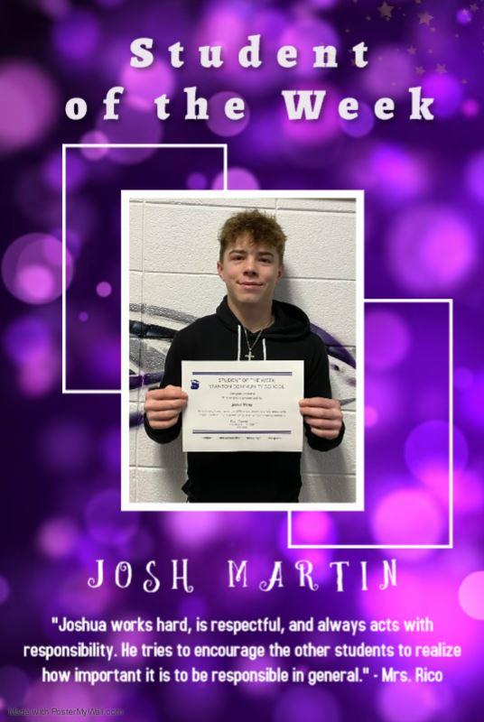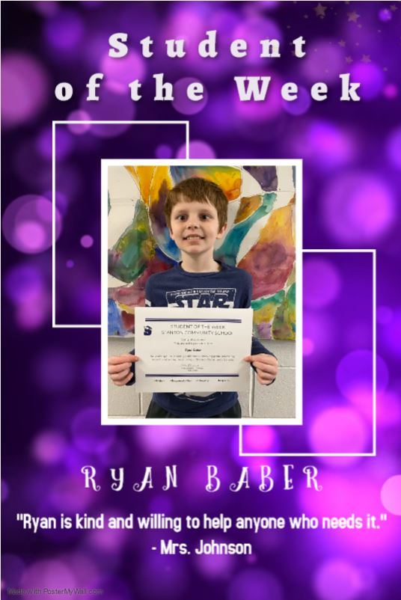



It is the policy of the Stanton Community School District not to discriminate on the basis of race, color, national origin, sex, disability, religion, creed, age (for employment), marital status (for programs), sexual orientation, gender identity and socioeconomic status (for programs) in its educational programs and its employment practices. There is a grievance procedure for processing complaints of discrimination. If you have questions or a grievance related to this policy, please contact Mrs. Sheila Mainquist, 605 Elliott St., Stanton, Iowa 51573, smainquist@stantonschools.com, (712) 829-2162.

