STANTON COMMUNITY SCHOOL FEBRUARY 25, 2022

SCHOOL ACTIVITIES
FCCLA/Red Cross Blood Drive
FCCLA/Red Cross Blood Drive will be held on Wednesday, March 16th, in the Viking Center Gymnasium, 8:00 a.m. to 2:00 p.m.
PUBLIC - Please call the school office at 829-2162 or visit RedCrossBlood.org and enter Vikings to schedule an appointment.
STUDENTS - Please stop in the office to make an appointment
By donating blood at the Stanton High School drive, not only are you helping save lives, you are also helping the school earn a scholarship for one or more of their graduating seniors.
Hydro Dip

Hydro Dipping is a process of accessorizing your personal items by mashing paint together into a cool design. Hydro Drip Inc, a class business at Stanton High School, can do that all for you. To see our amazing designs or to learn more about us visit @shs_hydro_drip on Instagram or email us at hyrdodrip@gmail.com.

Don’t Miss Out
Don’t miss out on the 2022 yearbook as there are only a couple left to purchase. Contact a yearbook staffer to order and pay for your book.

You may also purchase your yearbook online with a credit card. To order online, go to www.stantonschools.com and click on the link that you see pictured above. That will take you to shopjostens.com where you can purchase your book.
Regardless of which method you use to order, the book has lots of film worthy moments that the staff has worked very hard on so don’t miss out on a great “LIFE, CAMERA, ACTION” book about Stanton High School.
Individual Speech
On Wednesday, February 23rd, the Stanton High School speech students traveled to South Page Community School. The Corner Conference Speech Contest started at 1:00 p.m. and it was a great opportunity for our students to have a judged performance before Individual District Speech Contest. We had a nice afternoon refining our pieces and watching the other students in the Corner Conference. The school would like to thank South Page Community School for hosting the event and making it a very successful day!
On Saturday, February 26th, the Stanton High School speech students will venture to Shenandoah High School for Individual District Speech Contest. Please keep a careful watch on the Stanton School's Facebook Page for the performance times. The times keep adjusting as the week goes on, but we will do our best to share to most up-to-date information. The following is a list of students and their area(s) of performance:
Dacey Henneman - Literary Program and Prose
AJ Baker - Literary Program and Poetry
Levi Martin - Acting and Improv
Axel King - Spontaneous Speaking
Preston Carpenter - Radio News
Zooey Allen - Literary Program
Amanda Benson - Acting
Mackenzie Rocha - Acting
Good luck to all speech students competing this Saturday at District Contest!
All School Play
All School Play is postponed due to the bleacher project. More information on a date will be coming later.

GUIDANCE
Scholarships
Buick Achievers Scholarship Program – Feb. 27
Montgomery County Farm Bureau Scholarship - due Feb. 26
https://www.iowafarmbureau.com/page/file?path=Files%2Fpage-874%2Fa1215.pdf
Page County Farm Bureau – due Feb. 26
Iowa Farm Bureau Federation Scholarship Program - due Feb. 26
Apply at
https://www.iowafarmbureau.com/page/file?path=Files%2Fpage-874%2Fa1215.pdf
John Deere Scholarship- March 1
John Deere will sponsor 5 $2000

Check it out online at https://www.petersons.com/scholarship/john-deere-company-scholarship-111_192163.aspx
Mark Earl and Esther Ruth Spencer Technical Scholarship (MCEC Technical Scholarships)–due March 1-$1,000
https://grandlodgeofiowa.org/wp-content/uploads/2021/10/MCEC_ScholarshipApplication_2022.pdf
Governor Terry E. Branstad Iowa State Fair Scholarship
-due March 1
https://www.iowacollegeaid.gov/content/iowa-state-fair-scholarship
-four scholarships ranging up to $5000
Iowa Automobile Dealers Foundation for Education Scholarship - due March 1 https://iada.com/about/iad-foundation-for-education/for-students/
Aureon - Formerly NETINS – March 1
https://www.aureon.com/eventpages/aureon-scholarship-program/
ACACIA Leadership Scholarship - due March 1
www.isuacacia.org
Southwest Iowa Rural Electric Cooperative Scholarship–March 1
-$500 scholarships
-application may be downloaded at https://www.swiarec.coop/scholarships
NTCA Foundation for Rural Services Scholarship Program
–due March 5 https://www.frs.org/programs/youth-programs/scholarships/faqs
Communications Alliance Scholarships March 4

ATHLETICS
Viqueen’s Season is One for the Record Books
The Queen’s season ended in the finals of the Region 8 tournament on Wednesday vs Exira-Elkhorn. Exira won the contest 63-47. Exira opened up red hot from 3-point range going 9-13 in the first half. Coach Dave Snyder said, “We needed to keep pace offensively, while at the same time intensify the defense on the other end.” The shots early on were not falling for the Queen’s which opened up a 31-16 difference by half time. This proved to be the difference in the game as the Queen’s played nearly even in the second half. “We had shots and in a big game you have to make everything count, also in the game of basketball your success often relies on the opponents’ failures, they shot an incredible percentage from 3-point range tonight, something they or any team will not normally do,” said Coach Snyder. The Viqueen’s finish at 24-1 on the season tying a record for highest winning percentage in a season. It was an incredible season, one we all can be proud of.
We want to thank all of those that helped to make this happen, the Administration, clock and score keepers, the fans of the Stanton Community and student body. Thank you for your contributions to our success. We do not graduate a senior from this team, and we look forward to continued success next year.
Viking Basketball
The boys basketball season came to an end with their loss last Thursday to Council Bluffs, St. Albert in the Regional semifinal game. The Vikings ended their season with a record of 15-8. Some highlights from the season include: Corner Conference Tournament Champions, big non-conference win vs CAM, avenging a 38 point loss to Sidney by beating them the next two times, Carter Johnson going over 1,000 career points, and many other small victories throughout the season. We will greatly miss our senior class of Carter Johnson, Jack Roberts, Quentin Thornburg, Levi Martin, Logan Roberts, Tristan Frank, John Peterson, and Ransom Mascher. This senior class was a part of 3 conference championships and had a career record of 67-22. Thank you for your support all season and we look forward to next year. Vikes for life!
Junior High Girls Track
The junior high girls track team will begin practice on Monday, March 7th. The week of March 7th and the week of March 14th, the team will conclude practice at school dismissal time daily (3:23 p.m., 1:15 on Wednesday, March 9th). Beginning Monday, March 21st, the team will practice 8th hour and after school until 4:15 daily. The first track meet for the team is scheduled for Tuesday, April 12th as we host our Jr. Viking and Viqueen Relays at home. A meet schedule will be sent home with those girls who will be participating.

COMING EVENTS
Saturday, 26th District Individual Speech Contest at
Shenandoah
Wednesday, 2nd 1:05/1:15-Early Dismissal
Saturday, 5th District FFA Convention at Carroll

BREAKFAST MENUS FEBRUARY 28-MARCH 4
Monday  Brownie  Muffin/Fruit  Juice/Milk | Tuesday  Breakfast Sandwich  Muffin/Fruit  Juice/Milk | Wednesday  Oatmeal Bar  Muffin/Fruit  Juice/Milk | Thursday  Breakfast Pizza  Muffin/Fruit  Juice/Milk | Friday  Breakfast Boat  Muffin/Fruit  Juice/Milk

LUNCH MENUS FEBRUARY 28-MARCH 4
Monday  Cheesy Pull-Aparts  Lettuce  Celery  Pears  Applesauce  Milk | Tuesday  Chicken Nuggets  Baked Beans/Coleslaw  Pineapple  Oranges  Banana Muffin  Milk | Wednesday  Tuna Noodle Casserole  Peas/Green Beans  Mixed Fruit  Pineapple  Roll  Milk | Thursday  Pork Pattie  Mashed Potatoes/Gravy  Cooked Carrots  Peaches/Apple Slices  Roll  Milk | Friday  Pizzaboli  Lettuce  Carrots  Applesauce  Fruit Medley  Milk

Menus Subject to Change

MS/HS STUDENT OF THE WEEK ELEMENTARY STUDENT OF THE WEEK

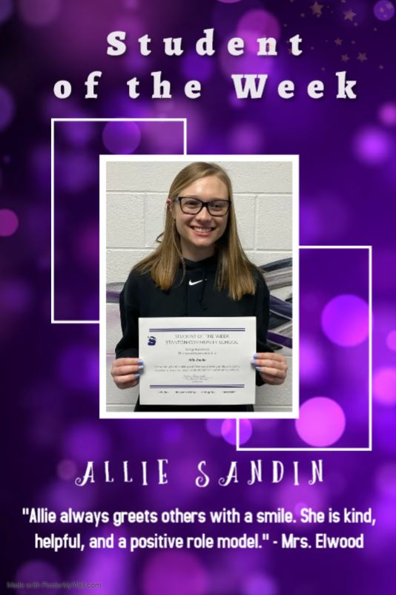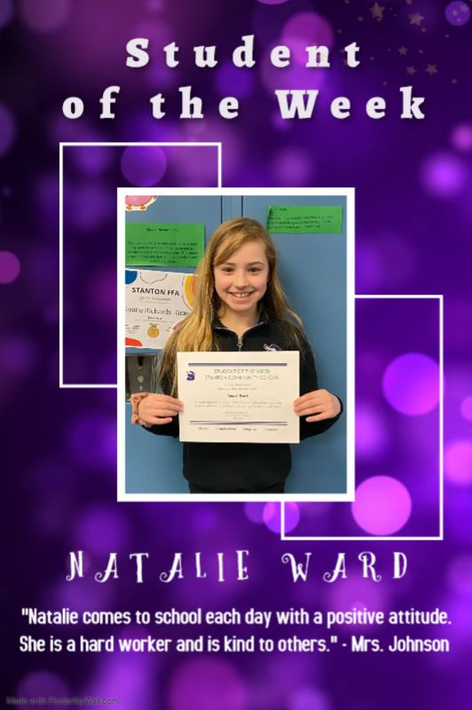

STANTON COMMUNITY SCHOOL
PATRON NOTIFICATION OF
OPEN ENROLLMENT REQUIREMENTS
Parents/guardians considering the use of the open enrollment option to enroll their child/ren in another public school district in the state of Iowa should be aware of the following dates:
March 1, 2022—Last date for regular open enrollment requests for the 2022-2023 school year for students in grades 1-12.
September 1, 2022—Last date for open enrollment requests for entering kindergarten students and those students falling under the “good cause” definition for the 2022-2023 school year.
Parents/guardians of open enrolled students whose income falls below 160% of the federal poverty guidelines are eligible for transportation assistance. This may be in the form of actual transportation or in the form of a cash stipend.
Parents should be aware that open enrollment may result in the loss of athletic eligibility.
For further details, contact the school office at 712-829-2162.

It is the policy of the Stanton Community School District not to discriminate on the basis of race, color, national origin, sex, disability, religion, creed, age (for employment), marital status (for programs), sexual orientation, gender identity and socioeconomic status (for programs) in its educational programs and its employment practices. There is a grievance procedure for processing complaints of discrimination. If you have questions or a grievance related to this policy please contact Mrs. Sheila Mainquist, 605 Elliott St., Stanton, Iowa 51573, smainquist@stantonschools.com, (712) 829-2162.

