STANTON COMMUNITY SCHOOL FEBRUARY 18, 2022

PRINCIPAL
The Stanton Community School District is excited to announce their partnership with TeamMates Mentoring. Stanton TeamMates board members include: Alex Cabbage, Aubrey Dreyer, Katie Elwood, Nick Gray, and Matt King. Our Program Coordinators are Jody Druivenga and Sheila Mainqust.
The TeamMates Mentoring Program began in 1991 with the vision of University of Nebraska Head Football Coach Tom Osborne and his wife Nancy. Coach Osborne felt that the athletes in his program could make an impact on the middle school students, and twenty-two football players began meeting with middle school students in the Lincoln Public Schools. Of the 22 original mentees, 21 went on to graduate from high school while one left school early to pursue a successful Motocross career. Eighteen of the original mentees also obtained some form of post-secondary education.
The program has changed quite a bit since then. We now serve thousands of boys and girls across the Midwest, and our mentors come from all walks of life. One thing, however, remains the same— our mentors just have to be there. It’s that simple. TeamMates is a school-based one-to-one mentoring program that matches screened, trained volunteer mentors with youth in grades 3-12. Mentors and mentees meet once a week at the mentee’s school and focus on building a long-term relationship that ideally lasts until the mentee graduates from high school.
Parents or staff may nominate a student for mentoring, or a student can self-nominate for mentoring. Nomination forms are available in both the elementary and high school offices. Completed nomination forms may be returned to either Mrs. Mainquist or Mrs. Druivenga. Once the district receives a nomination form, parents will also receive a permission form to complete before matches can be made.
We are also looking for community members to become mentors at the school. Mentors and mentees are matched based on similar interests. If you have questions about the mentor eligibility criteria and the information below, please contact either Jody Druivenga, Sheila Mainquist, or Katie Elwood at 712-829-2171. The mentoring application will take approximately 15 minutes to complete at www.teammates.org
Mentor Eligibility Criteria:
To become a TeamMates mentor, you must fulfill all of the following:
- Be 18 years of age
- Have a high school diploma, GED, or equivalent life experience
- Demonstrate a desire to participate in the program and abide by TeamMates Mentoring Program's guidelines, policies, and procedures
- Be able to commit to three years of mentoring with the goal of continuing to mentor a young person through high school graduation.
- Give permission for TeamMates to conduct a periodic criminal background check.

Green Hills AEA will be hosting a symposium called “Grow With Green Hills: From Surviving to Thriving.” Adults, especially parents, are experiencing unparalleled levels of stress. It’s important to prioritize wellness and healthy habits for you and your family. By incorporating the eight dimensions of wellness into your life, you can have a positive impact on the overall health and wellness of your family. The symposium will be held at Riverside High School in Oakland Iowa on August 2nd and 3rd, 2022.

Reminders:
- The Stanton Community School District will not have school on Monday, February 21st.
- There will not be an early dismissal on Wednesday, February 23rd.
- The end of the 3rd Quarter is Friday, March 11th.
- Parent Teacher Conferences will be held on Thursday, March 17th, and we will not have school on Friday, March 18th.

SCHOOL ACTIVITIES
FCCLA/Red Cross Blood Drive
FCCLA/Red Cross Blood Drive will be held on Wednesday, March 16th, in the Viking Center Gymnasium, 8:00 a.m. to 2:00 p.m.

PUBLIC - Please call the school office at 829-2162 or visit RedCrossBlood.org and enter Vikings to schedule an appointment.
STUDENTS - Please stop in the office to make an appointment
By donating blood at the Stanton High School drive, not only are you helping save lives, you are also helping the school earn a scholarship for one or more of their graduating seniors.
Hydro Dip

Hydro Dipping is a process of accessorizing your personal items by mashing paint together into a cool design. Hydro Drip Inc, a class business at Stanton High School, can do that all for you. To see our amazing designs or to learn more about us visit @shs_hydro_drip on Instagram or email us at hyrdodrip@gmail.com.

Don’t Miss Out
Don’t miss out on the 2022 yearbook as there are only a couple left to purchase. Contact a yearbook staffer to order and pay for your book.

You may also purchase your yearbook online with a credit card. To order online, go to www.stantonschools.com and click on the link that you see pictured above. That will take you to shopjostens.com where you can purchase your book.
Regardless of which method you use to order, the book has lots of film worthy moments that the staff has worked very hard on so don’t miss out on a great “LIFE, CAMERA, ACTION” book about Stanton High School.

GUIDANCE
Scholarships
Buick Achievers Scholarship Program – Feb. 27
Montgomery County Farm Bureau Scholarship - due Feb. 26
https://www.iowafarmbureau.com/page/file?path=Files%2Fpage-874%2Fa1215.pdf
Page County Farm Bureau – due Feb. 26
Iowa Farm Bureau Federation Scholarship Program - due Feb. 26
Apply at
https://www.iowafarmbureau.com/page/file?path=Files%2Fpage-874%2Fa1215.pdf
John Deere Scholarship- March 1
John Deere will sponsor 5 $2000
Check it out online at https://www.petersons.com/scholarship/john-deere-company-scholarship-111_192163.aspx
Mark Earl and Esther Ruth Spencer Technical Scholarship (MCEC Technical Scholarships)–due March 1-$1,000
https://grandlodgeofiowa.org/wp-content/uploads/2021/10/MCEC_ScholarshipApplication_2022.pdf
Governor Terry E. Branstad Iowa State Fair Scholarship
-due March 1
https://www.iowacollegeaid.gov/content/iowa-state-fair-scholarship
-four scholarships ranging up to $5000
Iowa Automobile Dealers Foundation for Education Scholarship - due March 1 https://iada.com/about/iad-foundation-for-education/for-students/
Aureon - Formerly NETINS – March 1
https://www.aureon.com/eventpages/aureon-scholarship-program/
ACACIA Leadership Scholarship - due March 1
www.isuacacia.org
Southwest Iowa Rural Electric Cooperative Scholarship–March 1
-$500 scholarships
-application may be downloaded at https://www.swiarec.coop/scholarships
NTCA Foundation for Rural Services Scholarship Program
–due March 5 https://www.frs.org/programs/youth-programs/scholarships/faqs
Communications Alliance Scholarships March 4

ATHLETICS
Viqueen Basketball
The 1st round of Regionals matched the 2nd seeded Viqueen’s vs 15th seeded Orient-Macksburg. The Queen’s wasted little time building a comfortable lead, ending the night with a running clock.
Coach Dave Snyder said, “We were able to play everyone and rest our starters due to the big first half.” By half the Queen’s had a commanding lead at 44-13. The dominate team performance included 21 offensive rebounds and 35 total boards and 15 total steals.
The 2nd round of Regionals pitted Stanton vs Fremont-Mills for the 4th time this season. “This was a unique situation and having some shooting woes did not help,” said Coach Snyder. Fremont-Mills was able to hang with Stanton, a team that the Queen’s had beaten three times this season. Coach Snyder said, “Fortunately our defense was solid from start to finish.” The Queen’s would hold the Knights to 16% shooting including 1-19 from 3-point range in the game. The low scoring affair had the Viqueen’s up 19-12 after 3 quarters. FM would cut the lead to three before the Viqueen’s put it away on the free throw line. Stanton would make good on 18 of 25 free throws on the night to help seal the victory. Stanton will move on to take on CAM tonight at 7:00 p.m. in Stanton.
Viking Basketball
The Vikings finished their regular season last Friday night with a close loss at Clarinda. The loss moved the Vikings to 14-7 on the year. Following Friday's game, the Vikings began their postseason run with a 55-46 victory over the Lenox Tigers in the District Quarterfinal on Monday night. With the W, the Vikings advanced to play St. Albert last night in Malvern. Thank you for your support and Go Vikes!
Junior High Girls Track
The junior high girls track team will begin practice on Monday, March 7th. The week of March 7th and the week of March 14th, the team will conclude practice at school dismissal time daily (3:23 p.m., 1:15 on Wednesday, March 9th). Beginning Monday, March 21st, the team will practice 8th hour and after school until 4:15 daily. The first track meet for the team is scheduled for Tuesday, April 12th as we host our Jr. Viking and Viqueen Relays at home. A meet schedule will be sent home with those girls who will be participating.

COMING EVENTS
Friday, 18th 7:00-Girls Regional Basketball, Here
Monday, 21st NO SCHOOL
Tuesday, 22nd 7:00-Boys District Basketball at Clarinda
Wednesday 23rd No Early Dismissal
1:00- Conference Speech Contest at South Page
7:00-Girls Regional Final Basketball at Site TBD
Saturday, 26th District Individual Speech Contest at
Shenandoah
7:00-Boys Substate Basketball at Site TBD

BREAKFAST MENUS FEBRUARY 21-25
Monday  NO SCHOOL | Tuesday  Cereal Bar  Muffin/Fruit  Juice/Milk | Wednesday  Cinni Mini  Muffin/Fruit  Juice/Milk | Thursday  Pancake & Sausage  on a Stick  Muffin/Fruit  Juice/Milk | Friday  Donut Holes  Muffin/Fruit  Juice/Milk

LUNCH MENUS FEBRUARY 21-25
Monday  NO SCHOOL | Tuesday  Rib/Hot Dog  Baked Beans  Tri-Tater  Mandarin Oranges  Pineapple  Milk | Wednesday  Grilled Chicken/Bun  Mixed Vegetables  Corn  Tropical Fruit/Applesauce  Chocolate Cake  Milk | Thursday  Mini Corn Dog  Mac & Cheese  Potato Wedges  Green Beans  Mixed Fruit/Apple Slices  Milk | Friday  Pizzaboli  Lettuce  Carrots  Applesauce  Fruit Medley  Milk

Menus Subject to Change

MS/HS STUDENT OF THE WEEK ELEMENTARY STUDENT OF THE WEEK
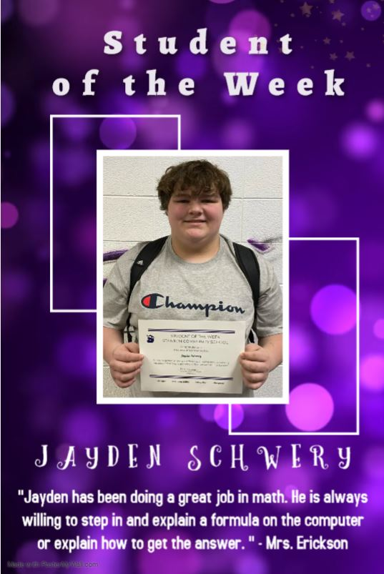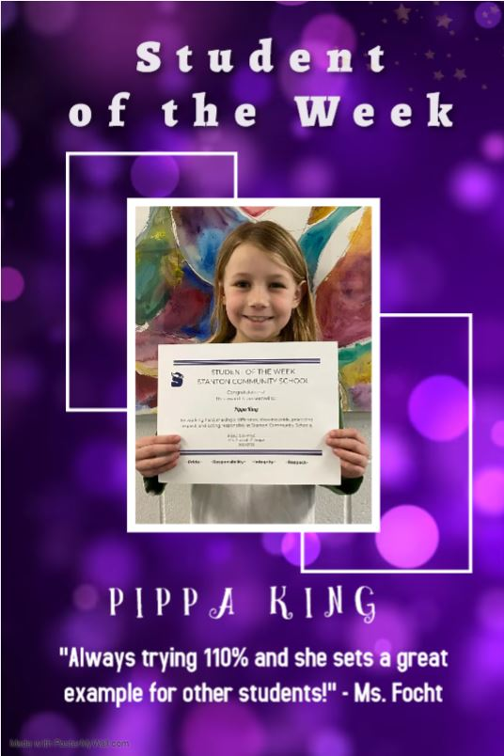

STANTON COMMUNITY SCHOOL
PATRON NOTIFICATION OF
OPEN ENROLLMENT REQUIREMENTS
Parents/guardians considering the use of the open enrollment option to enroll their child/ren in another public school district in the state of Iowa should be aware of the following dates:
March 1, 2022—Last date for regular open enrollment requests for the 2022-2023 school year for students in grades 1-12.
September 1, 2022—Last date for open enrollment requests for entering kindergarten students and those students falling under the “good cause” definition for the 2022-2023 school year.
Parents/guardians of open enrolled students whose income falls below 160% of the federal poverty guidelines are eligible for transportation assistance. This may be in the form of actual transportation or in the form of a cash stipend.
Parents should be aware that open enrollment may result in the loss of athletic eligibility.
For further details, contact the school office at 712-829-2162.

It is the policy of the Stanton Community School District not to discriminate on the basis of race, color, national origin, sex, disability, religion, creed, age (for employment), marital status (for programs), sexual orientation, gender identity and socioeconomic status (for programs) in its educational programs and its employment practices. There is a grievance procedure for processing complaints of discrimination. If you have questions or a grievance related to this policy please contact Mrs. Sheila Mainquist, 605 Elliott St., Stanton, Iowa 51573, smainquist@stantonschools.com, (712) 829-2162.

