STANTON COMMUNITY SCHOOL FEBRUARY 11, 2022

SCHOOL ACTIVITIES
Large Group Speech Contest
The Stanton High School speech students traveled to West Des Moines Valley High School on Saturday, February 5th. It was great to be back in person for the State Large Group Speech Contest. The radio broadcasting group, 8DEZ FM, received an overall mixed Division 1 rating. Their group included Abby Burke, Addison Olson, Allie Sandin, April Vanderholm, Brooklyn Silva, Carli Smith, Jenna Stephens, and Leah Sandin. The radio broadcasting group, GEEK FM, received an overall straight Division 1 rating. Their group included Amanda Benson, Ashley Henneman, Axel King, Dacey Henneman, Elly McDonald, Evan Hopf, Preston Carpenter, and Slade Graham. The radio broadcasting group, FOOD FM, received an overall mixed Division 1 rating. Their group included Ella Peterson, Emma Sallach, Hannah Olson, Kiela Franzen, Kyla Hart, Lauren Johnson, and Riley Burke. We are extremely thankful for the support from our families at this contest! Congratulations to all Stanton High School speech students at the State Large Group Speech Contest that received a Division 1 rating!
FCCLA/Red Cross Blood Drive
FCCLA/Red Cross Blood Drive will be held on Wednesday, March 16th, in the Viking Center Gymnasium, 8:00 a.m. to 2:00 p.m.
PUBLIC - Please call the school office at 829-2162 or visit RedCrossBlood.org and enter Vikings to schedule an appointment.
STUDENTS - Please stop in the office to make an appointment
By donating blood at the Stanton High School drive, not only are you helping save lives, you are also helping the school earn a scholarship for one or more of their graduating seniors.
Hydro Dip

Hydro Dipping is a process of accessorizing your personal items by mashing paint together into a cool design. Hydro Drip Inc, a class business at Stanton High School, can do that all for you. To see our amazing designs or to learn more about us visit @shs_hydro_drip on Instagram or email us at hyrdodrip@gmail.com.

Strength and Conditioning Coordinator
We are pleased to announce the hiring of Mr. Adam Jorgensen as our new Strength and Conditioning Coordinator here at Stanton Community Schools. Mr. Jorgensen will be applying his experience and knowledge in personal fitness and athlete training into workout sessions for our 6th-12th grade students here at Stanton. While Mr. Jorgensen will be working closely with our coaches, we'd like to stress that these sessions are available to all students, not just those who participate in athletics. Sessions are Monday, Wednesday, Friday, mornings from 6:30-7:30 AM as well as Monday, Wednesday, Friday, afternoons from 3:30-4:30 PM. If you have any questions or concerns, please reach out to Mr. Lord, jlord@stantonschools.com
Teammates Mentoring of Stanton
Stanton Community Schools is excited to announce that we have partnered with Teammates Mentoring! If you are interested in making a difference and mentoring at Stanton Community Schools,
please reach out to any of the following individuals for more information:
Jody Druivenga - jdruivenga@stantonschools.com
Katie Elwood - kelwood@stantonschools.com
Sheila Mainquist - smainquist@stantonschools.com

GUIDANCE
Scholarships
World Class, The Mediacom Scholarship Program – February 15 You may download the application at http://www.mediacomworldclass.com/
Conservation District of Iowa and Montgomery Soil and Water Conservation District Scholarships
due Feb 12
scholarship application is online at https://cdiowa.org/
Buick Achievers Scholarship Program – Feb. 27, 2021.
Montgomery County Farm Bureau Scholarship - due Feb. 26
https://www.iowafarmbureau.com/page/file?path=Files%2Fpage-874%2Fa1215.pdf
Page County Farm Bureau – due Feb. 26

Iowa Farm Bureau Federation Scholarship Program - due Feb. 26
Apply at
https://www.iowafarmbureau.com/page/file?path=Files%2Fpage-874%2Fa1215.pdf

ATHLETICS
Viqueen’s Finish Regular Season Undefeated
Lenox came to town Monday to take on Stanton that would prove to be an offensive shootout between two schools that had a combined total of 35 wins on the season. Coach Dave Snyder said, “We set goals for every game and a big part of our game is defense, with our goal being 35 or less points allowed”. By half the idea of holding Lenox to that goal was pretty well exhausted with the Queen’s hanging on to a 26-24 half time lead. “It was very apparent that our ability to score points was going to play a major factor in us winning this game, it came down to us making runs and countering any Lenox scoring run,” said Coach Snyder. And that is exactly how it would play out; Stanton continued to cling to a 2-point lead going into the 4th quarter. During the 4th Stanton would build some cushion behind the efforts of team play that generally ended with a Jenna Stephens bucket only to have Lenox make a late run to tie the game at the end of regulation. In overtime the Queen’s would again have to scramble to cut a 4-point deficient and tie the game at 64 with 3 seconds left. That’s when the late game heroics of Jenna Stephens ended the game with a deep 3 at the buzzer. Coach Snyder said, “The play was set up to go to Jenna, the girls did a great job of improvising for what Lenox’s defense gave us and she made the play.” Jenna would break the school record for scoring in a game with 41 points. Stanton finishes the regular season 21-0.
Viking Basketball
The Vikings ended last week with a 2-2 record as they had wins over Essex and Griswold and fell during road games at Tri-Center and Conestoga. Early this week the Vikings got back on track with a win over Lenox. They will wrap up their regular season with a JV/V game at Clarinda on Friday night and then postseason begins Monday at home vs Lenox. During last weeks game at Tri-Center, Senior, Carter Johnson, eclipsed the 1,000 pts career mark. Thank you for your support and Go Vikes!
Junior Varsity Girls
January 13 –Stanton 54 SWV 10. Lauren Johnson had 21 points, 4 rebounds & 5 assists. Kiela Franzen had 13 points and 1 block. Hannah had 9 points. Carly Roberts had 5 points & 5 assists.
January 27 –Stanton 22 CAM 21. Hannah Olson had 9 points, 5 rebounds & 2 blocks. Riley Burke had 6 points. Carly Roberts had 5 points and Lauren Johnson added 2 points in the win.
January 28 –Stanton 36 Essex 11. Hannah Olson had 18 points. Lauren Johnson had 11 points, 3 assists & 2 steals.
January 31–Stanton 31 Griswold 8. Hannah Olson had 16 points, 7 rebounds, 4 blocks. Lauren Johnson had 10 points, 4 assists & 5 steals.
February 1 –JV Viqueens came up short in OT against FM. Stanton 16 FM 17. Hannah Olson had 7 points, 5 rebound. Lauren Johnson had 5 points 4 rebounds.
February 7 –Stanton 29 Lenox 25. Hannah Olson had 14 points & 5 rebounds. Lauren Johnson had 13 points & 4 rebounds.
The JV Viqueens ended their season with a record of 9-2 with both losses just being by 1 point each game. The girls continue to improve each day and we are looking forward to what the future holds with this team. Congratulations on a great JV season girls.

COMING EVENTS
Friday, 11th 6:00-Junior Varsity/Varsity Boys Basketball at
Clarinda
Monday, 14th 7:00-Boys District Basketball, Here
Stanton vs Lenox
Tuesday, 15th 7:00-Girls Regional Basketball, Here
Wednesday,16th 1:05/1:15-Early Dismissal
Thursday, 17th 6:30-Boys District Basketball at East Mills
Friday, 18th 7:00-Girls Regional Basketball, Here
Monday, 21st NO SCHOOL

BREAKFAST MENUS FEBRUARY 14-18
Monday  Cereal  Muffin/Fruit  Juice/Milk | Tuesday  Donut  Muffin/Fruit  Juice/Milk | Wednesday  Bosco Stick  Muffin/Fruit  Juice/Milk | Thursday  Breakfast Bar  Muffin/Fruit  Juice/Milk | Friday  Bagel Bites  Muffin/Fruit  Juice/Milk

LUNCH MENUS FEBRUARY 14-18
Monday  Pork Chopette/Bun  Baked Beans  Ranch Potatoes  Apple Sauce  Mixed Fruit  Milk | Tuesday  Pizza  Lettuce  Carrots  Applesauce  Pears  Milk | Wednesday  Ham & Cheese Sandwich  Peas  Green Beans  Peaches/Strawberries  Rice  Milk | Thursday  Meat Loaf  Mashed Potatoes  Cooked Carrots  Mixed Fruit  Mandarin Oranges/Roll  Milk | Friday  Chicken Wrap  Mixed Vegetables  Cheesy Broccoli  Oranges  Pineapple  Milk

Menus Subject to Change

MS/HS STUDENT OF THE WEEK ELEMENTARY STUDENT OF THE WEEK

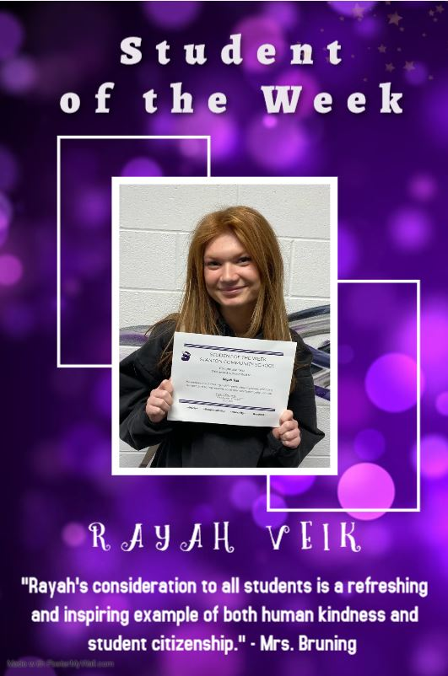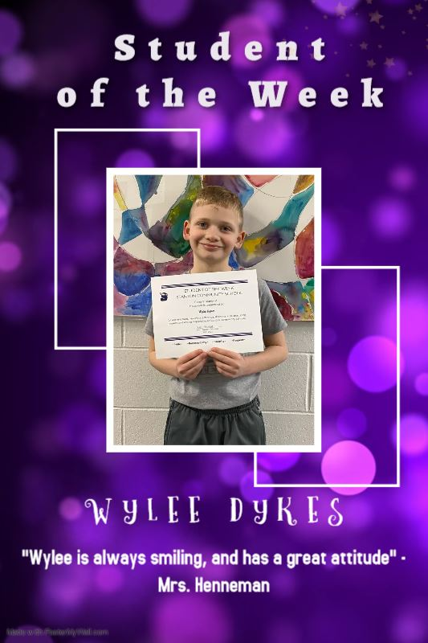

STANTON COMMUNITY SCHOOL
PATRON NOTIFICATION OF
OPEN ENROLLMENT REQUIREMENTS
Parents/guardians considering the use of the open enrollment option to enroll their child/ren in another public school district in the state of Iowa should be aware of the following dates:
March 1, 2022—Last date for regular open enrollment requests for the 2022-2023 school year for students in grades 1-12.
September 1, 2022—Last date for open enrollment requests for entering kindergarten students and those students falling under the “good cause” definition for the 2022-2023 school year.
Parents/guardians of open enrolled students whose income falls below 160% of the federal poverty guidelines are eligible for transportation assistance. This may be in the form of actual transportation or in the form of a cash stipend.
Parents should be aware that open enrollment may result in the loss of athletic eligibility.
For further details, contact the school office at 712-829-2162.

It is the policy of the Stanton Community School District not to discriminate on the basis of race, color, national origin, sex, disability, religion, creed, age (for employment), marital status (for programs), sexual orientation, gender identity and socioeconomic status (for programs) in its educational programs and its employment practices. There is a grievance procedure for processing complaints of discrimination. If you have questions or a grievance related to this policy please contact Mrs. Sheila Mainquist, 605 Elliott St., Stanton, Iowa 51573, smainquist@stantonschools.com, (712) 829-2162.

