STANTON COMMUNITY SCHOOL FEBRUARY 4, 2022

PRINCIPAL
The Stanton Community School District will have a 12:50/1:00 p.m. dismissal on today, February 4th, so that students and staff can attend the HS basketball games at the Mid America Center at 2:30 p.m.
Good Shepherd Preschool in partnership with Stanton Community School is looking for a lead preschool teacher for the 2022-23 school year. Please contact Katie Elwood at 712-829-2162 or kelwood@stantonschools.com with any questions regarding the position.

Our district is experiencing an increased need for substitute and/or activity route bus drivers. Please understand that if we do not have enough drivers, this could impact bus routes and times. We ask that anyone who may be interested in being a substitute driver please contact Mrs. Elwood The district is also currently looking for additional substitute teachers, substitute paras, and substitute kitchen staff. If you are interested in being a substitute for the district, please contact Mrs. Elwood, K-12 Principal, at 712-829-2162 or kelwood@stantonschools.com.

SCHOOL ACTIVITIES
Valentine’s Day
Valentine’s Day is quickly approaching. Please remember the district’s Peanut/Nut Awareness Policy when planning classroom snacks and valentines that your student might be passing out. Reminder: only snacks that are peanut/tree nut free, individually packaged, and contain an ingredient list will be allowed to be passed out. Below you will find a list of candy that is acceptable:
AirHeads Blow Pop Suckers Dots Dum Dum Suckers
Fun Dips Jolly Ranchers Junior Mints Laffy Taffy
Mike and Ikes Nerds Ring Pops Rolos
Skittles Sour Patch Kids Starburst Swedish Fish
Sweet Tarts Tootsie Rolls/Tootsie Pops Twizzlers Whoppers
* Any item that says “manufactured in a factory with peanut/nut products” is not acceptable.
Please contact 712-829-2171 with any questions or further snack suggestions.
Large Group Speech Contest
The Stanton High School speech team will be traveling to West Des Moines Valley High School in West Des Moines this Saturday, February 5th. There are twenty-three students that will be competing in the state large group speech contest. The following are the performance times:
*Center 12/Room 1311-Radio Broadcasting-8DEZ FM 11:55 a.m.
*Center 12/Room 1311-Radio Broadcasting-FOOD FM 12:15 p.m.
*Center 12/Room 1311- Radio Broadcasting-GEEK FM 12:25 a.m.
ALL TIMES ARE AN ESTIMATE. PLEASE PLAN ON ATTENDING BEFORE THE SCHEDULED TIME.
We are excited to be back in person for contest! Please plan on attending the state large group speech contest this Saturday, February 5th.
There are a few "speech norms" with speech culture. Things like- no school apparel in contest centers, questions about ratings are addressed with the coach- not the judge. No entering rooms when doors are closed, hallways need to be kept quiet, no recording performances.
Also, the IHSSA encourages masks for all guests in hallways and performance centers.
FCCLA/Red Cross Blood Drive
FCCLA/Red Cross Blood Drive will be held on Wednesday, March 16th, in the Viking Center Gymnasium, 8:00 a.m. to 2:00 p.m.
PUBLIC - Please call the school office at 829-2162 or visit RedCrossBlood.org and enter Vikings to schedule an appointment.
STUDENTS - Please stop in the office to make an appointment
By donating blood at the Stanton High School drive, not only are you helping save lives, you are also helping the school earn a scholarship for one or more of their graduating seniors.
Lowest Price Yearbook Sales

The 2022 “LIFE, CAMERA, ACTION” $45 yearbook sale has been extended until Sunday, February 6th. This is the lowest price as the book will go up to $60 starting on Monday, February 7th. Contact a
yearbook staffer to order and pay for your book.
You may also purchase your yearbook online with a credit card. To order online, go to www.stantonschools.com and click on the link that you see pictured above. That will take you to shopjostens.com where

you can purchase your book.
You can personalize your yearbook as follows:
Icons (up to 4) for $3.75
One line of personalization for $7.00
Regardless of which method you use to order, the book has lots of film worthy moments that the staff has worked very hard on so don’t miss out on a great “LIFE, CAMERA, ACTION” book about Stanton High School.

GUIDANCE
Scholarships
Elks National Foundation due February 7
Forms available at https://www.elks.org/scholars/scholarweb/legacy/rules.cfm?CFID=117036137&CFTOKEN=cec3990db643bdf-CE84CB82-D3DB-5637-AA13E80D2ABAC867
Iowa Newspaper Foundation Scholarships – due February 11, 2022
applications available at: https://inanews.com/foundation/scholarships/
World Class, The Mediacom Scholarship Program – February 15
You may download the application at http://www.mediacomworldclass.com/
Conservation District of Iowa and Montgomery Soil and Water Conservation District Scholarships
due Feb 12
scholarship application is online at https://cdiowa.org/
Buick Achievers Scholarship Program – Feb. 27, 2021.
Montgomery County Farm Bureau Scholarship - due Feb. 26
https://www.iowafarmbureau.com/page/file?path=Files%2Fpage-874%2Fa1215.pdf
Page County Farm Bureau – due Feb. 26
Iowa Farm Bureau Federation Scholarship Program - due Feb. 26
Apply at
https://www.iowafarmbureau.com/page/file?path=Files%2Fpage-874%2Fa1215.pdf

ATHLETICS
Viqueen Basketball
Victories against Essex, Griswold and Fremont-Mills seal the deal for a repeat regular season championship for the Queens. The Viqueen winning streak reaches 19.
Stanton 61-Essex 27
Stanton 61-Griswold 23
Stanton 56-FM 45
The Queens shot 58% from 2-point range 14-24 and knocked down 16 of 22 free throws for the game.
Stanton 45-CAM 34
The charity stripe proved to be the difference in this one Stanton was 14-16 while CAM was 4-7.
Viking Basketball
The Vikings have been rolling as they knocked off Essex, Griswold, and Fremont-Mills the last 3 games. With the wins, the Vikings are now 13-1 since December 10th. They have a busy slate ahead as they played Tri Center on last night, and also will play Conestoga tonight and Lenox on Monday and wrap up their regular season on February 11th at Clarinda. Thank you for following along and for your support all season. We hope to see the gym packed for any remaining home games. Go Vikes!

ANNOUNCMENTS
Survey
The City of Stanton has partnered with AARP and The University of Iowa to launch a survey for Stanton area residents. The survey link is below and takes around 10 minutes. If you would like a paper copy, please contact Jenna Ramsey at (712)829-7340 or stop by Southwest Iowa REC to get a copy from Marilyn Rubel, City Clerk. Thank you for providing feedback as we continue to move forward in the Stanton Community!
https://bit.ly/SurveyStanton
.



COMING EVENTS
Friday, 4th 12:50/1:00-Early Dismissal
2:30-Varisty Basketball with Conestoga at the
MAC
Saturday, 5th State Large Group Speech Contest at West Des
Moines Valley High School
Monday, 7th 4:00-Junior Varsity Basketball with Lenox, Here
6:00-Varsity Basketball with Lenox, Here
Wednesday, 9th 1:05/1:15-Early Dismissal
Sub District FFA Contest at Clarinda
Thursday, 10th Girls Regional Basketball
Friday, 11th 6:00-Junior Varsity/Varsity Boys Basketball at
Clarinda

BREAKFAST MENUS FEBRUARY 7-11
Monday  Pop Tart  Muffin/Fruit  Juice/Milk | Tuesday  Pancakes  Muffin/Fruit  Juice/Milk | Wednesday  Omelet/Toast  Muffin/Fruit  Juice/Milk | Thursday  Churro  Muffin/Fruit  Juice/Milk | Friday  Waffle  Muffin/Fruit  Juice/Milk

LUNCH MENUS FEBRUARY 7-11
Monday  Hamburger/Bun  Waffle Fries  Baked Beans  Mixed Fruit  Cherry Crisp  Milk | Tuesday  Chicken Strips  Mashed Potatoes/Gravy  Cooked Carrots  Oranges/Pineapple  Roll  Milk | Wednesday  Burrito/Hot Dog  Corn  Tomato Juice  Mandarin Oranges  Apricots  Milk | Thursday  Lasagna Roll-Up  Lettuce  Carrots  Pears/Applesauce  Breadstick  Milk | Friday  Grilled Cheese  Tomato Soup  Tri-Tater  Applesauce  Mixed Fruit  Milk

Menus Subject to Change

MS/HS STUDENT OF THE WEEK ELEMENTARY STUDENT OF THE WEEK
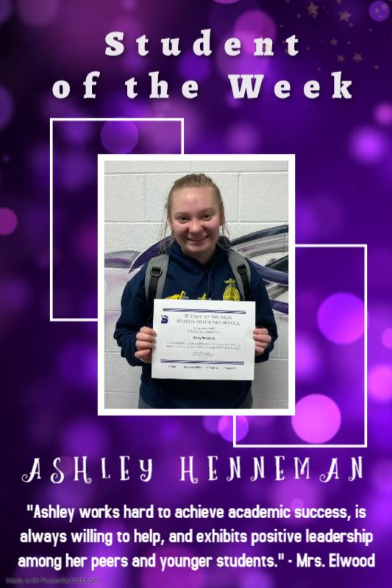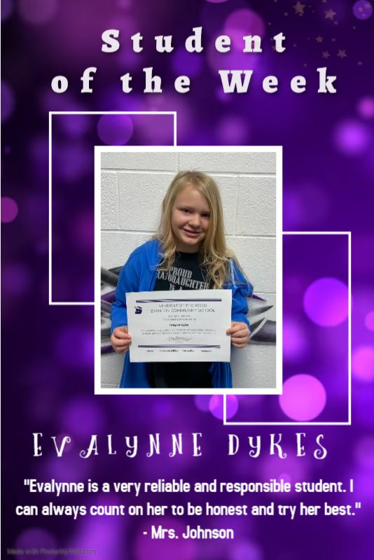

STANTON COMMUNITY SCHOOL
PATRON NOTIFICATION OF
OPEN ENROLLMENT REQUIREMENTS
Parents/guardians considering the use of the open enrollment option to enroll their child/ren in another public school district in the state of Iowa should be aware of the following dates:
March 1, 2022—Last date for regular open enrollment requests for the 2022-2023 school year for students in grades 1-12.
September 1, 2022—Last date for open enrollment requests for entering kindergarten students and those students falling under the “good cause” definition for the 2022-2023 school year.
Parents/guardians of open enrolled students whose income falls below 160% of the federal poverty guidelines are eligible for transportation assistance. This may be in the form of actual transportation or in the form of a cash stipend.
Parents should be aware that open enrollment may result in the loss of athletic eligibility.
For further details, contact the school office at 712-829-2162.

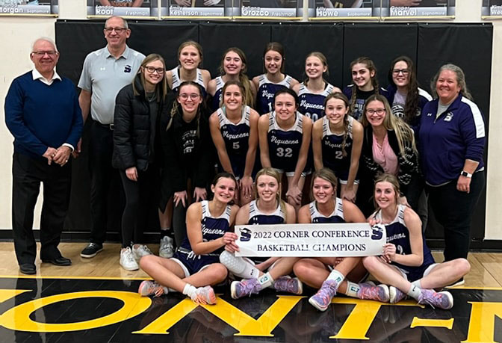

It is the policy of the Stanton Community School District not to discriminate on the basis of race, color, national origin, sex, disability, religion, creed, age (for employment), marital status (for programs), sexual orientation, gender identity and socioeconomic status (for programs) in its educational programs and its employment practices. There is a grievance procedure for processing complaints of discrimination. If you have questions or a grievance related to this policy please contact Mrs. Sheila Mainquist, 605 Elliott St., Stanton, Iowa 51573, smainquist@stantonschools.com, (712) 829-2162.

