STANTON COMMUNITY SCHOOL JANUARY 28, 2022

Please note the following schedule change. On Friday, February 4th, we will have a 12:50/1:00 p.m. early dismissal for all K-12 students. Our HS basketball teams are scheduled to play at 2:30 p.m. at the Mid America Center in Council Bluffs and our dance team will perform at halftime.

SCHOOL ACTIVITIES
District Large Group Speech Contest
The Stanton High School speech students traveled to Abe Lincoln High School on Saturday, January 22nd. It was great to be back in person for district large group speech contest. The radio broadcasting group, 8DEZ FM, received a Division 1 rating. Their group included Abby Burke, Addison Olson, Allie Sandin, April Vanderholm, Brooklyn Silva, Carli Smith, Jenna Stephens, and Leah Sandin. The radio broadcasting group, GEEK FM, received a Division 1 rating. Their group included Amanda Benson, Ashley Henneman, Axel King, Dacey Henneman, Elly McDonald, Evan Hopf, Preston Carpenter, and Slade Graham. The radio broadcasting group, FOOD FM, received a Division 1 rating. Their group included Ella Peterson, Emma Sallach, Hannah Olson, Kiela Franzen, Kyle Hart, Lauren Johnson, and Riley Burke. The improv group, CARD, received a Division 2 rating. The group included Cameron Sallach, Amanda Benson, Ransom Mascher, and Damian Meek. All groups that received a Divison 1 rating will advance to state large group speech contest at West Des Moines Valley High School on February 5th. This was the very first year for teams to be able to have three radio broadcasting groups. In talking with the state speech office, Stanton is the only school in the state to have three out of three radio broadcasting groups advance to the state contest. We are extremely thankful for the support from our families!
National Honor Society
Tuesday, February 1st is the last day to order a Valentine’s Day treat. Support the National Honor Society and show someone you care. Forms are available in the High School office.
Yearbook Sales

The 2022 “LIFE, CAMERA, ACTION” yearbook went on sale beginning January 24th. From January 24th through 31st, the books cost $45.00 and starting February 1st, the books will cost $60. Contact a yearbook staffer to order and pay for your book.
You may also purchase your yearbook online with a credit card. To order online, go to www.stantonschools.com and click on the link that you see pictured above. That will take you to shopjostens.com where you can purchase your book. This link will go into effect starting January 24th.
You can personalize your yearbook as follows:
Icons (up to 4) for $3.75
One line of personalization for $7.00
Regardless of which method you use to order, the book has lots of film worthy moments that the staff has worked very hard on so don’t miss out on a great “LIFE, CAMERA, ACTION” book about Stanton High School.
State LEGO League
Addy Gettler and Corinne Hopf attended the state LEGO League competition at Iowa State University on Saturday, January 22nd.
They competed in a robot challenge and presented an innovation project based on improving transportation and delivery of packages. Addy and Corinne did a great job with their presentation to the judges and also achieved their highest score to date in the robot competition! Congratulations Addy and Corinne!!

GUIDANCE
Scholarships
Robert E. Byers Scholarship Trust – January 30
applications are available online at www.keepiowabeautiful.com
Tribute Award – January 31
To apply online, go to https://www.discover.com/student-loans/college-planning/scholarships/award
Elks National Foundation due February 7
Forms available at https://www.elks.org/scholars/scholarweb/legacy/rules.cfm?CFID=117036137&CFTOKEN=cec3990db643bdf-CE84CB82-D3DB-5637-AA13E80D2ABAC867
Dora Ossian Eastlack Scholarship

Iowa 4-H Scholarships - February 1
list of scholarships, instructions, and application available at -https://www.iowa4hfoundation.org/index.cfm?nodeID=31466&audienceID=1
also available at the Montgomery County Extension office
Masonic Scholarship - due February 1
https://grandlodgeofiowa.org/wp-content/uploads/2021/09/ScholarshipApplication_2022.pdf
Iowa Newspaper Foundation Scholarships – due February 11, 2022
applications available at: https://inanews.com/foundation/scholarships/
World Class, The Mediacom Scholarship Program – February 15
You may download the application at http://www.mediacomworldclass.com/
Conservation District of Iowa and Montgomery Soil and Water Conservation District Scholarships
due Feb 12
scholarship application is online at https://cdiowa.org/
Buick Achievers Scholarship Program – Feb. 27, 2021.
Montgomery County Farm Bureau Scholarship - due Feb. 26
https://www.iowafarmbureau.com/page/file?path=Files%2Fpage-874%2Fa1215.pdf
Page County Farm Bureau – due Feb. 26
Iowa Farm Bureau Federation Scholarship Program - due Feb. 26
Apply at
https://www.iowafarmbureau.com/page/file?path=Files%2Fpage-874%2Fa1215.pdf

ATHLETICS
Viqueen Basketball
The Viqueen’s crossed paths with an old conference foe Friday, taking on and defeating Sidney 40-34. This was the third meeting between the two, Stanton winning the prior contests. Coach Dave Snyder said, “The pressure was on us, trying to beat Sidney a third straight time and winning the tournament three straight years.” Sidney did start hot, scoring 15 first quarter points to Stanton’s 9. Sidney would score a total of 19 points the next three quarters. Stanton would manage a 1-point lead by halftime and maintain that margin through three quarters. Down the final stretch Stanton made good on 6 of 7 free throw attempts to seal the victory.
Tuesday Stanton returned to conference regular season play against East Mills. Stanton would start slow struggling to keep pace on the defensive end. “Fortunately, we were scoring which allowed us to stay in the game, but the defense was a step slow,” said Coach Snyder. East Mills would punish the Stanton defense hitting cutters through the lane for easy buckets ending the half leading 28-20. East Mills wound open the second half hitting on two 3 pointers and extend the lead to 14. Stanton would not fold and by quarters end finding themselves down 5 with a quarter to play. Of course, the path to victory would take a turn when Jenna Stephens picked up her 5th foul with the team down 4 with 4 minutes to go. Coach Snyder said, “With Jenna out we switched our offensive scheme to post up our guards and in turn we got to the free throw line.” Stanton would hit 11 free throws in a row to seal the victory, connecting on 22 of 30 for the game and winning 59-48.
Last night the Viqueen’s played 11-3 CAM. Stanton girls and boys teams will be playing on Friday, February 4th at the Mid-America Center in Council Bluffs vs Conestoga with game time at 2:30 p.m.
Viking Basketball
The Vikings wrapped up last week with a victory over East Mills in the Corner Conference Tournament Championship. During their tournament run the Vikings avenged early season losses to both the Sidney Cowboys and East Mills Wolverines. The Championship was the 5th for the boys in the last 7 years. Following the tournament, the Vikings hosted the same East Mills team on Tuesday night. The Vikings hung tight with East Mills but ultimately lost 52-65. They were back in action last night vs CAM and tonight at Essex. Their record on the year is 9-4. Thank you for your continued support and Go Vikes!

ANNOUNCMENTS
Bake-Off Competition for Outdoor Basketball Court Fundraiser
Everyone is invited to attend the Bake-Off Competition at Fika Coffee Hus this Saturday, January 29th featuring Kevin Cabbage, FMTC CEO, and Kathie Bell, Retired FMTC Employee for the Chocolate Chip Cookie Challenge. Anyone can vote for their favorite cookie from 8:00 a.m.-12:00 p.m. The live competition will be from 10am-11am. Free will donations will be accepted for the outdoor basketball court
Survey
The City of Stanton has partnered with AARP and The University of Iowa to launch a survey for Stanton area residents. The survey link is below and takes around 10 minutes. If you would like a paper copy, please contact Jenna Ramsey at (712)829-7340 or stop by Southwest Iowa REC to get a copy from Marilyn Rubel, City Clerk. Thank you for providing feedback as we continue to move forward in the Stanton Community!
https://bit.ly/SurveyStanton
.

COMING EVENTS
Friday, 28th 4:00-Junior Varsity Basketball at Essex
6:00-Varsity Basketball at Essex
Monday, 31st 4:00-Junior Varsity Basketball with Griswold
Here
5:00-Music Department Meal
6:00-Varsity Basketball with Griswold, Here
Tuesday, 1st 4:00-Junior Varsity Basketball at Fremont-Mills
6:00-Varsity Basketball at Fremont-Mills
Wednesday, 2nd 1:05/15-Early Dismissal
Friday, 4th 12:50/1:00-Early Dismissal
2:30-Varisty Basketball with Conestoga at the
MAC
Saturday, 5th State Large Group Speech Contest at West Des
Moines Valley High School

BREAKFAST MENUS JANUARY 31-FEBRUARY 4
Monday  Cookie  Muffin/Fruit  Juice/Milk | Tuesday  French Toast  Muffin/Fruit  Juice/Milk | Wednesday  Crescent Roll  Muffin/Fruit  Juice/Milk | Thursday  Cinni Mini  Muffin/Fruit  Juice/Milk | Friday  Breakfast Boat  Muffin/Fruit  Juice/Milk

LUNCH MENUS JANUARY 31-FEBRUARY 4
Monday  Deep Dish Pizza  Lettuce  Carrots  Pears  Applesauce  Milk | Tuesday  Chicken Alfredo  California Vegetables  Cooked Carrots  Apple Slices/Peaches  Roll  Milk | Wednesday  Sloppy Joe  Baked Beans  Cheesy Broccoli  Pineapple  Apple Crisp  Milk | Thursday  Ham & Potato Casserole  Peas  Green Beans  Mixed Fruit  Mandarin Oranges  Milk | Friday  Fiestada  Lettuce  Corn  Pears  Applesauce  Milk

Menus Subject to Change

MS/HS STUDENT OF THE WEEK ELEMENTARY STUDENT OF THE WEEK
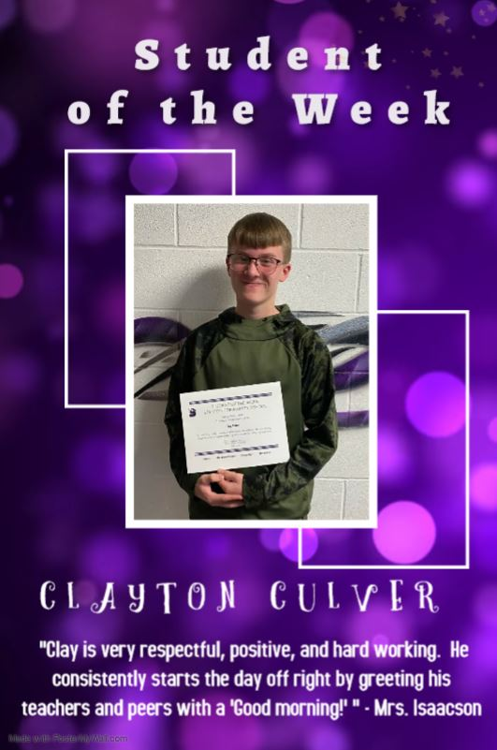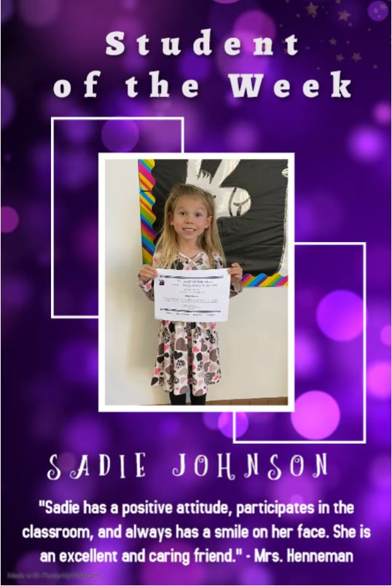

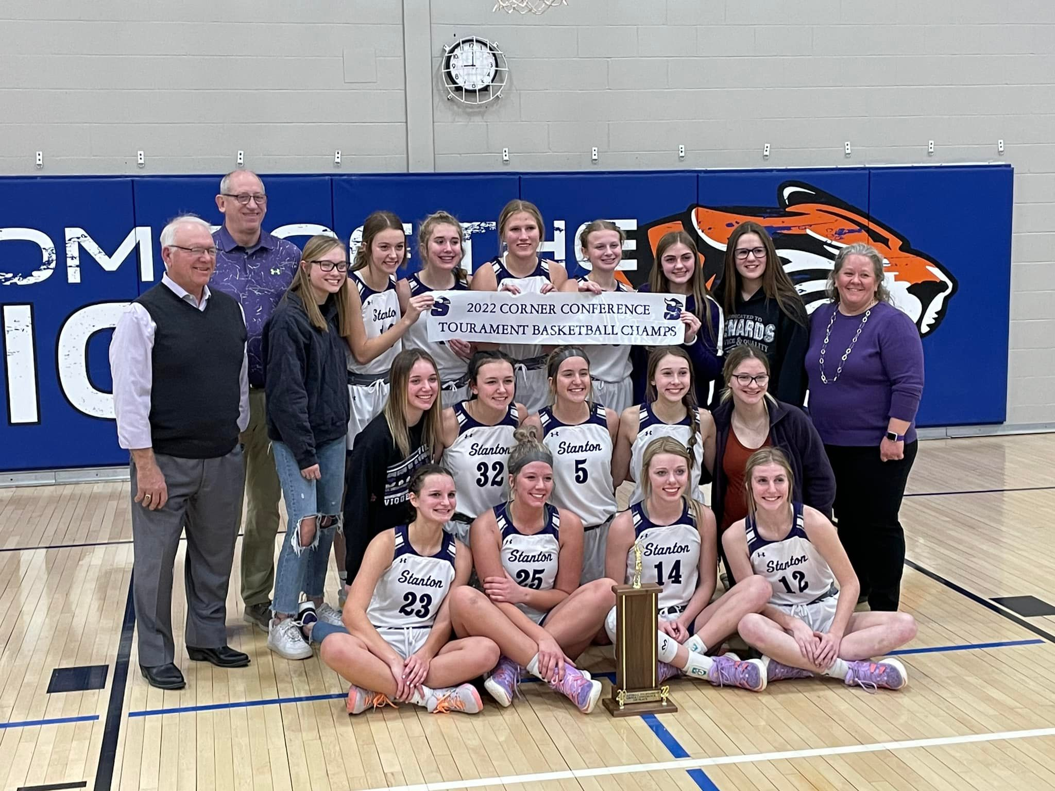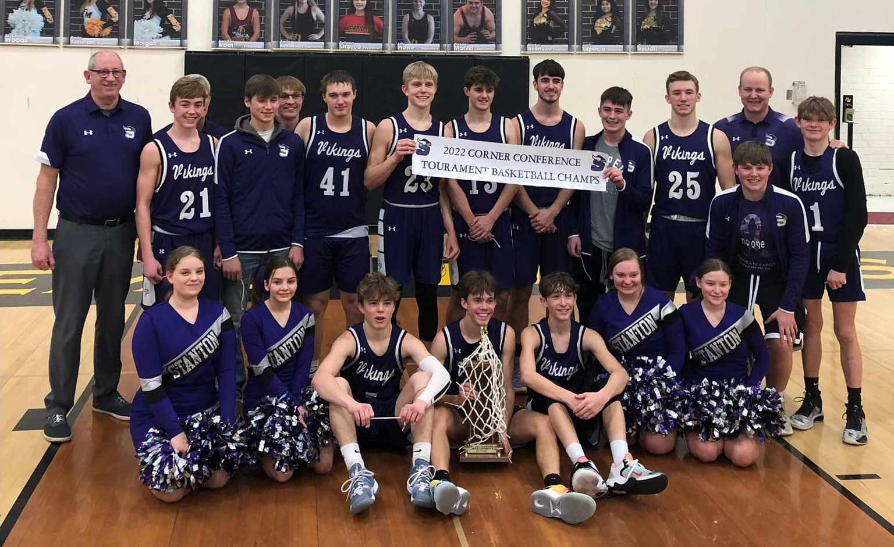

It is the policy of the Stanton Community School District not to discriminate on the basis of race, color, national origin, sex, disability, religion, creed, age (for employment), marital status (for programs), sexual orientation, gender identity and socioeconomic status (for programs) in its educational programs and its employment practices. There is a grievance procedure for processing complaints of discrimination. If you have questions or a grievance related to this policy please contact Mrs. Sheila Mainquist, 605 Elliott St., Stanton, Iowa 51573, smainquist@stantonschools.com, (712) 829-2162.

