STANTON COMMUNITY SCHOOL JANUARY 21, 2022

OPEN POSITIONS
Good Shepherd Preschool in partnership with Stanton Community School is looking for a lead preschool teacher for the 2022-23 school year. Please contact Katie Elwood at 712-829-2162 or kelwood@stantonschools.com with any questions regarding the position.


Our district is experiencing an increased need for substitute and/or activity route bus drivers. We ask that anyone who may be interested in being a substitute driver please contact Mrs. Elwood. The district is also currently looking for additional substitute teachers, substitute paras, and substitute kitchen staff. If you are interested in being a substitute for the district, please contact Mrs. Elwood, K-12 Principal, at 712-829-2162 or kelwood@stantonschools.com.

SCHOOL ACTIVITIES
District Large Group Speech Contest
The Stanton High School speech team will be traveling the Abraham Lincoln High School in Council Bluffs this Saturday, January 22nd. There are twenty-seven students that will be competing in the district large group speech contest. The following are the performance times:
*Center 2-Radio Broadcasting-F00D FM 8:32-8:40 AM
*Center 2-Radio Broadcasting-GEEK FM 9:24-9:32 AM
*Center 3-Group Improv-CARD 11:30-11:40 AM
*Center 8-Radio Broadcasting-8DEZ FM 1:10-1:18 PM
ALL TIMES ARE AN ESTIMATE. PLEASE PLAN ON ATTENDING BEFORE THE SCHEDULED TIME.
We are excited to be back in person for contest! Please plan on attending the district large group speech contest this Saturday, January 22nd.
There are a few "speech norms" with speech culture. Things like- no school apparel in contest centers, questions about ratings are addressed with the coach- not the judge. No entering rooms when doors are closed, hallways need to be kept quiet, no recording performances.
Also, the IHSSA encourages masks for all guests in hallways and performance centers. Additionally, Abraham Lincoln High School has adjusted their mask recommendation to "masks strongly encouraged".
National Honor Society
Order a Crush for your crush! The National Honor Society will be offering Crush soda pops this year. Forms are available in the high school office until January 28th and are due back by February 1st. Thank you for supporting the Stanton chapter of the National Honor Society!
The 2022 “LIFE, CAMERA, ACTION” yearbook will go on sale beginning January 24th. From January 24th through 31st, the books will cost $45.00 and starting February 1st, the books will cost $60. Contact a yearbook staffer to order and pay for your book.
You may also purchase your yearbook online with a credit card. To order online, go to www.stantonschools.com and click on the link that you see pictured above. That will take you to shopjostens.com where you can purchase your book. This link will go into effect starting January 24th.

You can personalize your yearbook as follows:
Icons (up to 4) for $3.75
One line of personalization for $7.00
Regardless of which method you use to order, the book has lots of film worthy moments that the staff has worked very hard on so don’t miss out on a great “LIFE, CAMERA, ACTION” book about Stanton High School.

GUIDANCE
Scholarships
Robert E. Byers Scholarship Trust – January 30
applications are available online at www.keepiowabeautiful.com
Tribute Award – January 31
To apply online, go to https://www.discover.com/student-loans/college-planning/scholarships/award
Elks National Foundation due February 7

Forms available at https://www.elks.org/scholars/scholarweb/legacy/rules.cfm?CFID=117036137&CFTOKEN=cec3990db643bdf-CE84CB82-D3DB-5637-AA13E80D2ABAC867
Dora Ossian Eastlack Scholarship
Iowa 4-H Scholarships - February 1
list of scholarships, instructions, and application available at -https://www.iowa4hfoundation.org/index.cfm?nodeID=31466&audienceID=1
also available at the Montgomery County Extension office
Masonic Scholarship - due February 1
https://grandlodgeofiowa.org/wp-content/uploads/2021/09/ScholarshipApplication_2022.pdf
Iowa Newspaper Foundation Scholarships – due February 11, 2022
applications available at: https://inanews.com/foundation/scholarships/
World Class, The Mediacom Scholarship Program – February 15
You may download the application at http://www.mediacomworldclass.com/
Conservation District of Iowa and Montgomery Soil and Water Conservation District Scholarships
due Feb 12
scholarship application is online at https://cdiowa.org/
Buick Achievers Scholarship Program – Feb. 27, 2021.
Montgomery County Farm Bureau Scholarship - due Feb. 26
https://www.iowafarmbureau.com/page/file?path=Files%2Fpage-874%2Fa1215.pdf
Page County Farm Bureau – due Feb. 26
Iowa Farm Bureau Federation Scholarship Program - due Feb. 26
Apply at
https://www.iowafarmbureau.com/page/file?path=Files%2Fpage-874%2Fa1215.pdf

ATHLETICS
Viqueen Basketball
The Queen’s were on the road in Corning January 13th for a non-conference battle with the Timberwolves. A quick start gave the Queen’s an early lead that would not be relinquished, overpowering their opponent 63-20.
Tuesday the Queen’s began Corner Conference Tournament pool play with a game against Griswold at home. Again the Queen’s got off to a quick start offensively scoring 19 first quarter points but gave up 11 to the Tigers. Coach Dave Snyder said, “We tried to pressure them at half court and they handled it fairly well, we backed off in the second half to cut down the gaps they were able to exploit”. The adjustment paid off as Griswold would not score in the 3rd quarter and only managed 6 points the second half. Final Stanton 51-27.
Viking Basketball
The Vikings advanced to the Conference Tournament semifinal with their win over Griswold Tuesday night. The Vikings played vs Sidney at East Mills last night. Thank you for your continued support!

ANNOUNCMENTS
Booster Club Meal
The Booster Club will be hosting a meal on Tuesday, January 25th, from 5:00-7:00 p.m. during the basketball games. Stanton will be hosting East Mills. There will be a choice of chili or potato soup, cinnamon roll, and drink.

COMING EVENTS
Friday, 21st 6:00- Corner Conference Girls Basketball
Tournament Consolation at Griswold
7:30- Corner Conference Girls Basketball
Tournament Championship at Griswold
Saturday, 22nd District Large Group Speech Contest at AL
6:00- Corner Conference Boys Basketball
Tournament Consolation at Fremont-Mills
7:30- Corner Conference Boys Basketball
Tournament Championship at Fremont-Mills
Tuesday, 25th 4:00-Junior Varsity with East Mills, Here
5:00-Booster Club Meal
6:00-Varsity Basketball with East Mills, Here
Wednesday, 26th 1:05/1:15-Early Dismissal
Thursday, 27th 4:00-Junior Varsity Basketball with CAM, Here
6:00-Varsity Basketball with Cam, Here
Friday, 28th 4:00-Junior Varsity Basketball at Essex
6:00-Varsity Basketball at Essex

BREAKFAST MENUS JANUARY 24-28
Monday  Brownie  Muffin/Fruit  Juice/Milk | Tuesday  Long John  Muffin/Fruit  Juice/Milk | Wednesday  Breakfast Sandwich  Muffin/Fruit  Juice/Milk | Thursday  Oatmeal Bar  Muffin/Fruit  Juice/Milk | Friday  Bacon & Egg Pizza  Muffin/Fruit  Juice/Milk

LUNCH MENUS JANUARY 24-28
Monday  Taquito/Hot Dog  Corn  Lettuce  Mandarin Oranges  Raisins  Goldfish  Milk | Tuesday  Chili  Carrots  Pears  Applesauce  Cinnamon Roll  Milk | Wednesday  Shrimp Poppers  Potato Wedges  Corn  Mixed Fruit/Pineapple  Graham Crackers/Cheese Sticks  Milk | Thursday  Teriyaki Beef  Fried Rice  Egg Roll  Cooked Carrots  Mandarin Oranges/Peaches  Fortune Cookie  Milk | Friday  Chicken Fried Steak/Bun  Sweet Potatoes  Baked Beans  Pears  Mixed Berries  Milk

Menus Subject to Change

MS/HS STUDENT OF THE WEEK ELEMENTARY STUDENT OF THE WEEK
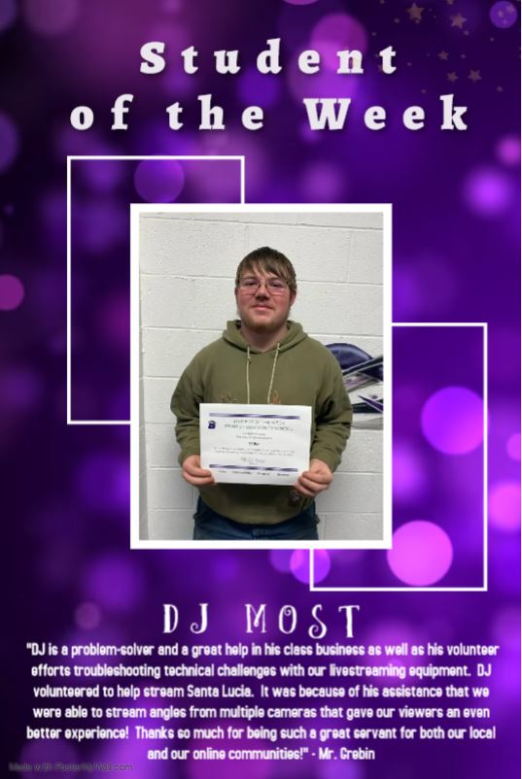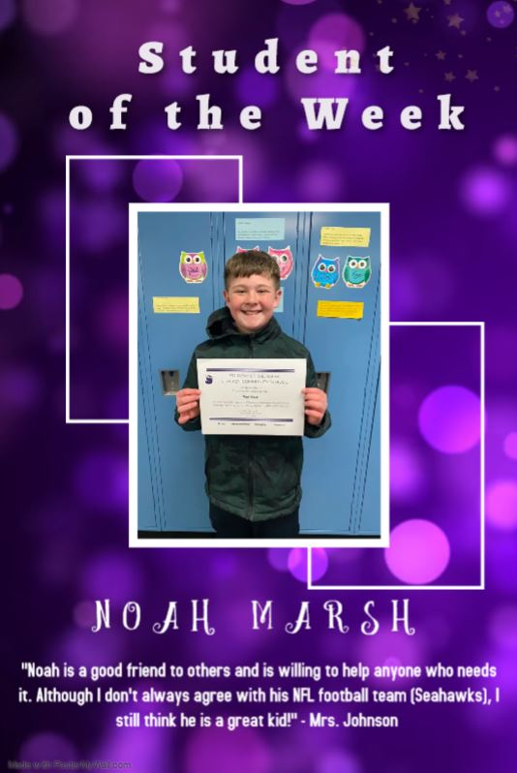

It is the policy of the Stanton Community School District not to discriminate on the basis of race, color, national origin, sex, disability, religion, creed, age (for employment), marital status (for programs), sexual orientation, gender identity and socioeconomic status (for programs) in its educational programs and its employment practices. There is a grievance procedure for processing complaints of discrimination. If you have questions or a grievance related to this policy please contact Mrs. Sheila Mainquist, 605 Elliott St., Stanton, Iowa 51573, smainquist@stantonschools.com, (712) 829-2162.

