STANTON COMMUNITY SCHOOL JANUARY 14, 2022

OPEN POSITIONS
Good Shepherd Preschool in partnership with Stanton Community School is looking for a lead preschool teacher for the 2022-23 school year. Please contact Katie Elwood at 712-829-2162 or kelwood@stantonschools.com with any questions regarding the position.


Our district is experiencing an increased need for substitute and/or activity route bus drivers. Please understand that if we do not have enough drivers, this could impact bus routes and times. We ask that anyone who may be interested in being a substitute driver please contact Mrs. Elwood. The district is also currently looking for additional substitute teachers, substitute paras, and substitute kitchen staff. If you are interested in being a substitute for the district, please contact Mrs. Elwood, K-12 Principal, at 712-829-2162 or kelwood@stantonschools.com.

PRINCIPAL
Congratulations to the sophomore class and Mrs. Lihs on their work in publishing the first edition “The Stanton Scoop” in the Red Oak Express on December 14th. Look for more Stanton news to come in next week’s edition of the Red Oak Express!
Reminder - we will not have school on Monday, January 17th due to staff in-service that day. Due to no classes on Monday, we will not have an early dismissal on Wednesday, January 19th.
Drivers Education classes start on Monday, January 17th from 8:00-11:00 a.m. in the school library.

SCHOOL ACTIVITIES
District Large Group Speech Contest
The Stanton High School speech students are preparing for their upcoming contest. The district large group contest will be on Saturday, January 22nd. Our students will be traveling to Abe Lincoln High School in Council Bluffs. There are twenty-six students competing this year. We are taking three radio broadcasting groups and one group improv. The students have been working to polish up their entries and we are excited about the district speech contest. Please come out and support the great work that the students are creating! Performance times and locations will be shared with the students and also on the Stanton School's Facebook page soon. Good luck to all the Stanton Large Group Speech students!
National Honor Society
We are one month away from Valentine’s Day. The National Honor Society will be offering treats again this year. Forms will be available in the high school office from January 17th-28th and are due back by February 1st. Treats will be given on February 14th. Thank you for supporting the Stanton chapter of the National Honor Society!
Music Department Meal
The Music Department will be serving a spaghetti meal tonight, 5:00-7:00 p.m. Meal includes spaghetti, salad, garlic bread, bottle of water, and dessert. Cost is a Free Will Donation. All proceeds will go towards the Music Department activities.

GUIDANCE
Scholarships
Robert E. Byers Scholarship Trust – January 30
applications are available online at www.keepiowabeautiful.com
Tribute Award – January 31
To apply online, go to https://www.discover.com/student-loans/college-planning/scholarships/award
Elks National Foundation due February 7
Forms available at https://www.elks.org/scholars/scholarweb/legacy/rules.cfm?CFID=117036137&CFTOKEN=cec3990db643bdf-CE84CB82-D3DB-5637-AA13E80D2ABAC867
Dora Ossian Eastlack Scholarship
Iowa 4-H Scholarships - February 1
list of scholarships, instructions, and application available at -https://www.iowa4hfoundation.org/index.cfm?nodeID=31466&audienceID=1
also available at the Montgomery County Extension office
Masonic Scholarship - due February 1
https://grandlodgeofiowa.org/wp-content/uploads/2021/09/ScholarshipApplication_2022.pdf
Iowa Newspaper Foundation Scholarships – due February 11, 2022

applications available at: https://inanews.com/foundation/scholarships/
World Class, The Mediacom Scholarship Program – February 15
You may download the application at http://www.mediacomworldclass.com/
Conservation District of Iowa and Montgomery Soil and Water Conservation District Scholarships
due Feb 12
scholarship application is online at https://cdiowa.org/
Buick Achievers Scholarship Program – Feb. 27, 2021.
Montgomery County Farm Bureau Scholarship - due Feb. 26
https://www.iowafarmbureau.com/page/file?path=Files%2Fpage-874%2Fa1215.pdf
Page County Farm Bureau – due Feb. 26
Iowa Farm Bureau Federation Scholarship Program - due Feb. 26
Apply at
https://www.iowafarmbureau.com/page/file?path=Files%2Fpage-874%2Fa1215.pdf

ATHLETICS
Viqueen Basketball
Sidney Cowgirls came to town to start our second round of Corner Conference regular season games. Sidney’s defensive scheme proved to be challenging coupled with some cold shooting for the Queens made for a close contest. Coach Dave Snyder said, “On nights when the ball is not going through the hoop you better be on the top of your game defensively.” By the end of the first quarter, it was evident the Queens were ready to play the “D” holding Sidney to two points and by games end a season low 28 points. “Brooklyn Silva will not show up in the offensive stats that we tend to pay a lot of attention to, but the defense she played was outstanding.” said Coach Snyder. Brooklyn held Sidney’s top scorer, scoreless. Although Stanton would never trail in the game, they could not gain a comfortable lead. Final Stanton 35, Sidney 28. The Queen’s ran their winning streak to 10-0 with the victory.
Stanton Viqueen’s have secured the top seed in the upcoming Corner Conference Tournament and will be hosting on the following nights
Tuesday January 18th vs Griswold at 6 p.m. followed by the boys vs Griswold at 7:30 p.m. Wednesday January 19th vs FM at 7:30 p.m.
Viking Basketball
The Viking basketball team got off to a great start after Christmas break with a 5 point win over the Sidney Cowboys. The win avenged a 38 point loss to the Cowboys earlier in the season. The Vikings are currently in the middle of a 4 game win streak. They continued with action last night against SW Valley and tonight vs Griswold. Next week the Vikings will compete in the Corner Conference Tournament where they will be the 3rd seed. Thank you for your support and GO VIKES!
JV Girls
The JV Viqueens came up just short losing to AHSTW 10-11 on January 6th. Hannah Olson and Lauren Johnson each had 4 points and Kiela Franzen had 2 points.
On January 11th the JV Viqueens defeated the Sidney Cowgirls 34-25. Hannah Olson had 11 points and 1 block; Lauren Johnson had 10 points, Kyla Hart had 5 points, 3 assists and 2 steals; Carly Roberts added 4 assists, 3 steals and 2 blocks.

ANNOUNCMENTS
Booster Club Meal
The Booster Club will be hosting a meal on Tuesday, January 25th, from 5:00-7:00 p.m. during the basketball games. Stanton will be hosting East Mills. There will be a choice of chili or potato soup, cinnamon roll, and drink.
5th Quarter
There will be a 5th Quarter this Friday, January 14th, after the basketball games at Mamrelund Lutheran Church. Any Stanton student in grades 7-12 may attend.

COMING EVENTS
Friday, 14th 4:00-Junior Varsity Basketball with Griswold,
Here
5:00-Music Department Meal
6:00-Varsity Basketball with Griswold, Here
Monday, 17th NO SCHOOL, Teacher Professional
Development
Tuesday, 18th 6:00-Corner Conference Girls Basketball
Tournament, Here, Stanton vs Griswold
7:30-Corner Conference Boys Basketball
Tournament, Here, Stanton vs Griswold
Wednesday, 19th NO EARLY DISMISSAL
7:30- Corner Conference Girls Basketball
Tournament, Here, Stanton vs Fremont-Mills
Thursday, 20th 6:00- Corner Conference Boys Basketball
Tournament at East Mills
Stanton vs Sidney
Friday, 21st 6:00- Corner Conference Girls Basketball
Tournament Consolation at Griswold
7:30- Corner Conference Girls Basketball
Tournament Championship at Griswold
Saturday, 22nd District Large Group Speech Contest at AL
6:00- Corner Conference Boys Basketball
Tournament Consolation at Fremont-Mills
7:30- Corner Conference Boys Basketball
Tournament Championship at Fremont-Mills

BREAKFAST MENUS JANUARY 17-21
Monday  NO SCHOOL | Tuesday  Cereal Bar  Muffin/Fruit  Juice/Milk | Wednesday  Breakfast Bar  Muffin/Fruit  Juice/Milk | Thursday  Pancake & Sausage  on a Stick  Muffin/Fruit  Juice/Milk | Friday  Donut Holes  Muffin/Fruit  Juice/Milk

LUNCH MENUS JANUARY 17-21
Monday  NO SCHOOL | Tuesday  French Bread Pizza  Lettuce  Broccoli  Pears  Applesauce  Milk | Wednesday  Pork Chopette/Bun  Baked Beans  Ranch Potatoes  Oranges  Mixed Fruit  Milk | Thursday  Beef Fritter  Mashed Potatoes/Gravy  Cooked Carrots  Mandarin Oranges/Peaches  Roll  Milk | Friday  Corn Dog  Baked Beans  Sweet potatoes  Macaroni Salad  Applesauce/Pineapple  Milk

Menus Subject to Change

MS/HS STUDENT OF THE WEEK ELEMENTARY STUDENT OF THE WEEK
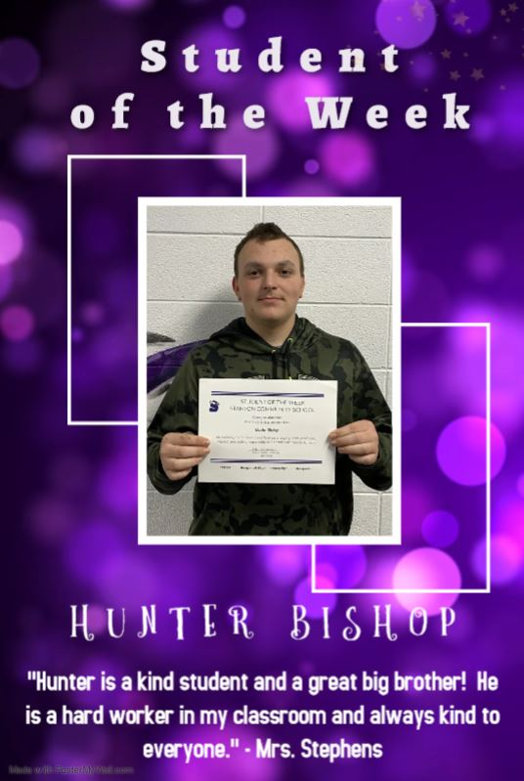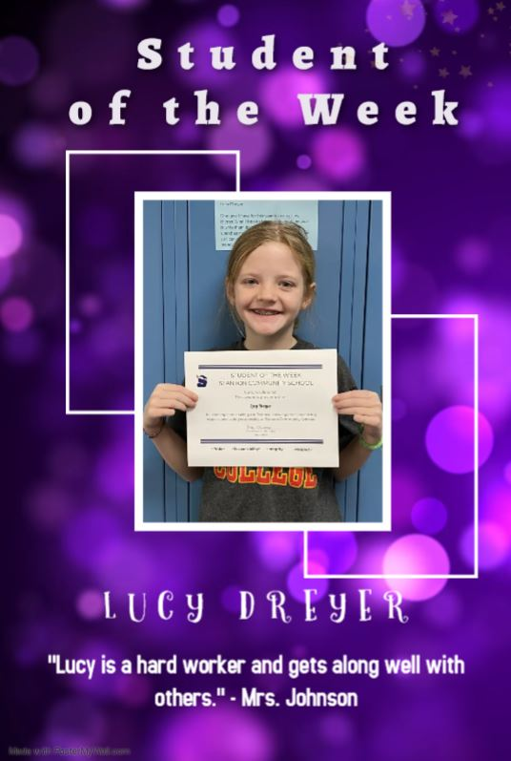

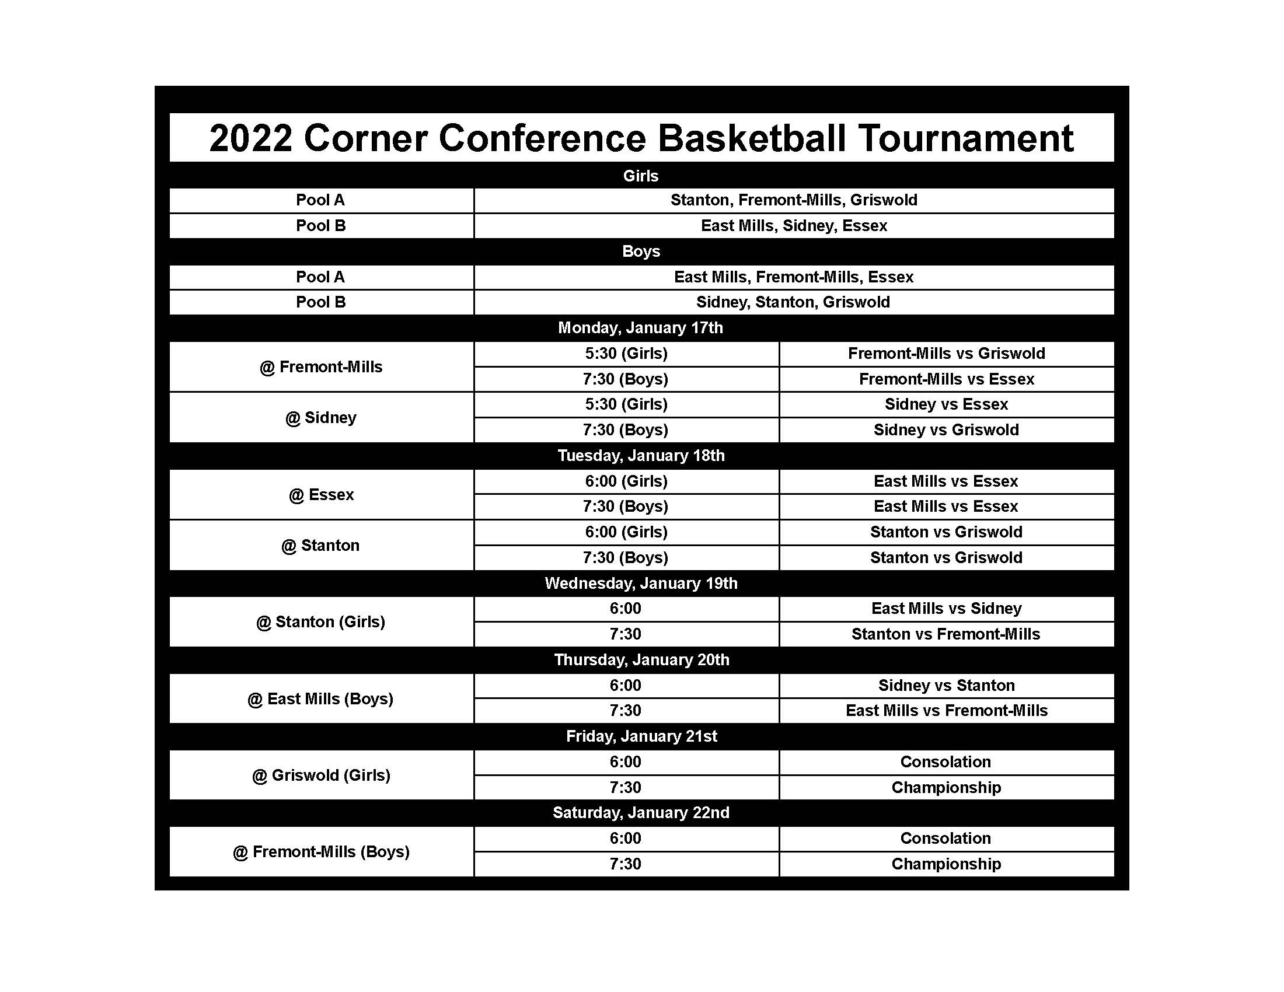

It is the policy of the Stanton Community School District not to discriminate on the basis of race, color, national origin, sex, disability, religion, creed, age (for employment), marital status (for programs), sexual orientation, gender identity and socioeconomic status (for programs) in its educational programs and its employment practices. There is a grievance procedure for processing complaints of discrimination. If you have questions or a grievance related to this policy please contact Mrs. Sheila Mainquist, 605 Elliott St., Stanton, Iowa 51573, smainquist@stantonschools.com, (712) 829-2162.

