STANTON COMMUNITY SCHOOL JANUARY 7, 2022

SCHOOL ACTIVITIES

Supplies

With the new semester beginning it would be the opportune time to replenish school supplies for your students!
Iowa Western Community College Honor Band
Congratulations to Corrine Hopf, Adrian Haynie, Evan Hopf, Ella Peterson, and James McDonald on being selected to participate in the Iowa Western Community College Honor Band. They will be performing a concert with other select students from Iowa, Missouri, and Nebraska on Monday, January 24th, in the IWCC auditorium.
"Get In Treble"
Twelve Stanton JH & HS students will participate in the Iowa Choral Directors Association's event, "Get In Treble," on Tuesday, January 18th. This event takes place during the school day and allows female students from across southwest Iowa to improve their singing skills by working with choral directors from across the area.
Iowa State University Cyclone Honor Band
Congratulations to Evan Hopf, Ella Peterson, and Levi Martin on being selected to participate in Iowa State University's two day honor band event on February 4th-5th. They will perform a concert with other select students at 3:00 pm. in Stephens Auditorium on February 5th.
Thank You
The Stanton Band Department would like to thank all who contributed to fundraising for our new marching band uniforms. Enough money was raised to purchase 40 new marching band uniforms for our 7th-12th grade band members. We were able to wear our new uniforms this marching season as well as have our new uniforms worn by Evan Hopf and Levi Martin in the 2021 Holiday Bowl Parade with the Southwest Iowa Honor Marching Band. Your support is greatly appreciated!

GUIDANCE
Scholarships
FFA Scholarships–due Jan 15
-information available at http://scholarships.ffa.org and click on the “scholarship” link
Robert E. Byers Scholarship Trust – January 30
applications are available online at www.keepiowabeautiful.com
Tribute Award – January 31
To apply online, go to https://www.discover.com/student-loans/college-planning/scholarships/award
Elks National Foundation due February 7
Forms available at https://www.elks.org/scholars/scholarweb/legacy/rules.cfm?CFID=117036137&CFTOKEN=cec3990db643bdf-CE84CB82-D3DB-5637-AA13E80D2ABAC867
Dora Ossian Eastlack Scholarship
Iowa 4-H Scholarships - February 1

list of scholarships, instructions, and application available at -https://www.iowa4hfoundation.org/index.cfm?nodeID=31466&audienceID=1
also available at the Montgomery County Extension office
Masonic Scholarship - due February 1
https://grandlodgeofiowa.org/wp-content/uploads/2021/09/ScholarshipApplication_2022.pdf
Iowa Newspaper Foundation Scholarships – due February 11, 2022
applications available at: https://inanews.com/foundation/scholarships/
World Class, The Mediacom Scholarship Program – February 15
You may download the application at http://www.mediacomworldclass.com/
Conservation District of Iowa and Montgomery Soil and Water Conservation District Scholarships
due Feb 12
scholarship application is online at https://cdiowa.org/
Buick Achievers Scholarship Program – Feb. 27, 2021.
Montgomery County Farm Bureau Scholarship - due Feb. 26
https://www.iowafarmbureau.com/page/file?path=Files%2Fpage-874%2Fa1215.pdf
Page County Farm Bureau – due Feb. 26
Iowa Farm Bureau Federation Scholarship Program - due Feb. 26
Apply at
https://www.iowafarmbureau.com/page/file?path=Files%2Fpage-874%2Fa1215.pdf

ATHLETICS
Viking Basketball
The Viking Basketball team is prepared to get the 2nd half of their season going on Tuesday vs the Sidney Cowboys. The Vikings come into the game with a record of 4-3 and are currently on a 3 game winning streak. Following Tuesday's game, the Vikings will be in action Thursday at SW Valley and Friday vs Griswold here in Stanton. Head on out and support the boys!

COMING EVENTS
Monday, 10th 4:00-Junior High Boys at Hamburg
Tuesday, 11th 4:00-Junior Varsity Basketball with Sidney, Here
6:00-Varsity Basketball with Sidney, Here
Wednesday 12th Large Group Picture Day
1:05-1:15-Early Dismissal
Thursday, 13th 6:00-Junior Varsity Basketball at SW Valley
6:00-Varsity Basketball at SW Valley
Friday, 14th 4:00-Junior Varsity Basketball with Griswold,
Here
5:00-Music Department Meal
6:00-Varsity Basketball with Griswold, Here

BREAKFAST MENUS JANUARY 10-14
Monday  Pop Tart  Muffin/Fruit  Juice/Milk | Tuesday  Donut  Muffin/Fruit  Juice/Milk | Wednesday  Waffle  Muffin/Fruit  Juice/Milk | Thursday  Omelet/Toast  Muffin/Fruit  Juice/Milk | Friday  Breakfast Sliders  Muffin/Fruit  Juice/Milk

LUNCH MENUS JANUARY 10-14
Monday  Hamburger/Bun  Smilie Potatoes  Baked Beans  Mixed Fruit  Cherry Crisp  Milk | Tuesday  Chicken Strips  Mashed Potatoes/Gravy  Cooked Carrots  Oranges/Pineapple  Roll  Milk | Wednesday  Burrito/Hot dog  Corn  Ice Cream  Mandarin Oranges  Peaches  Milk | Thursday  Lasagna Roll Up  Lettuce  Carrots  Pears/Applesauce  Breadstick  Milk | Friday  Fish Sandwich  Potato Spudsters  Baked Beans  Pineapple  Apple Slices  Milk

Menus Subject to Change

MS/HS STUDENT OF THE WEEK ELEMENTARY STUDENT OF THE WEEK
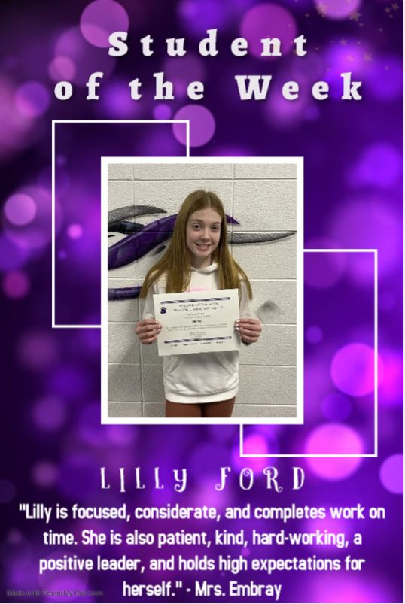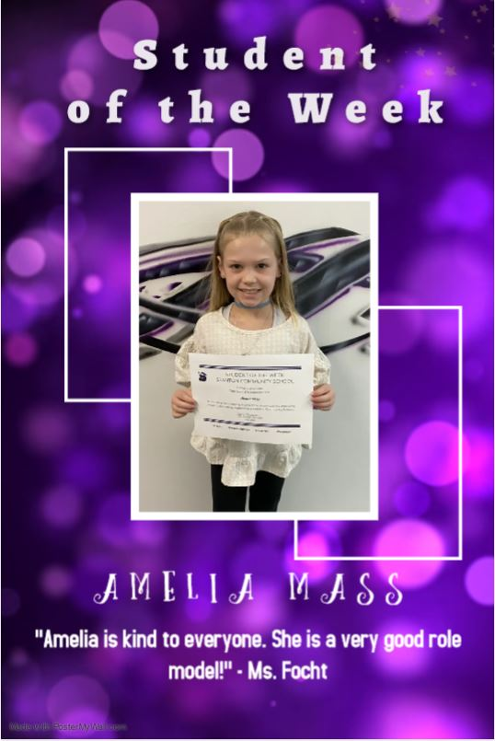

It is the policy of the Stanton Community School District not to discriminate on the basis of race, color, national origin, sex, disability, religion, creed, age (for employment), marital status (for programs), sexual orientation, gender identity and socioeconomic status (for programs) in its educational programs and its employment practices. There is a grievance procedure for processing complaints of discrimination. If you have questions or a grievance related to this policy please contact Mrs. Sheila Mainquist, 605 Elliott St., Stanton, Iowa 51573, smainquist@stantonschools.com, (712) 829-2162.

