STANTON COMMUNITY SCHOOL MARCH 12, 2021

PRINCIPAL
As we approach the one-year mark from when we had to close last spring, the administration wants to extend a thank you to our students, staff, parents, and community for all you have done to support the district throughout this school year. We are thankful that we have been able to have in-person learning for the 2020-2021 school year, and we greatly appreciate everyone’s patience and understanding throughout the year.
The end of the 3rd quarter is this Friday, March 12th. Report cards will be sent out next week.
Our 6th-11th grade students will be taking the Iowa Statewide Assessment of Student Progress (ISASP) next week (March 15th-March 19th). Our 3rd-5th grade students will be taking this assessment during the week of March 22nd. While seniors do not take the statewide assessment, they will be taking CPR training during the week of March 15th. Please note that this is a requirement for graduation. Please contact Mrs. Elwood or Mrs. Mainquist if you have any questions regarding this statewide assessment or the CPR requirement.

SCHOOL ACTIVITIES.
Corner Conference Quiz Bowl
Stanton hosted the Corner Conference Quiz Bowl on Wednesday. Eight teams competed with 2 teams from East Mills, Fremont-Mills, Griswold and Stanton.
Congratulations to all teams participating, everyone did a great job! Congratulations to Stanton’s A Team and Griswold’s B Team on winning their brackets in the Quiz Bowl.
Representing Stanton on the A Team were Amanda Benson, Roary Blair, Carter Johnson, Levi Martin, Logan Roberts, and Cameron Sallach. Stanton’s B Team was made up of Abby Burke, Preston Carpenter, Axel King, Jack Krueger, Damien Meek, and Addison Olson.
We would like to thank our “Quiz Masters” who read questions to the students, Charmla Carpenter, Kristin King, Matt King and Wendy Gardner from the East Mills/Fremont Mills schools. Thank you also to the score keepers and timers; Riley Burke, Kiela Franzen, Kyla Hart, Lauren Johnson, James McDonald, Hannah Olson, Caden Sallach, Simon Showalter and Devon Taylor.
A big thank you also to staff and students who helped with the event this afternoon from moving chairs and tables to setting up buzzer systems. We could not have pulled it off without your help!
Yearbook
The 2021 “BLEEDING PURPLE AND WHITE” yearbook is for sale. Cost of the book is $60.00. Contact a yearbook staffer to order and pay for your book.
You may also purchase your yearbook online with a credit card. To order online, go to www.stantonschools.com and click on yearbook icon. That will take you to shopjostens.com where you can purchase your book.
You can personalize your yearbook as follows:
Icons (up to 4) for $3.65
One line of personalization for $6.25

Starting this year there is a new feature for HS students. They can upload their own pictures for others to see in the yearbook. The students can scan this barcode to start the process.

Regardless of which method you use to order, the book will have lots of colorful moments that the staff is working very hard on so you will not want to miss out on a great “BLEEDING PURPLE AND WHITE” book about Stanton High School.
FCCLA/Red Cross Blood Drive-March 17th
Please call the school office at 829-2162 or visit RedCrossBlood.org and enter: Vikings to schedule an appointment. STUDENTS - Please stop in the office to make an appointment. By donating blood at the Stanton High School drive, not only are you helping save lives, you are also helping the school earn a scholarship for one or more of their graduating seniors.
All-School Play
Thank you for the support last Friday night! The high school students involved with the play had such a great time this year! It was a unique play and we appreciated the audience participation. This was a year to remember and the "case was solved". Thanks again for supporting the fine arts!
Individual Speech State Contest
On Thursday, the high school speech students competed at Individual Speech State Contest. The contest was held in the high school library and started at 5:00 PM. It was nice to have in-person judging this year. The students have worked very hard this speech season. It has also been great to have support from teachers, parents, and community members. Please check the school's Facebook page for results.
Elementary/6th Grade Musicals
Bedtime is Stanton elementary students’ favorite time of day, and they know that it may be strange to say. They just like to put on their pajamas to end their day. When mother calls, they listen and obey because her marching orders must be followed right away. They have to brush their teeth, pick up their clothes and toys, grab their cozy, special friend, and of course look for monsters under their bed!
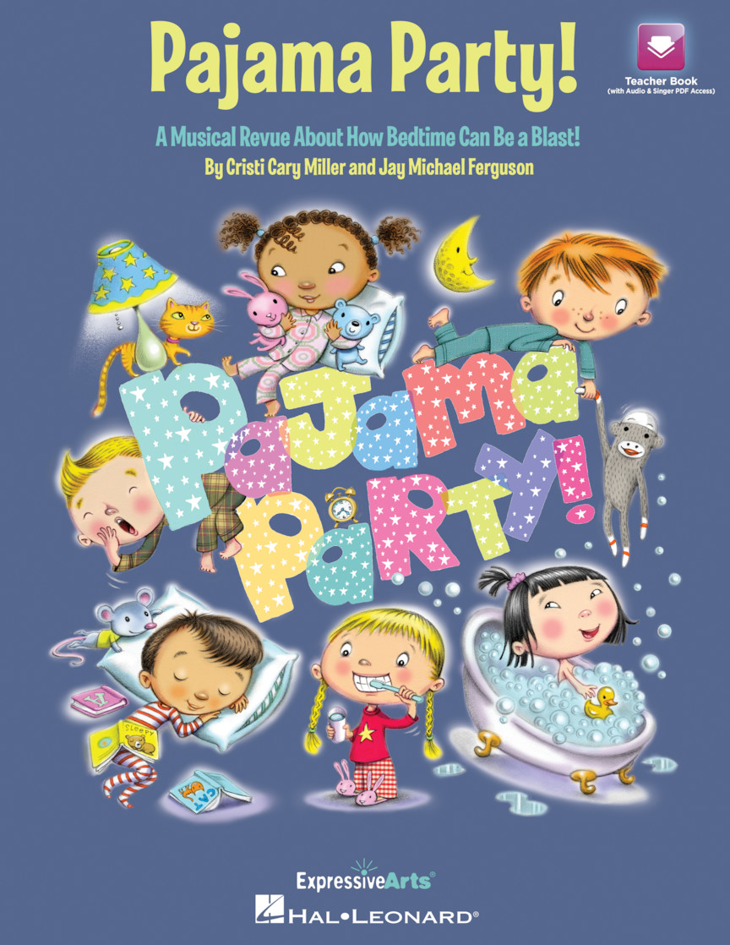
Stanton’s kindergarten through third grade students will be performing their musical, “Pajama Party,” on Friday, March 12th, at 7:00 PM. Due to COVID-19 guidelines, each student will be allowed three spectators. Spectator tickets have been sent home with students. This performance will also be live streamed on the school’s website for those who cannot attend in person.
Stanton’s 4th-6th graders are going summer camping at good, old-fashioned Camp Runamok. This is the same camp their parents went
to when they were kids. They are very skeptical at first and are not sure if they are going to like this summer camp experience. The
camp director is a former Marine Corps drill sergeant and is pretty strict. He makes them do pushups, wash their face in the pond, brush their teeth in the creek, and do all sorts of other crazy chores. A lot of them haven’t been to camp before and are not sure if they are going to make it.
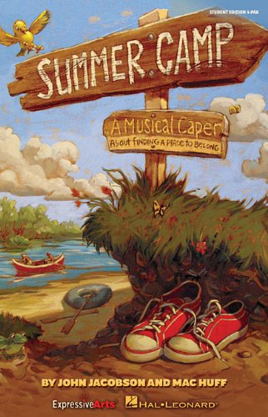
Join us on Friday, March 12th, at 7:40 p.m. to see their performance of the musical “Summer Camp.” Due to COVID-19 guidelines, each student will be allowed three spectators. Spectator tickets have been sent home with students. This performance will also be live streamed
on the school’s website for those who cannot attend in
person.

GUIDANCE.
Iowa Statewide Assessments of Student Progress (ISASP)
The Stanton Community Schools will administer the Iowa Statewide Assessments of Student Progress beginning Monday, March 15th, to all students in grades 6th-11th and March 22nd-March 26th for 3rd-5th.
The Iowa Statewide Assessment of Student Progress is aligned with the Iowa Core standards, providing a clear and accurate assessment of student learning outcomes. Just as in the everyday school activities, you can help your child do their best by seeing that he/she is fully rested.
Scholarships
LOCAL STANTON SCHOLARSHIPS - due March 19
Michelle Mead-Salley Scholarship
The Michelle Mead-Salley Scholarship was established in the spring of 2021. Michelle lost a hard-fought battle with pancreatic cancer in January of 2021.
Michelle graduated from Stanton Community School in 1990. She went on to further her education at the University of Iowa where she earned her degree in nursing. She loved being a wife, mother, and nurse. She loved life and gave 100% to everything she did. She was known for her knowledge and skill as a nurse and was loved by her patients and the doctors and nurses with whom she worked.
Terms of the scholarship:
-The amount of the scholarship will be determined yearly.
-It is open to all senior students pursuing a post-secondary education.
-Applicants will be judged on their integrity, respect for others, being responsible, and for exhibiting a good attitude.
-Special consideration may be given to students entering the medical
field.
-Students are to submit a local scholarship application which includes a written letter giving information including their personal information, post-secondary educational goals, and career plans.
-The scholarship will be given after the student has completed a successful first semester and enrolled in their second semester.
Double Dozen Scholarship-Academics, character, leadership and potential for growth and success.
Duane Falk Scholarship-Based on academics, leadership, and participation in school and community activities. Number and amount designated annually.
Larmon Scholarship-Based on academic excellence and achievement in school and community activities. Number and amount designated annually.
American Legion Scholarship-Sponsored by the American Legion and Legion Auxiliary. Based on academic and leadership accomplishments. Must be a relative of a veteran.
National Honor Society Scholarship-One member---one non-member. Based on classes taken and grades. $100.00 each
Stanton Faculty and Administrators Scholarship-Must be going into an education field.
Stephanie (Peterson) and Christopher Stein Scholarship-Must be attending Iowa State University. Based on moral character, attitude, leadership, activities in school, and community service. Number of scholarships designated annually. $500
Ashley and Brooke Maley Memorial Scholarship-Amount to be determined yearly. Open to all senior students. Students may be pursuing any type of post-secondary education.
Class of 1963–One scholarship given to a graduating senior from Stanton Community High School. Students may be pursuing any type of post-secondary education.
Stewart Sisters Scholarship-As alumnae of Stanton H. S., Shauna, Shalée, and ShaRee value the education they received here and feel it is important to give back. Based on academics, leadership, and participation in school and community activities. Open to graduating high school seniors. Submit a local scholarship application. Number and amount designated annually.
Sherie Goodemote Wistrom Memorial Scholarships-One $250 music or medical (nursing) related scholarship will be given. In order to receive the scholarship, you must be a graduating senior from Stanton Community High School, you will need to maintain a grade point average of 3.0 and be registered for college the following semester.
Robert E. Johnson Memorial Scholarship-Based on academics, leadership, and participation in school and community activities. $500
Myrna Johnson Memorial Scholarship-Based on academics, leadership, and participation in school and community activities. $500
Brooke Engstrand Scholarship-The Brooke Engstrand scholarship established in the spring of 2013 is intended for seniors planning to further their education in a 4-year or 2-year college program, or a technical school. Brooke had a passion for music and making the most of her life and the opportunities she was given. She was involved in many activities while a student at Stanton Community School, both in and out of school. Her love of horses and for others filled her life with joy and fulfillment. Brooke graduated in 2008 from Stanton High School. The number and amount of scholarships will be determined yearly. Scholarships go to a graduating senior. Submit a local scholarship application, including a letter with personal information, post-secondary education plans, and need for this scholarship.
Darwin L. “Rosy” Rossander Memorial Scholarship-A scholarship has been established in memory of Darwin L. “Rosy” Rossander, a lifelong Stanton resident and community supporter. Youth, the activities youth were involved in, and the Stanton community were his passion. He attended almost every Stanton school event and loved supporting the Vikings and Viqueens. Rosy was a 4-H leader. He led 4-H shooting sports and enjoyed helping youth improve their skills. Through his American Legion activities, he planned and organized numerous community service events and projects, including the veterans’ memorial that is on Main Street. The scholarship will be given to a Stanton student with evaluation based on involvement including, but not limited to: athletics, 4-H, choir, and community service activities.
Stanton Masonic Tarkio Lodge #645 A.F.& A.M. Scholarship Endowed Fund -This scholarship was established in 2018. The scholarship shall be awarded to a graduating senior of Stanton Community Schools. Applicants will submit a local scholarship application and will include a written letter containing personal information and post-secondary education plans. Based on: Integrity, citizenship, leadership, and participation in school, church, and community activities. Amount to be designated annually. The scholarship money will be available in August of the awarded year.
Cassie Rae Williams Memorial Scholarship-Cassie Rae (Gilliland) Williams was a 2005 Stanton graduate, she attended college, and went out to explore the world. When it came time to raise her family she returned to Stanton. She joined several committees and organizations giving back to the community she loved. Cassie was taken tragically in an automobile accident in 2019. In her spirit of giving back this scholarship has been established in her memory. The number of scholarships and amounts awarded will be determined on a yearly basis. Scholarships go to a graduating senior. Submit a local scholarship application, including a letter or essay with personal information, and post-secondary education plans.
IOWA AMVETS-March 15
Better Business Bureau-Student of Integrity Scholarship
March 19
Southwest Iowa Educational Foundation–March 22
Meredith Communications Southwest Iowa Scholarship
March 27
Hospital Education and Research Foundation (IHERF)-March 30
Page County Cattlemen Scholarship–March 30
P.E.O. Scholarship–March 31

ATHLETICS
Junior High Girls Track
The junior high girls track team began practice on Monday, March 1st. Beginning Monday, March 15th, the team will practice 8th hour and after school until 4:15 daily. The first track meet for the team is scheduled for Tuesday, April 13th, as we host our Jr. Viking and Viqueen Relays at home. An updated meet schedule will be sent home with the girls the first week of practice.

ANNOUNCEMENTS

Activity Kits
The Viking Center is looking for donations for children's Activity Kits. These activity kits would be used if students are taking shelter at the Viking Center for an extended period of time. Items include new or gently used board games, card games, new coloring books, 12 count crayons, 8 count washable markers, small bottled water, clear 40-66 qt totes with lids. Items can be dropped off at the Viking Center or sent with kids to school. If you have any questions, please feel free to contact the Viking Center via e-mail at vikingcenter@myfmtc.com.
Track Wearables
Track wearables are for sale from the Booster Club. The store closes Monday. Go to https://stanton-trackfield.itemorder.com/sale to order.
PTSO Board Meeting
The Stanton PTSO board meeting will be Thursday, March 18th, at 5:30 in the Viking Center. There is also a Zoom option to attend, please e-mail ptso@stantonschools.com for the link. Face masks are required while inside the Viking Center. Anyone is welcome to attend!

Pitch, Hit, and Run

The YMCA will be having Pitch, Hit, and Run on April 10th at 5:00 PM at the Red Oak Sports Complex (North 4th Street). This is open to all age 7-14 and there will be baseball and softball divisions. Age will be determined as of July 17, 2021. Participation is free.

COMING EVENTS
Friday, 12th End of 3rd Quarter
7:00-Elementary Musical
Monday, 15th Iowa Statewide Assessments of Student
Progress (ISASP) 6th-11th Grades
Tuesday, 16th Iowa Statewide Assessments of Student
Progress (ISASP) 6th-11th Grades
Wednesday 17th 1:05/1:15-Early Dismissal
Thursday, 18th Iowa Statewide Assessments of Student
Progress (ISASP) 6th-11th Grades
Friday, 19th Iowa Statewide Assessments of Student
Progress (ISASP) 6th-11th Grades

BREAKFAST MENUS MARCH 15-19
Monday  Breakfast Brownie  Muffin/Fruit  Juice/Milk | Tuesday  Bagel Bites  Muffin/Fruit  Juice/Milk | Wednesday  Breakfast Sliders  Muffin/Fruit  Juice/Milk | Thursday  French Toast Bar  Muffin/Fruit  Juice/Milk | Friday  Bosco Stick  Muffin/Fruit  Juice/Milk

LUNCH MENUS MARCH 15-19
Monday  Fiestada  Lettuce  Corn  Pears  Applesauce  Milk | Tuesday  Teriyaki Beef  Fried Rice/Egg Roll  Carrots  Peaches/Apple  Fortune Cookie  Milk | Wednesday  Mac & Cheese  Mini Corn Dogs  California Vegetables  Tri-Tater  Mixed Fruit/Strawberries  Milk | Thursday  Walking Taco  Lettuce/Cheese  Refried Beans/Corn  Pineapple  Mandarin Oranges  Milk | Friday  Tuna Noodle Casserole  Peas  Green Beans  Oranges/Peaches  Roll  Milk


